Name _________________________________ Date _____________

Algebra 1 PTech

Warm Up

1. The breakdown of a sample of a chemical compound is represented by the function , where  represents the number of milligrams of the substance and *t* represents the time, in years. In the function , explain what 0.5 and 300 represent.

2. Write an exponential equation for the graph shown below. (HINT: Make a table of points.)

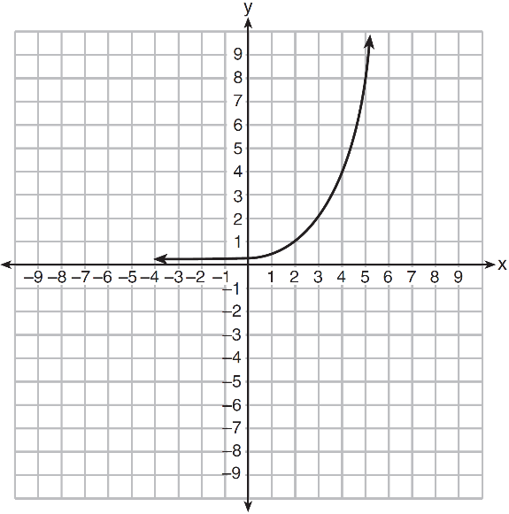

3. Rhonda deposited $3000 in an account in the Merrick National Bank, earning 4.2% interest, compounded annually. She made no deposits or withdrawals. Write an equation that can be used to find *B*, her account balance after *t* years.

Name _________________________________ Date _____________

Algebra 1 PTech

Cool Down

Given the two sequences below, determine which is arithmetic and which is geometric.

5, -10, 20, -40, … -3, 1, 5, 9, …

a) Circle one: a) Circle one:

Arithmetic or Geometric Arithmetic or Geometric

b) Initial Term: b) Initial Term:

a1 = a1 =

c) Circle one: c) Circle one:

Common Difference Common Difference

Common Ratio Common Ratio

d) From (c), what is it? d) From (c), what is it?

e) Define a recursive formula: e) Define a recursive formula:

f) Define an explicit formula: f) Define an explicit formula:

Name _________________________________ Date _____________

Algebra 1 PTech



Unit 6 Lesson 9

Homework

The population of a rare species of muskrat is degreasing at an alarming rate. When first tracking the population, it was discovered there were 384 in existence. The next year, it was noted that there were only 192 and the third year there were only 96.

a) If this pattern continues, how many will be in existence after the 5th year?

b) Does this represent an arithmetic or a geometric progression? Explain how you know.

c) Write an explicit formula that models this sequence.

d) According to this progression, how many muskrat will be in existence in the 10th year? Does this make sense? Why or why not?

