**Internal Conflict Creates a Crisis – Division within Islam (in Patterns of Interaction, ch. 10:2)**

Despite spectacular gains on the battlefield, the Muslim community had difficulty maintaining a unified rule. In 656, Uthman was murdered, starting a civil war in which various groups struggled for power. Ali, as Muhammad’s cousin and son-inlaw, was the natural choice as a successor to Uthman. However, his right to rule was challenged by Muawiya, a governor of Syria. Then, in 661, Ali, too, was assassinated. The elective system of choosing a caliph died with him.

A family known as the Umayyads (oo•MYE•yadz) then came to power. The Umayyads moved the Muslim capital to Damascus. This location, away from Mecca, made controlling conquered territories easier. However, the Arab Muslims felt it was too far away from their lands. In addition, the Umayyads abandoned the simple life of previous caliphs and began to surround themselves with wealth and ceremony similar to that of non-Muslim rulers. These actions, along with the leadership issue, gave rise to a fundamental division in the Muslim community.

**Sunni–Shi’a Split**

In the interest of peace, the majority of Muslims accepted the Umayyads’ rule. However, a minority continued to resist. This group developed an alternate view of the office of caliph. In this view, the caliph needed to be a descendant of the Prophet. This group was called Shi’a, meaning the “party” of Ali. Members of this group are called Shi’ites. Those who did not outwardly resist the rule of the Umayyads later became known as Sunni, meaning followers of Muhammad’s example. Another group, the Sufi (SOO•fee), rejected the luxurious life of the Umayyads. They pursued a life of poverty and devotion to a spiritual path.

Vigorous religious and political opposition to the Umayyad caliphate led to its downfall. Rebel groups overthrew the Umayyads in the year 750. The most powerful of those groups, the Abbasids (AB•uh•SIHDZ), took control of the empire.

When the Abbasids came to power in 750, they ruthlessly murdered the remaining members of the Umayyad family. One prince named Abd al-Rahman escaped the slaughter and fled to Spain. There he set up an Umayyad caliphate. Spain had already been conquered and settled by Muslims from North Africa, who were known as Berbers. The Berber armies advanced north to within 200 miles of Paris before being halted at the Battle of Tours in 732. They then settled in southern Spain, where they helped form an extraordinary Muslim state in al-Andalus (al•AN•duh•LUS).

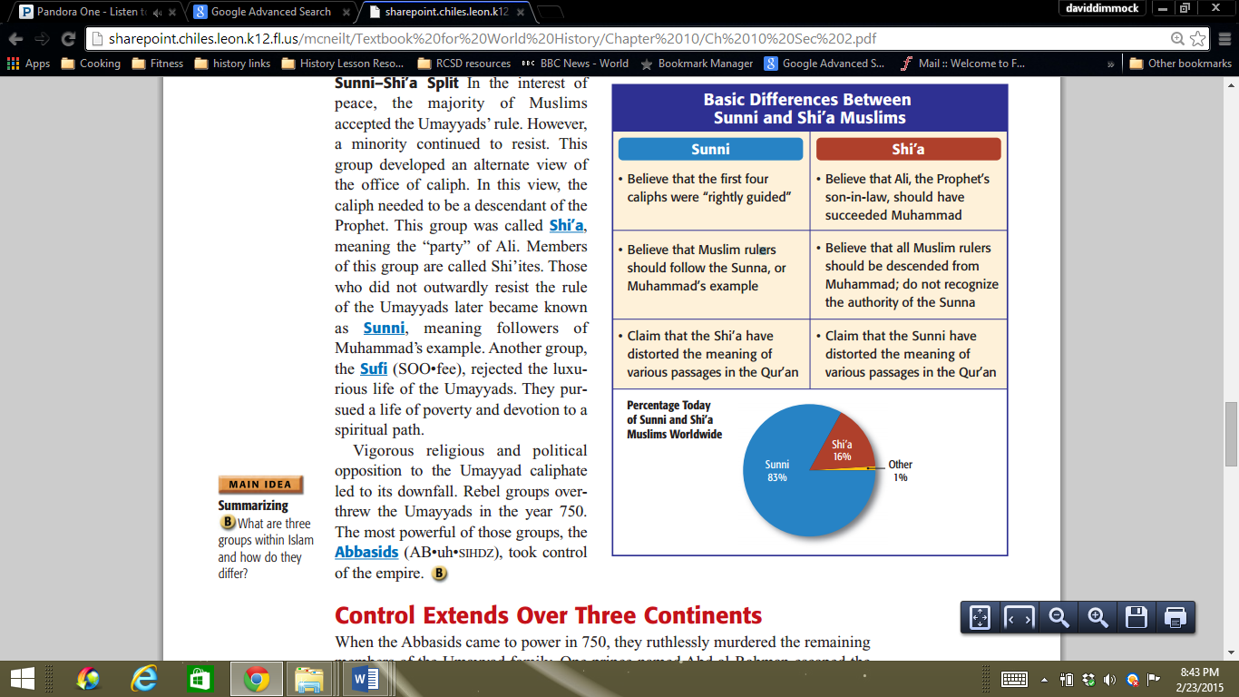**Abbasids Consolidate Power**

To solidify power, the Abbasids moved the capital of the empire in 762 to a newly created city, Baghdad, in central Iraq. The location on key trade routes gave the caliph access to trade goods, gold, and information about the far-flung empire.

The Abbasids developed a strong bureaucracy to conduct the huge empire’s affairs. A treasury kept track of the money flow. A special department managed the business of the army. Diplomats from the empire were sent to courts in Europe, Africa, and Asia to conduct imperial business. To support this bureaucracy, the Abbasids taxed land, imports and exports, and non-Muslims’ wealth.