***Teacher Evaluation Guide* SUPPLEMENT A Independent Evaluator Process**

# INDEPENDENT EVALUATOR as part of TEACHER OBSERVATION Component

Evaluation by an Independent Evaluator (formerly CIT Peer Reviewer) is mandatory for teachers who received an APPR Composite or Transition Rating of “Ineffective” for the previous school year and is optional for all other teachers. The teacher’s professional practice will be evaluated by the teacher’s Administrator Supervisor (80% of Observation component) ***AND*** an appropriately trained CIT Lead Teacher/Independent Evaluator (20% of Observation component) who will each conduct multiple observations using the Teachscape Rubric.

The use of Lead Teachers as part of the evaluation process has always been part of Rochester’s Peer Assistance and Review (PAR) programs and represents the highest principles of teacher professionalism and teacher leadership. Trained CIT Lead Teacher-Mentors use the same framework and rubric language that are used in teacher evaluation. As part of the negotiated APPR Agreement, the use of an Independent Evaluator builds these principles into the structure of our teacher evaluation process with the goal of improving instruction and supporting student learning.

CIT Independent Evaluators conduct classroom observations of teachers (in their field whenever possible) followed by rich learning-focused conferences. They provide verbal and written feedback, and then assign ratings for Domains 2 and 3 (Classroom Environment and Instruction) as part of the teacher evaluation process (80% of the APPR “Observation” component).

In Rochester, CIT Independent Evaluators are selected from a corps of trained Lead Teacher-Mentors. Lead Teacher-Mentors are vetted and selected by the collaborative CIT Governing Panel made up of teachers and administrators. They are well trained in the Learning-focused Conversation skills that are the heart of an effective evaluation system with professional growth as its goal. In addition to their selection and training as mentors, Independent Evaluators must be recommended for this role by the CIT Governing Panel and successfully complete the Teachscape Proficiency Focus Assessment. Independent Evaluators must have a solid understanding of the Danielson Teachscape rubrics and apply them to the observation and evaluation process with minimal bias in order to provide feedback and fair, accurate ratings for teachers.

Research by Susan Moore Johnson and others suggest that a well-designed Peer Review program that is built on trust, communication, and credibility can provide subject matter expertise, classroom perspective, and teacher leadership into the evaluation process. CIT survey data from 2014-2015 supports that view:

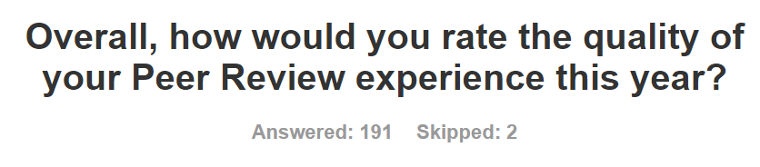

**COMMENTS:**

“I can honestly say that my teaching has improved as a result of the constructive feedback and conversations we had.”

“I love having a peer reviewer! There are things that he sees that other reviewers do not because they are not teachers, or haven’t been in a long time. I always feel like he "gets it" and offers the best recommendations and suggestions.”

“Our conversations inspired me to grow as a teacher. I was able to see where I could improve, how I could use class routines in a way that encouraged student ownership of the classroom.”

“All interactions I had with my Peer Reviewer were respectful and constructive. I felt that my Peer Reviewer fairly evaluated my work, and offered constructive feedback that has helped me in the classroom.”

“Although we did not always agree, my peer evaluator professionally and with much consideration pointed out areas of weakness and provided suggests (strategies and methods) to improve practice. This is attention I seldom receive from administration.”

“The peer reviewer understood my certification area and because of that the suggestions were better aligned with the needs of my classroom.”

“My peer reviewer is an amazing asset and an integral part of my development as an educator!”

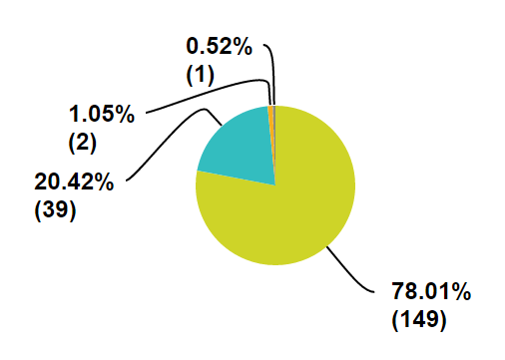

**Effective**

**Highly Effective**

**Developing**

**Ineffective**

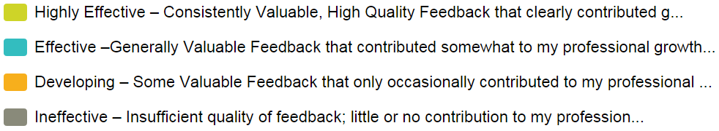

**Teacher Evaluation Guide SUPPLEMENT A (continued)**(This is a summary of the process for teachers who select Independent Evaluation.)

**CIT INDEPENDENT EVALUATOR PROCESS**

To comply with changes in New York State education law, the RCSD-RTA APPR Agreement includes an “Independent Evaluator” option to replace “Peer Review.” We hope to preserve the opportunity to receive rich feedback from colleagues in our field. The goal is to ensure that our evaluation system includes meaningful professional growth.

1. **Contact**:

You will be contacted by your assigned CIT Lead Teacher Independent Evaluator (IE). The IE will describe the process, timetable, and forms to be used. This first meeting can take place as part of the Classroom Visit with Feedback.

1. **Classroom Visit(s) with Feedback:**

Your IE will watch you work with students, take notes, engage in rich discussion about your teaching practice, and provide some targeted, informal feedback.

1. **Unannounced Observation**

Your IE will observe, take notes, and schedule a Post-observation Conference. You will discuss observation evidence, questions, and suggestions. The IE will provide rich written feedback aligned with Domains 2 and 3 of the Danielson *Framework for Teaching* rubrics. This feedback will be entered in the TeachBoost “Unannounced Observation (IE)” form, and the Post-observation Conference will be documented in the “Post-observation Conference (IE)” form. You will have the opportunity to add additional reflection, comments and/or a rebuttal.

1. **Ratings as part of APPR Summative Ratings**

Based on observation evidence, your IE will submit ratings for components in Domains 2 and 3 of the Danielson *Framework for Teaching* rubrics as part of the TeachBoost “Unannounced Observation (IE)” form. Components for which there is insufficient evidence may be unrated. You will discuss these ratings with the Independent Evaluator. The ratings will automatically flow into the “Summative End-of-year Ratings,” and you will have the opportunity to complete a “Performance Evaluation Comments/Rebuttal” form. **Independent Evaluator ratings will count as 20% of the APPR Observation Component.**

**Independent Evaluators should complete observations, evaluation ratings, and conferences in TeachBoost by May 21 (April 30 for non-tenured teachers).**

Refer to the Teacher Evaluation Guide for additional information: [www.rcsdk12.org/CIT/APPR](https://www.rcsdk12.org/CIT/APPR).

Questions about the overall APPR process should be sent to [APPR@rcsdk12.org](mailto:APPR@rcsdk12.org).

RTA resources about the APPR process can be found here: [rochesterteachers.org/appr](http://rochesterteachers.org/appr/).

TeachBoost Help: [support.teachboost.com](https://support.teachboost.com/hc/en-us/articles/8083933591060). RCSD Tutorials: [RCSD Tutorials Google Drive Folder](https://drive.google.com/drive/folders/1BkOVwU13208TV1dlndteYvgNp_Xqa04I)

Please address questions about the Independent Evaluator process to [CIT@rcsdk12.org](mailto:CIT@rcsdk12.org).