**Read Books Daily**



Read books daily for at least twenty minutes. Although your child may not be able to read the words, he or she can tell you what is happening or ask questions by looking at the pictures. Then you can read the story to your child.

After reading a story, ask questions to your child, such as: Who was in the story? Where did the story take place? What happened at the beginning, middle, and end of the story?

**Counting Numbers**

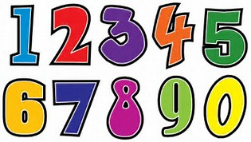

Practice counting items with your child: steps, stairs, crackers, noodles, toys, etc. It would be very helpful for your child to be able to count out loud to at least the number 20.

Practice writing the numbers 0-10 on paper to show “How many?” objects were counted.

**Practice Cutting With**

**Scissors**



Have your child practice cutting paper using a pair of child safety scissors. You could draw lines on a paper (straight, curvy, or jagged) and have your child cut along the lines. Your child could also cut out pictures in magazines, coloring books, or newspapers.

**Things to work on this Summer…**

**How to Buckle a Belt**



If your child will be wearing a belt to school, your child will be expected to unbuckle and buckle his or her own belt when it is time to use the restroom.

**Practice Writing Own Name**



Have your child practice writing his or her own first and last names. Make sure the first letter is capitalized and the rest of the letters in the name are lowercase and formed correctly.

**Tying Shoes**

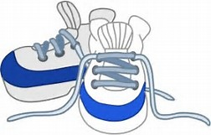

Begin teaching your child how to tie his or her own shoes. This is an invaluable skill as students will be expected to wear sneakers every other day for P.E. classes.