Name _________________________________ Date _____________

Algebra 1 PTech

Warm Up

1. The school newspaper surveyed the student body for an article about club membership. The table below shows the number of students in each grade level who belong to one or more clubs.

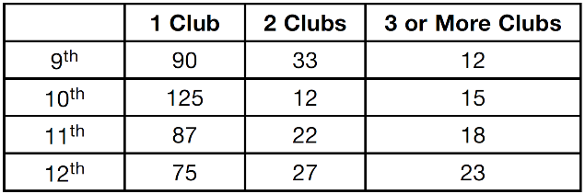

If there are 180 students in ninth grade, what percentage of the ninth grade students belong to more than one club?

2. A function is shown in the table below.

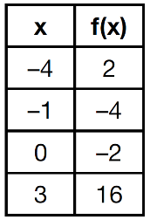

If included in the table, which ordered pair,  or , would result in a relation that is no longer a function? Explain your answer.

Name _________________________________ Date _____________

Algebra 1 PTech

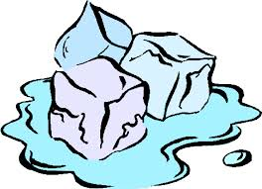Cool Down

1. Subtract  from . Express the result as a trinomial.

2. Graph the following function on the set of axes below.



