**THE HALLAM HERALD **

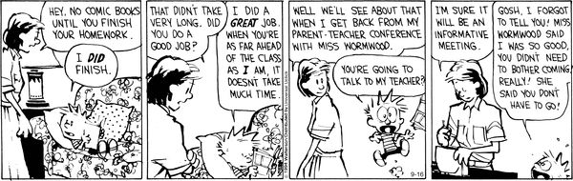

Dear Parents,

I will be conducting Parent-Teacher Conferences this week and next. If you would like to come in, please provide a date and time that you are available (after school hours.) Hopefully, there will not be time conflicts with other parents. If you prefer a telephone conference instead, we can do that (after school hours.) Please provide an updated telephone number. Thank you.

Sincerely,

Mrs. K. Hallam

**Parent-Teacher Conference at School #22:**

**Student Name _______________________________________________________________**

**Parent Name ________________________________________________________________**

Date: ___________________________________________ Time: ______________________

Alternate Date: ___________________________________ Time: ______________________

**Parent-Teacher Conference via Telephone:**

**Student Name _______________________________________________________________**

**Parent Name ________________________________________________________________**

Date: ___________________________________________ Time: ______________________

Alternate Date: ___________________________________ Time: ______________________

Telephone Number: ___________________________________________________________