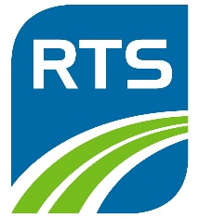

How to use RTS Neighborhood Direct Service
Franklin Campus
Finding your Neighborhood Direct Service Route, or NDS, is easy.

Going to School
All routes going to World of Inquiry School will have a three-digit route number starting with the number “4”.
- Look at the map on your Neighborhood Direct Service Schedule. Find the route that travels closest to your neighborhood. Note the three-digit route number and route name.
- Be sure to be at your bus stop at least 7 minutes before the scheduled departure time. Look for the bus with your three-digit route number: it will be on a digital sign and will also read “FRANKLIN”.

Going back home
- Look at the map on your Neighborhood Direct Service schedule and find the route that travels closest to your neighborhood.
- Find the bus with your route’s three-digit number on its digital sign. The sign will also display the name of your neighborhood.

Questions? Contact Customer Service at 585-288-1700.

