

**MYP Science Level 2 Unit 4 Summative Assessment**

**Unit Title:** Rocks and Minerals

**Unit Question:** When is enough, enough?

**Significant Concept:** Resources here today may be gone tomorrow

**Area of Interaction:** Community and Service

**Deadline:**

**Purpose:** To become knowledgeable about classification of rocks and the effects of weathering and erosion on Rochester, as well as the dangers this can pose.

**Task:**

1. You will create a key to be used to identify rocks and minerals. Your key will be given to another group to use to identify your unknown samples. You will write a RAFT essay about an erosion problem facing Rochester, NY and the dangers posed by weathering and erosion. You will create a plan that can be used by the community to fix the problems/ dangers posed by erosion and weathering.

**Grading:**

* See attached MYP Science Criteria A- One World and E-Processing Data

**Criterion A – One World**

|  |  |  |
| --- | --- | --- |
| 0 | The student does not reach a standard described by any of the descriptors below. | * Assessment is not turned in * Student describes mining but does not include any applications from science |
| 1-2 | **The student partially states how** science is applied to address a specific problem or issue in a local or global context.  The student partially **states** the effectiveness of science and its application in solving the problem or issue. | * Student connects the dangers of weathering and erosion to mining * States example of danger without creating a plan for solving the problem * There is limited or no mention of community impact or support * Graphic organizer is incomplete |
| 3-4 | The student **states** how science is applied and how it may be used to address a specific problem or issue in a local or global context.  The student **states** the effectiveness of science and its application in solving the problem or issue. | * Student states what mining is * Student states dangers of mining * Creates plan to stop the erosion * Implementation of plan is not explained * Science behind plan or implementation is vague or not practical * Graphic organizer is complete |
| 5-6 | The student **describes** how science is applied and how it may be used to address a specific problem or issue in a local or global context.  The student **describes** the effectiveness of science and its application in solving the problem or issue.  The student **describes** the implications of the use and application of science interacting with **at least one** of the following factors: moral, ethical, social, economic, political, cultural and environmental. | * Student describes what mining is * Student describes dangers of mining and applies understanding of weathering and erosion * Creates detailed plan to stop the erosion * Provides detailed information for effectively implementing a solution * Science behind plan or implementation clear and understandable as well as relevant to the problem being addressed. * Graphic organizer is complete and 150 word essay is written. |

Criterion E: Processing data (modified)

**Maximum: 6**

Processing data refers to enabling students to organize, process and interpret quantitative and qualitative

data.

Students should be able to:

• collect and record data using units of measurement as and when appropriate

• organize, transform and present data using numerical and visual forms

• analyse and interpret the data

• draw conclusions consistent with the data and supported by scientific reasoning.

Suitable assessment tasks for criterion E include scientific investigations carried out by students, as well as

laboratory reports

|  |  |
| --- | --- |
| Achievement Level | Level Descriptor |
| 0 | The student does not reach a standard described by any of the descriptors below. |
| 1-2 | The student **states** a problem or research question and **makes a hypothesis** that are not related and **does not explain it** using scientific reasoning.  The student selects few **appropriate** materials and equipment and writes a **incomplete** method, mentioning **some of the variables** involved and how to manipulate them.  The student **slightly evaluates** the method.  The student **partially** **comments** on the validity of the hypothesis based on the outcome of the investigation.  The student **suggests little or no** improvements to the method or makes suggestions for further inquiry when relevant. |
| 3-4 | The student **states** a focused problem or research question and **makes a hypothesis** but **does not explain it** using scientific reasoning.  The student selects **appropriate** materials and equipment and writes a **mostly complete** method, mentioning **some of the variables** involved and how to manipulate them.  The student **partially evaluates** the method.  The student **comments** on the validity of the hypothesis based on the outcome of the investigation.  The student **suggests some** improvements to the method or makes suggestions for further inquiry when relevant. |
| 5-6 | The student states a **clear** focused problem or research question, **formulates a testable hypothesis** and **explains** the hypothesis using scientific reasoning.  The student selects appropriate materials and equipment and writes a **clear**, **logical** method, mentioning **all of the relevant variables** involved  and how to control and manipulate them, and describing how the data will be collected and processed.  The student **evaluates** the method, commenting on its **reliability** and **validity**.  The student comments on the validity of the hypothesis based on the outcome of the investigation.  The student suggests **realistic** improvements to the method and makes suggestions for further inquiry when relevant. |

Name _____________________________________________

Task: It is your job to create a key to be used to identify the eight rock and mineral samples you have been given. You key will be used by another group.

Use the stations that you completed previously as a guide for creating your key. Also, examples of two ways to make a key have been provided for you below.

Your key MUST include hardness and/or streak for the mineral section.

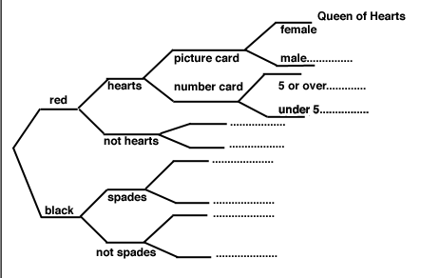

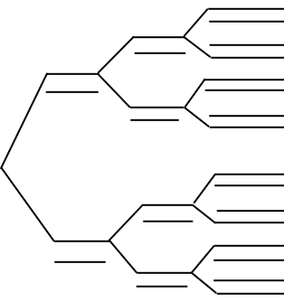

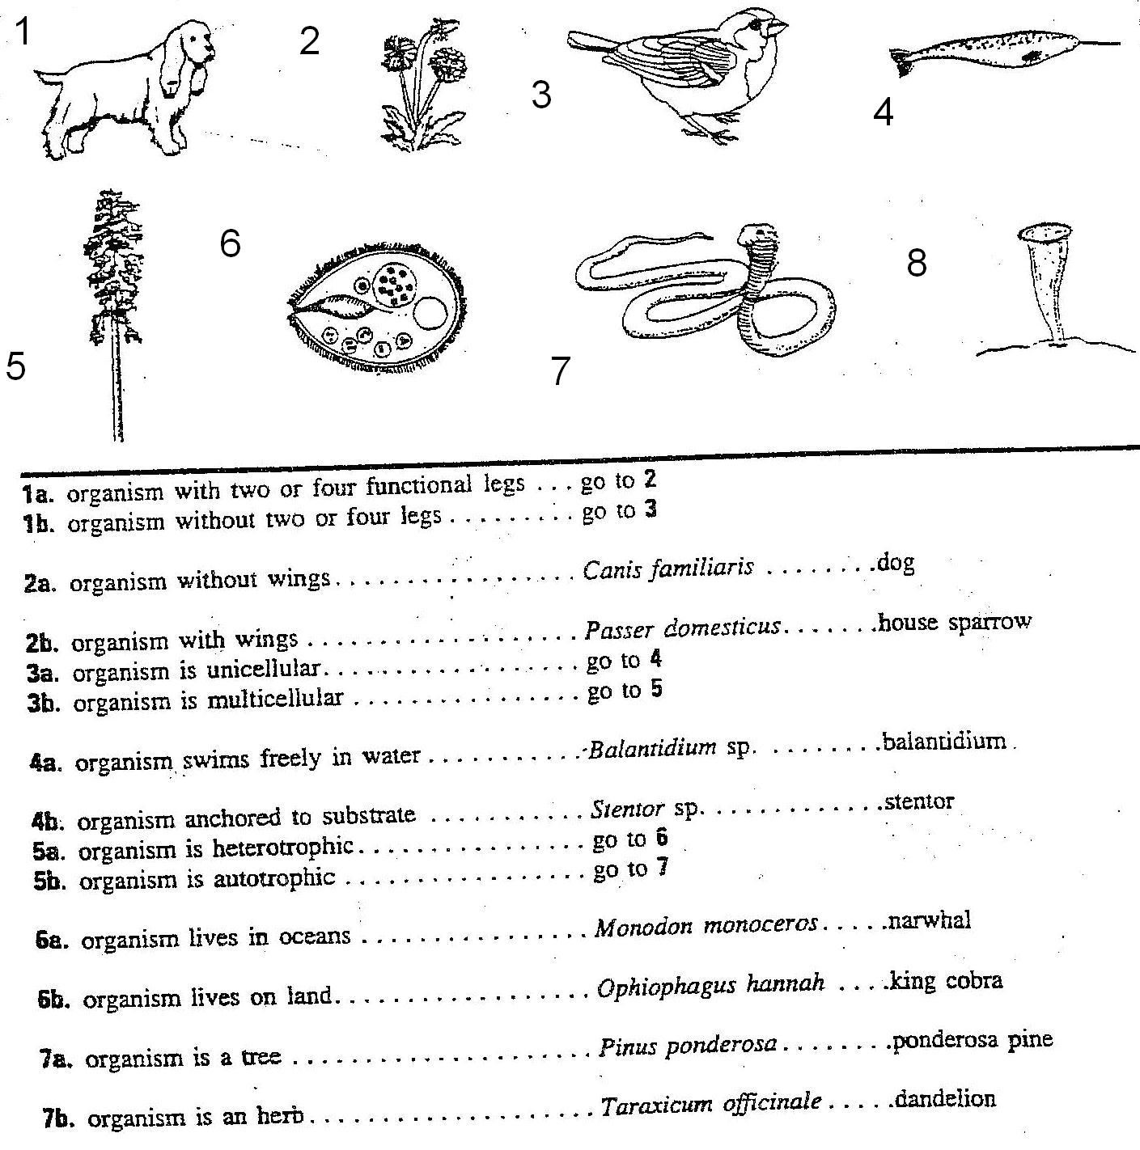

1a___________________________________________________ ----------------------------------- go to ____________

1b___________________________________________________ ----------------------------------- go to ____________

2a___________________________________________________ ----------------------------------- go to ____________

2b___________________________________________________ ----------------------------------- go to ____________

3a___________________________________________________ ----------------------------------- go to ____________

3b___________________________________________________ ----------------------------------- go to ____________

4a___________________________________________________ ----------------------------------- go to ____________

4b___________________________________________________ ----------------------------------- go to ____________

5a___________________________________________________ ----------------------------------- go to ____________

5b___________________________________________________ ----------------------------------- go to ____________

Reflection: What did I learn about the characteristics of minerals and rocks?

_____________________________________________________________________________________________________________________________________________________________________________________________________________________________________________________________________________________________________________________________________________________________________________________________________________________________________________________________________________________________________________________________________________________________________________________________________________________________

What do the characteristics of rocks and minerals have to do with how rocks are formed. (For example, why do metamorphic rocks have layers and the others do not?....this is the most important part of your reflection)

_____________________________________________________________________________________________________________________________________________________________________________________________________________________________________________________________________________________________________________________________________________________________________________________________________________________________________________________________________________________________________________________________________________________________________________________________________________________________

After having another group use your key what are some ways you could improve it or what are some things you did well?

_____________________________________________________________________________________________________________________________________________________________________________________________________________________________________________________________________________________________________________________________________________________________________________________________________________________________________________________________________________________________________________________________________________________________________________________________________________________________

How can/do we use keys like this in everyday life?

_____________________________________________________________________________________________________________________________________________________________________________________________________________________________________________________________________________________________________________________________________________________________________________________________________________________________________________________________________________________________________________________________________________________________________________________________________________________________

Name ____________________________________

Summative- Weathering and Erosion

Task: AFTER reading the research about diamond mining you need to completely answer the following prompts and write a well-supported report, using the RAFT format.

R- Role of the writer- who are you?

1. Audience- to whom are you writing?

F- Format- persuasive essay

T- Topic- what are you writing about?

1. Explain diamond mining.
2. What are the dangers of mining from weathering and erosion?
3. Develop a plan to stop/slow the erosion process.
4. How will your plan be used in the community?

Use the graphic organizer on the following page to help you structure your essay.

1) “T” Topic Sentence (Shows the main idea) _________________________________________________________________________________________________________________________

_________________________________________________________________________________________________________________________

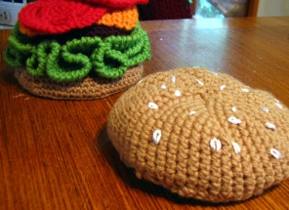

2) “ F” “A” (community) persuasive essay telling the community that weathering and erosion can cause mining to be dangerous.

_________________________________________________________________________________________________________________________

__________________________________________________________________________________________________________________________________________________________________________________________________________________________________________________

____________________________________________________________________________________________________________________________________________________________________________________________________________________________________________________________________________________________________________________________________________________________________________________________________________________________________________________________________________________________________

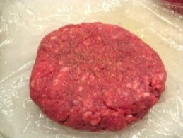

3) “R” your role is to inform the community mining and the effects of weathering and erosion on mining, and create a plan to stop/slow the process of erosion. _________________________________________________________________________________________________________________________

__________________________________________________________________________________________________________________________________________________________________________________________________________________________________________________

______________________________________________________________________________________________________________________________________________________________________________________________________________________________________________________________________________________________________________________________________________________________________________________________________________________________________________________________________________________________________________________________________________________________________________________________________________________________________________________________________________________________________________________________________________________



4) How will you implement your plan to stop/slow down erosion?

_________________________________________________________________________________________________________________________

_________________________________________________________________________________________________________________________

_________________________________________________________________________________________________________________________

_________________________________________________________________________________________________________________________

_________________________________________________________________________________________________________________________

_________________________________________________________________________________________________________________________

_________________________________________________________________________________________________________________________

_________________________________________________________________________________________________________________________

5.Concluding Sentence (Wraps of the paragraph) Rephrases the main idea _________________________________________________________________________________________________________________________

_________________________________________________________________________________________________________________________

_________________________________________________________________________________________________________________________

