**Name ______________________**

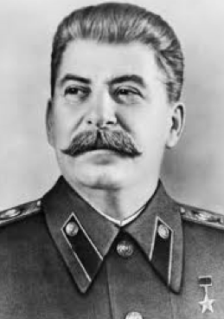**DIRECTIONS:**  Today you will be completing a web quest focused on Joseph Stalin,the leader of the Soviet Union from 1924-1953. Your task is to complete all the questions on this worksheet by searching the websites that have been provided for you. I expect beefy answers!!! Some of the questions may ask you to use your prior knowledge to analyze the new information. WATCH YOUR TIME!!! I will be collecting your work at the end of class.

**BACKGROUND:** Stalin had a difficult upbringing and his childhood was marked by family problems and illness. His relationship with his family partially accounts for his personal characteristics. Formally educated in the Classics, he pursued self-education throughout his life. His early interest in and commitment to Marxism helped propel his rise through the Communist Party, despite his crude behavior that the party's intellectuals disdained. In 1924, Lenin died, resulting in a struggle for power over who would rule the USSR. Despite Lenin’s warning in his Final Testament, that Stalin needed to be removed due to “character flaws,” Stalin won the power struggle and became the leader of the Soviet Union.

**PEASANT SOCIETY TO AN INDUSTRIAL SUPER POWER**

I.Go to [**http://tinyurl.com/aob9fpf**](http://tinyurl.com/aob9fpf) **and complete the following questions.**

1. Describe Stalin’s Five Year Plans and its goal. Were the Five Year Plans successful? List achievements.
2. Briefly define kulaks and gulags.
3. Stalin said “To slacken the pace would mean to lag behind; and those who lag behind are beaten…”? What did he mean? How does this quote relate to Russia’s history?
4. How does Stalin’s Five Year Plan resemble a command economy?

II. Go to [**http://tinyurl.com/cm2fdlo**](http://tinyurl.com/cm2fdlo)and answer the following questions.

1. Describe collectivization and its purpose.
2. What was the reaction of kulaks to collectivizing agriculture? Be specific.
3. What were the results of collectivization?
4. Read the primary source at the bottom of the website and draw a small sketch of what is being described.

III. Go to http://gulaghistory.org/nps/onlineexhibit/stalin/ and answer the following questions.

1. What were the Gulags? Why were they created?
2. Where were Gulags located?
3. Click on “Work in the Gulag,” describe the work in the Gulag. BE DETAILED!
4. Click on “Living in the Camp,” describe a prisoner’s life in the Gulag. BE DETAILED!

IV. Go to <http://www.spartacus.schoolnet.co.uk/RUSpurge.htm> and answer the following questions.

1. What was the goal of the purges?
2. Who was purged?
3. What was the NKVD’s (secret police) role in the purges?

To learn more about The Great Terror go to <http://www.history.com/videos/stalins-purges#stalins-purges> and watch the short video (3:14). Add to your answers above.

V. Overall how did Stalin use terror pervasively (to keep control in all places at all times) in Stalin Russia? Give examples.