Name__________________________________ Rotation Homework **Due 04/30** Date:

ABCDEF is a regular hexagon with center P.

1. Name the image of **A** for a 300º rotation counterclockwise about P. __________
2. Name the image of **C** for a 240º rotation clockwise about P. ____________

c. Name the image of **AB** for a 120º rotation counterclockwise about P. __________

1. Name the image of **AP** for a 180º rotation counterclockwise about P. __________

1. Name the image of **AP** for a 180º rotation clockwise about P. __________
2. Name the image of **EF** for a 60º rotation counterclockwise about P. __________

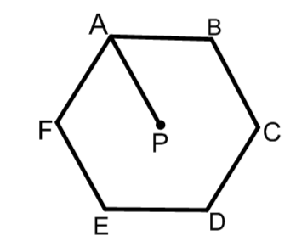

**QUESTION:** If I rotated Hexagon ABCDEF 200º clockwise, would the figure be carried onto itself? Explain

SQUA is a Quadrilateral with center M.

1. Name the image of **Q** for a 270º rotation counterclockwise about M. __________
2. Name the image of **U** for a 90º rotation clockwise about M. ____________

c. Name the image of **SQ** for a 180º rotation counterclockwise about M. __________

1. Name the image of **MS** for a 180º rotation counterclockwise about M. __________

1. Name the image of **MS** for a 180º rotation clockwise about M. __________
2. Name the image of **MQ** for a 360º rotation counterclockwise about M. __________

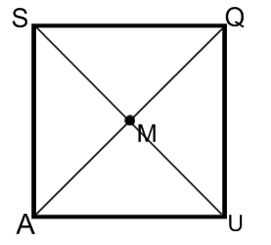

**QUESTION:** If I rotated Quadrilateral 270º Counterclockwise, would the figure be carried onto itself? Explain

*2.)Using a compass and straight edge construct the center of rotation and estimate the angle of rotation for each pair of figures below. Label the center of rotation as Point P*

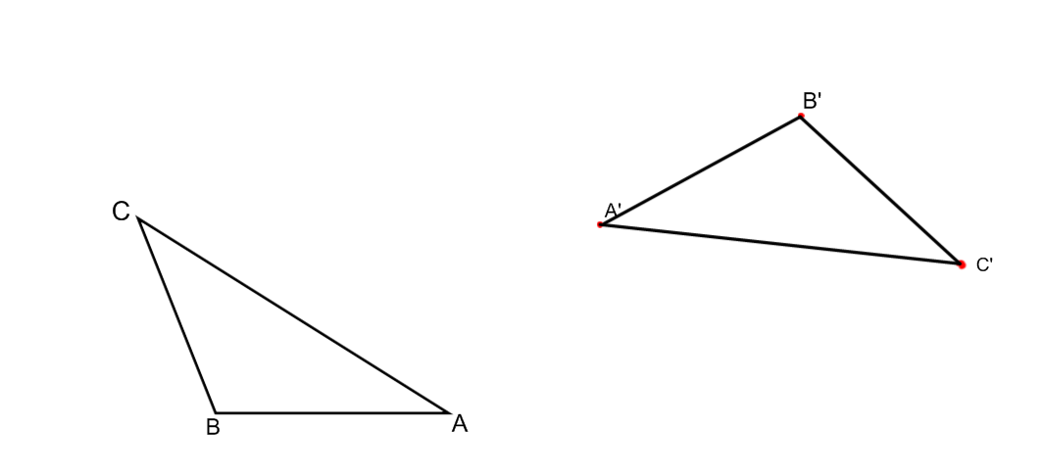

Are the triangles above Congruent to one another?

1. Draw Rectangle ABCD with the following points

A(5,2) B(-3,2) C(-3, -1) D(5,-1))

2.) Rotate the figure 90 degrees counterclockwise about the origin.

3.) Label the image A'B'C'D'

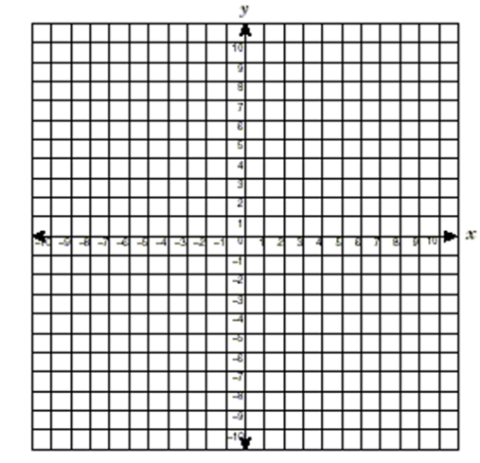

Is the Image of Rectangle ABCD Congruent to the original? Explain

Multiple Choice

|  |  |
| --- | --- |
| 1. |  |
| 2. |  |
| 3. |  |
| 4. |  |
| 5. |  |
| 6. |  |
| 7. |  |