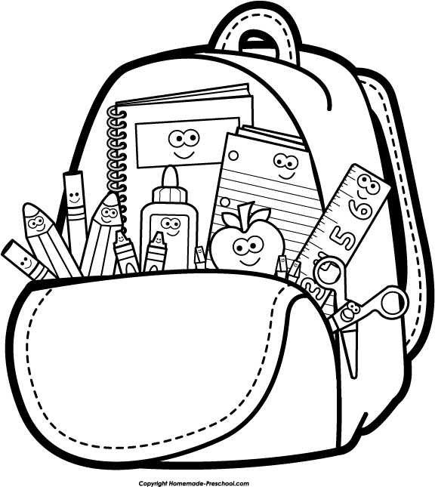 **THERE’S NOTHING IN MY BAG TODAY**

Today I did my math and science, I toasted bread.

I halved and quartered.

I counted, measured, used my eyes, and ears and head.

I added and subtracted on the way, I used a magnet, blocks and memory tray.

I learnt about a rainbow and how to weigh.

So please don’t say, anything in your bag today?

You see I’m sharing as I play.

I learned to listen and speak clearly when I talk, to wait my turn, and when inside to walk.

To put my thoughts into a phrase, and to guide a crayon through a maze.

To find my name and write it down, and to do it with a smile and not a frown.

To put my painting brush away,

So please don’t say, what, nothing in your bag today?

I’ve learnt about a snail and a worm, remembering how to take my turn.

Helped a friend when he was stuck, learnt that water runs off a duck.

I looked at words from left to right, agreed to differ, not to fight.

So please don’t say, did you only play today?

Dear families,

I thought you would enjoy reading about all the different things we will be learning this year, and hopefully calming your fears of the book bags that will sometimes come home with nothing new. Many of the things we learn in preschool are not done on paper, but rather take the whole of the child in the form of doing (actions).

Ms. McKinstry