School Based Planning Team: Henry Hudson School #28
Rolling Agenda for 2022-2023 School Year

Work Plan
Meeting Date | Objectives for this Meeting | Next Steps to Complete in time for this Meeting
- Review Title One Money
- Review the TNTP visit
- Look at the IReady data
- Review School 33’s WIG journal
- Review the Sensory floor plan

11/7/21
Roles
Facilitator | Time Keeper | Note Taker | Approve by | Next Meeting
S. Ladd |  | C. Doell | S. Burleigh | 12/5
Minutes
Time | Mins. | Activity
Review Title One Money
-
Review the TNTP visit
- Went to 8 classrooms
- Went classrooms based on target areas
- Are the school and district priorities visible?
- All ELA engaged with text
- Good culture of learning: good classroom atmosphere
- Good phonics and phonemic awareness
- Using data to drive instruction
- Math Kids using the language
- Collaborative groups
- Student voice with question and answer

Needs:
Learning targets and level of rigor
More student to student conversation
Less internalization: Let students do more of the work

Next:
Ms. Ladd will get the school report
And the district will get the district report

They will be back again in the Spring, not sure if they will be in the same or different classrooms.

Look at the Iready Data
ELA
Last week: 50%
Month: 53%
Math
Last week: 71%
Month: 62%

How are we going to have 100% at 60 minutes?
We need to celebrate, sooner than later for students to get excited about it. We need to increase motivation.

Perhaps take a look at the Iready’s Pick List of celebrations.
Need to discuss IStation for Bilingual
K-1 Does just I Station for ELA
Does Iready for Math
2-5 Does Istation and Iready for ELA
Does Iready for Math

Discuss at the next meeting
Review School 33’s WIG Journal

Examples:
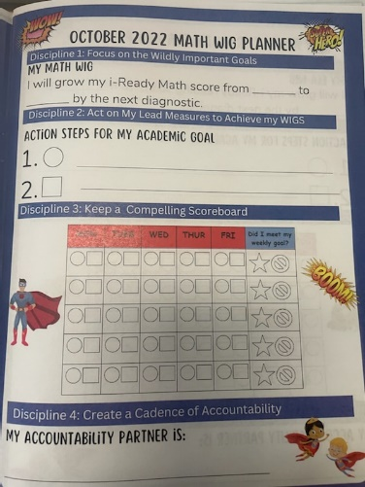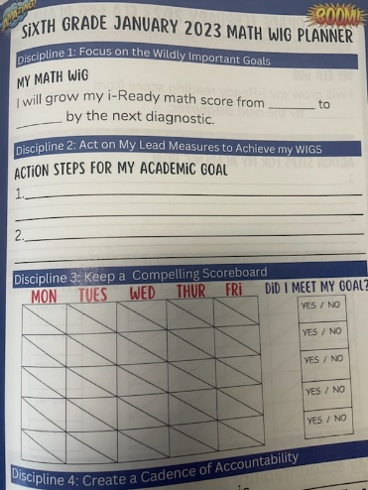

Review the Sensory Floor Plan
Where should a sensory floor/wall (1000 pieces) be placed?
**To be discussed at the next meeting

Future School Based Meetings Will be in Room 233

December 5th (4:00-5:30) Snack: Zaremba and Bolze
January 9th (4:00-5:30) Snack: Doell and Nelson
February 9th (4:00-5:30) Snack: Burleigh and Hovey
March 6th (4:00-5:30) Snack: Dostman and Ventura
April 10th (4:00-5:30) Snack: Harrington and Madrid
May 1st (2:00) Snack: Thombs, Nieves, DeWitz
June 8th (4-5:30) Offsite
 |  | For the Next Meeting:

Attendance and Members
 | 9-12-22 | 11-7-22
Admin
S. Ladd | X | X
J. Dewitz | X | X
B. Harrington | X | x
- Madrid | X | X
Teachers
C. Doell | X | X
K. Nelson | X | X
J. Ventura | X | X
L. Rosa | X | n/a
S. Burleigh | X | X
- Bolze | X
Thombs |  | X
R. Hovey |  | X
P. Dostman | X | X
RTA REP  C. Zaremba | X | X
RAP
- Nieves | X | X
Parents
Parent Liaison
Guests

Archived Meetings
Meeting Date | Objectives for this Meeting | Next Steps to Complete in time for this Meeting

