Name _________________________________ Date _____________

Algebra 1 PTech

Warm Up

The Fahrenheit temperature readings on 30 April mornings in Stormville, New York, are shown below.

41°, 58°, 61°, 54°, 49°, 46°, 52°, 58°, 67°, 43°,

47°, 60°, 52°, 58°, 48°, 44°, 59°, 66°, 62°, 55°,

44°, 49°, 62°, 61°, 59°, 54°, 57°, 58°, 63°, 60°

Using the data, complete the frequency table below.

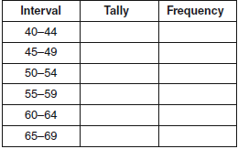

On the grid below, construct and label a frequency histogram based on the table.

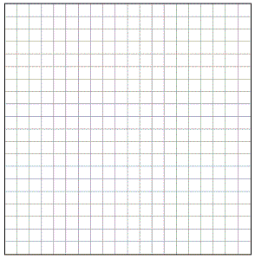

Name _________________________________ Date _____________

Algebra 1 PTech

Cool Down

The test scores from Mrs. Gray’s math class are shown below.

72, 73, 66, 71, 82, 85, 95, 85, 86, 89, 91, 92

Construct a box-and-whisker plot to display these data.



Name _________________________________ Date _____________

Algebra 1 PTech



Unit 10 Lesson 2

Homework

Using the line provided, construct a box-and-whisker plot for the 12 scores below.

26, 32, 19, 65, 57, 16, 28, 42, 40, 21, 38, 10



Determine the number of scores that lie above the 75th percentile.