Name: ___________________________________ Date: ___________________ **Algebra I** **Calculator Tips**

**Working with fractions**

|  |  |  |
| --- | --- | --- |
| The MathPrint Mode has templates to help you enter fractions quickly. Press  ALPHA and Y= (F1). Make a choice and use arrow keys to navigate. | fracpic1 | fracpic22 |

Type the following fractions in your calculator and hit the enter button. Write the result…

a. = b. = c. 2 =

**Converting Fractions and Decimals**

If you need to convert your decimal answer to a fraction, choose the MATH key and#1►Frac. The screen will show Ans►Frac. Hit Enter. You can also convert fractions to decimals (#2)

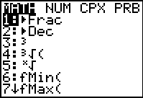 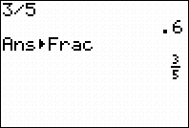 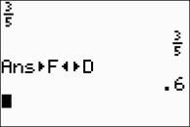

|  |  |  |
| --- | --- | --- |
|  |  |  |

Use your calculator to convert the following decimals to fractions:

a. 0.25 = b. 0.625 = c. 0.95 =

Use your calculator to convert the following decimals to fractions:

a. = b. = c. 5 =

**Exponents**

|  |  |
| --- | --- |
| To raise to any power, use the ^ (caret) symbol.  Enter the following exponents and write the results:  a. 25 = b. 9 = c. 2.98150 = | 255pic8 |

**Radicals**

|  |  |
| --- | --- |
| pic3  The square root symbol is  above the "squared" key. | pic4  The cube root and higher roots are found  under the **MATH** key. |

Enter the following radicals and write your results:

a. = b. 12 = c. =

d. = e. = f. =

**Absolute Value**

|  |  |
| --- | --- |
| You can find the absolute value function by accessing the **Math** key. Arrow to the right to find the **NUM** menu. On this screen you will find:  **#1 abs(**  Use your calculator to find the following: |  |

a. |-11| = b. |-9 - ( -4)| = c. -4|-15 + 7| =

**Finding Factors**

Push the Y= button and enter a given number divided by “x”. Push “2nd” -> TABLE to produce a list of factors.

Plot11 Plot2 Plot2 a. Which factors of 48 are perfect squares?

\Y1= 12/x

\Y2 =

\Y3 =

\Y4 =

\Y5 =

\Y6 =

\Y7 =

b. Which factors of 72 have a sum of 22?

**Storing a Number**

To store a number for “x”, use the STO> button. This function can be used to substitute a nuber for x and evaluate expressions.

*Example*: Press 5 STO> x. Now, x=5 in your calculator.

Type the following expressions and write the results:

a. x + 2 = b. = c. x3 - 2x2 + 3x + 17 =

**Basic Graphing**

To graph lines, enter given equations in the Y= screen. Multiple lines can plotted on the same graph. Graph will be displayed for equations with highlighted equal signs. The symbol to the far left of the equations indicates the type of graph you will see.

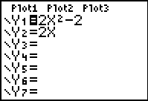 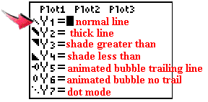

|  |  |
| --- | --- |
| Hit **GRAPH** to see your graphs. Notice that the second graph,  *y* = 2*x*, did not graph. To see the graph, the = sign must be highlighted. |  |

|  |  |
| --- | --- |
| If you need to see values relating to the graph, go to the TABLE (2nd GRAPH). You can control what you see in the table by going to TBLSET (2nd WINDOW). |  |

|  |  |  |
| --- | --- | --- |
| Choose the **viewing window**. The ZOOM key will let you chose various pre-set windows. The most common choice is #6 ZStandard which gives a [-10,10] by [-10,10] window. |  |  |

**Resetting the Calculator**

|  |  |
| --- | --- |
| * Start by choosing 2nd MEM * Select #7 Reset * Choose Defaultsif you simply want to return the calculator to the factory settings, such as Radian mode, Normal setting, Full screen, etc. Default will not erase programs or applications. |  |
| * Choose All Ram if you want to reset the factory settings AND erase any programs. * Try it... |  |

**Take a few minutes to explore the calculator functions….**

a. Write one thing you learned about *TI-84 Plus*.

b. What questions do you have about your calculator?

**Reset** your calculator