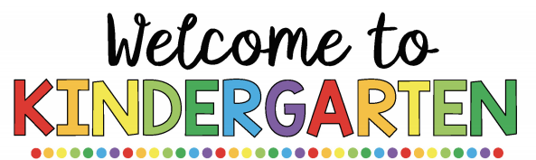

**Mrs. Cutaia’s Class 2022-2023**

My name is Mrs. Cutaia and I am going to be your child’s kindergarten teacher! I am so eager to meet you! This will be my 24th year teaching, and my third year teaching kindergarten. Kindergarten is an exciting year filled with lots of new friends, learning, and fun! I look forward to sharing these new experiences alongside of you.

I am eager to get to know you and your child. Please feel free to contact me with any questions that may arise before school begins.

Email: [laura.cutaia@rcsdk12.org](mailto:laura.cutaia@rcsdk12.org)

The first day of school is Wednesday September 7, 2022. School begins at 7:30 a.m. and dismissal is at 2:00. Our classroom is Room 154. Your child should bring their supplies, a smile, and be ready to meet their new classmates! 

**School Supplies**

1 box of crayons

Glue sticks (pack of 6)

Pencil box (8x5 in.)

Dry erase markers

Box of tissues

1 box of 12 pencils

1 pump bottle of hand sanitizer

1 container of Lysol or Clorox wipes

**Things to work on this Summer…**

**How to Buckle a Belt**



If your child will be wearing a belt to school, your child will be expected to unbuckle and buckle his or her own belt when it is time to use the restroom.

**Tying Shoes**

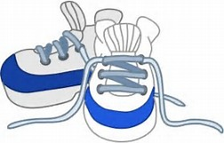

Begin teaching your child how to tie his or her own shoes. This is an important skill as students will be expected to wear sneakers for P.E. classes.

**Counting Numbers**

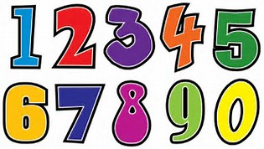

Practice counting items with your child: steps, stairs, crackers, noodles, toys, etc. It would be very helpful for your child to be able to count out loud to at least the number 20.

Practice writing the numbers 0-10 on paper to show “How many?” objects were counted.

**Read Books Daily**

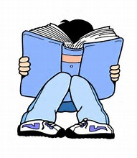

Read books daily for at least twenty minutes. Although your child may not be able to read the words, he or she can tell you what is happening or ask questions by looking at the pictures. Then you can read the story to your child.

After reading a story, ask questions to your child, such as: Who was in the story? Where did the story take place? What happened at the beginning, middle, and end of the story?

**Practice Cutting With**

**Scissors**



Have your child practice cutting paper using a pair of child safety scissors. You could draw lines on a paper (straight, curvy, or jagged) and have your child cut along the lines. Your child could also cut out pictures in magazines, coloring books, or newspapers.

**Practice Writing Own Name**

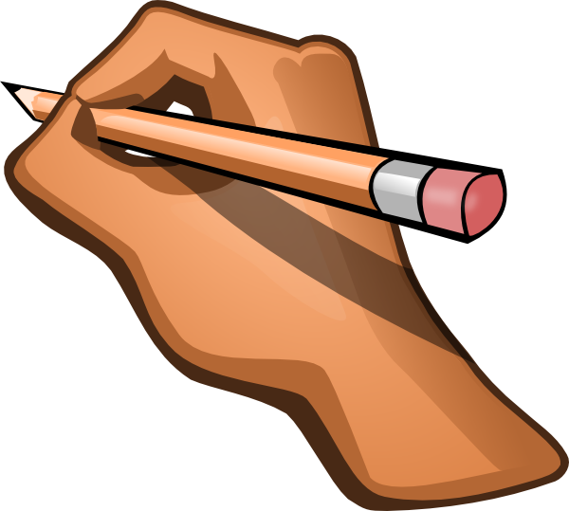

Have your child practice writing his or her own first and last names. Make sure the first letter is capitalized and the rest of the letters in the name are lowercase and formed correctly.