***WHAP***

***Summer Homework***

***(Please read the rubric)***

***Please Submit the essays* *Electronically***

***(Problems contact me at my email or cell 694-0311)***

[**James.tillotson@rcsdk12.org**](mailto:James.tillotson@rcsdk12.org)

**Essay Number One**

**(Due by 8pm, 07/09/17)**

In what ways (3) did geography and climate affect the development of human society?

**Essay Number Two**

**(Due by 8pm, 07/23/17)**

Compare and contrast agricultural, pastoral and foraging societies? Use evidence from Africa, the Americas and Southeast Asia.

**Essay Number Three**

**(Due by 8pm, 08/07/17)**

Compare and contrast the basic features (social, political, and economic) of two early civilizations? Choose two of the following: Mesopotamia, Mesoamerica, Shang, Indus

Greetings future WHAP students! The summer assignment must be completed and ready to go on the first day of school. Please read all directions carefully.

**I. Introductory Vocabulary**: our textbook is written at the college level and requires strong reading comprehension skills. Familiarizing yourself with the following list of words will help you with reading our textbook. **You have to write down and define these terms, we will have a vocabulary quiz over these words during the first week of school.**

1. B.C.E.
2. C.E.
3. abdicate
4. accession
5. aesthetic
6. agrarian
7. amenities
8. anarchy
9. animism
10. antiquity
11. appeasement
12. aristocracy
13. asceticism
14. assimilate
15. authoritarian
16. autocracy
17. barbarism
18. bureaucracy/bureaucrats
19. city-state
20. civic
21. classical
22. colonial
23. commerce
24. communal
25. concubine
26. conscription
27. cosmopolitan
28. coup
29. demography/demographic
30. despot
31. diaspora
32. dissent
33. dissident
34. domestic/domesticate
35. dynasty/dynastic
36. edict
37. egalitarian
38. elite
39. emigrate
40. epic
41. ethnocentric
42. feudalism
43. genocide
44. gentry
45. guild
46. hierarchy
47. hominids
48. homogenous
49. ideology
50. imperial/imperialism
51. indigenous
52. infrastructure
53. lineage
54. linguistic
55. manifest
56. maritime
57. martial
58. matrilineal
59. mercenary
60. monarchy
61. monopoly/monopolize
62. monotheism
63. mystical
64. nation-state
65. neo
66. Neolithic
67. nomadic
68. oligarchy
69. pantheon
70. papal/papacy
71. parliament/parliamentary system
72. pastoral
73. patriarchal
74. patrilineal
75. patronage
76. peasant
77. pharaoh
78. piety/pious
79. polity
80. polygamy
81. polytheism
82. proselytize
83. provincial
84. regent
85. republic
86. rhetoric/rhetorical
87. sedentary
88. serf
89. Sharia
90. Sinification
91. state
92. steppe
93. stratification
94. Sub-Saharan
95. subordinate
96. succession
97. syncretism
98. textiles
99. theocracy
100. theology
101. totalitarian
102. tributary state
103. tyranny
104. urban/urbanize
105. usurp
106. vernacular

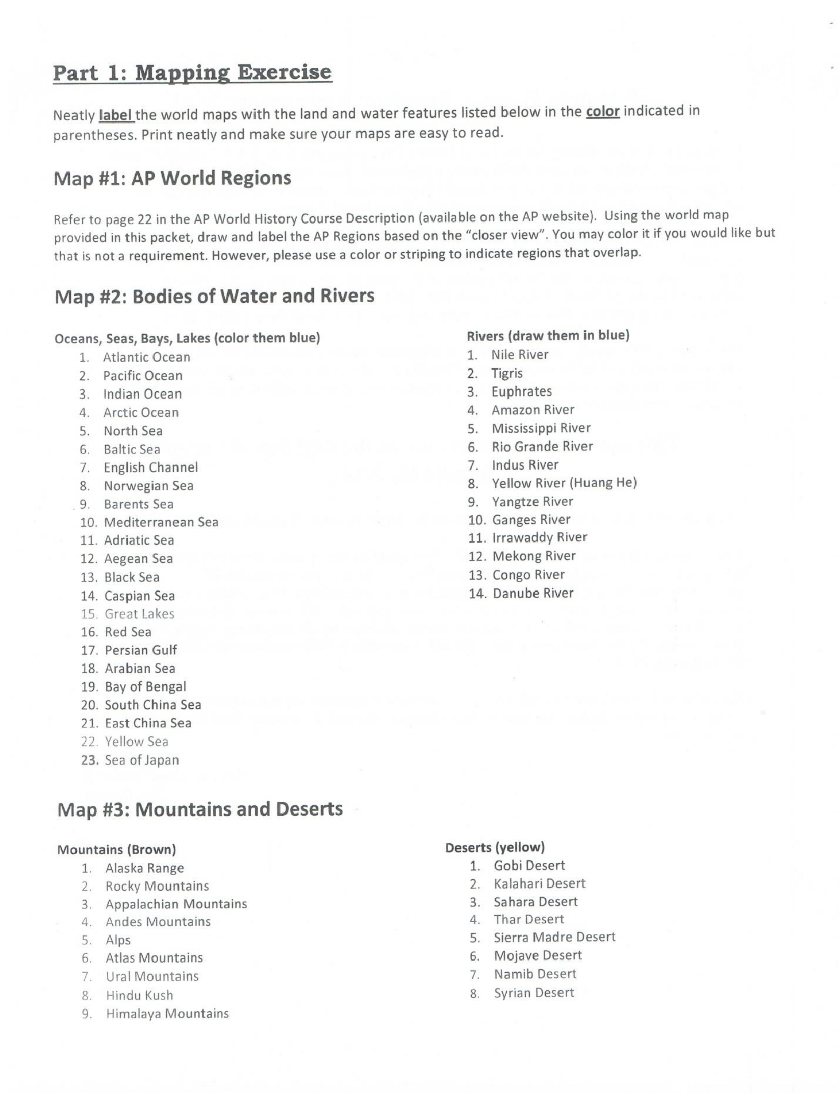

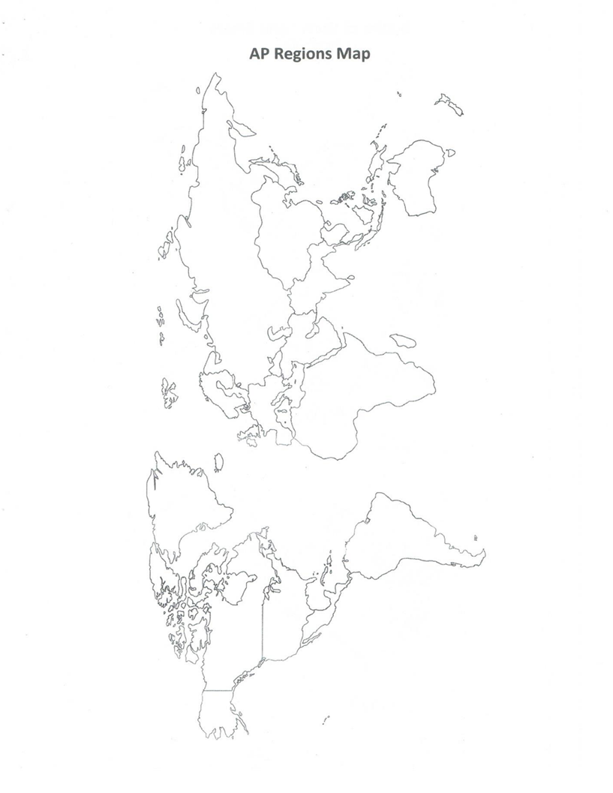

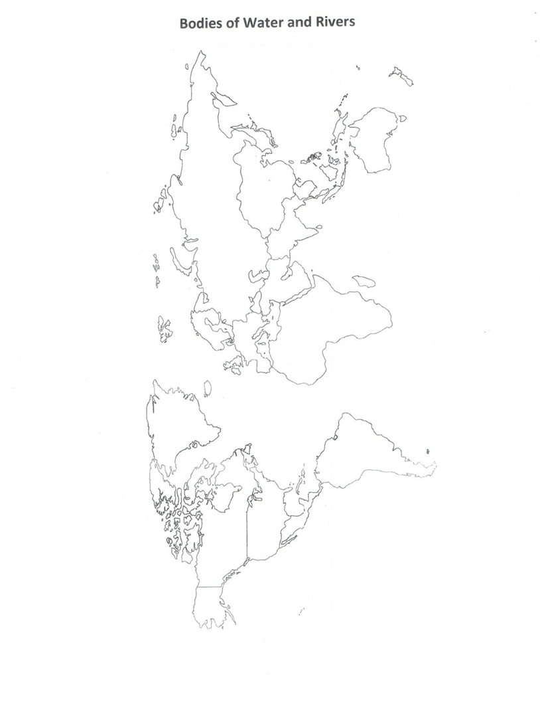

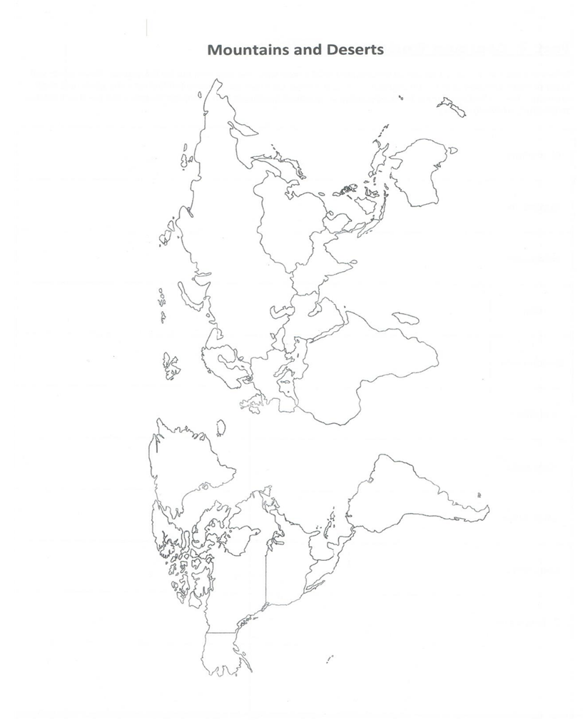

**AN EVENING WITH JOHN GREEN**

(please watch the following episodes of John Green crash course and complete the following questions)

|  |  |
| --- | --- |
|  | 1. HOW DO WE HAVE EVIDENCE OF HUNTER-GATHERERS (H- G) AND THEIR LIFEWAYS?  2. WHAT ADVANTAGES DID H-G HAVE OVER EARLY AGRICULTURALISTS?  3. WHERE DID AGRICULTURE EMERGE? WHICH FOOD CROPS ARE ASSOCIATED WITH WHICH AREAS?  4. WHAT ARE THE ADVANTAGES AND DISADVANTAGES OF AGRICULTURE?  5. WHAT IMPACT DOES AGRICULTURE HAVE ON THE ENVIRONMENT?  6. WHAT ADVANTAGES DO YOU THINK THAT EURASIA HAD WITH ITS ZOOLOGICAL SET OF ANIMALS COMPARED TO THE AMERICAS?  7. IF H-G HAD A “BETTER AND HEALTHIER” LIFEWAY, WHY DID PEOPLE BECOME AGRICULTURALISTS?  8. WHAT DO HISTORIANS SAY ARE THE DRAWBACKS TO COMPLEX CIVILIZATIONS AND AGRICULTURE? |
|  | 1. HOW IS THE CONCEPT OF “CIVILIZATION” A USEFUL CONSTRUCT? WHEN IS IT NOT A USEFUL CONSTRUCT?  2. HOW DOES JOHN GREEN DEFINE WHAT CONSTITUTES A CIVILIZATION? HOW DOES THIS COMPARE TO OTHER DEFINITIONS OF CIVILIZATION YOU HAVE LEARNED?  3. WHERE DID THE EARLIEST CIVILIZATIONS EMERGE? WHY THERE?  4. WHY WAS THE INDUS VALLEY A PRIME LOCATION? HOW DID THE ENVIRONMENT IMPACT THE PEOPLE WHO LIVED THERE?  5. WHAT EVIDENCE EXISTS OF LONG•DISTANCE TRADE AND WITH WHOM?  6. WHAT APPEARS TO BE UNIQUE ABOUT THE IVC, BASED ON YOUR KNOWLEDGE OF OTHER CIVILIZATIONS? |
|  | 1. JOHN GREEN BEGINS BY DISCUSSING ONE OF THE MOST OBVIOUS CONSEQUENCES OF AGRICULTURE...WHAT IS IT AND WHAT ARE THE MOST IMMEDIATE CONSEQUENCES FOR THOSE SOCIETIES?  2. HOW DOES MESOPOTAMIA COMPARE WITH THE INDUS RIVER VALLEY (IRV)? IDENTIFY BOTH SIMILARITIES AND DIFFERENCES. THINK OF WHY A SPECIFIC SIMILARITY AND A SPECIFIC DIFFERENCE MIGHT EXIST. (THIS IS ANALYSIS; ONE OF THE MORE CHALLENGING SKILLS YOU WILL NEED TO DEVELOP).  3. CUNIEFORM: WHAT THREE POINTS DOES JOHN GREEN MAKE ABOUT THE ADVENT OF WRITING?  4. WHAT WAS HAMMURABI’S MOST SIGNIFICANT CONTRIBUTION?  5. WHAT ARE THE CHALLENGES OF EMPIRE WHAT IS THE USUAL RESULT? OR TO PUT IT IN MATH TERMS: |
|  | 1. WHAT POINT IS JOHN GREEN MAKING ABOUT THE  DIFFERENT “LENSES” WE USE WHEN WE STUDY HISTORY?  2. HOW DID THE NILE RIVER SHAPE THE WORLDVIEW OF THE EGYPTIANS? HOW DID THIS COMPARE TO THE MESOPOTAMIAN WORLDVIEW?  3. HOW WAS EGYPTIAN CIVILIZATION DIFFERENT FROM MOST OTHER RIVER VALLEY CIVILIZATIONS? WHY DO YOU THINK THIS WAS?  4. WHAT DOES THE CONSTRUCTION OF THE PYRAMIDS REPRESENT? (NOT “WHAT WAS THE PURPOSE OF THE PYRAMIDS?”)  5. WHAT WAS THE MOTIVATION FOR BUILDING THE PYRAMIDS? (NOT “WHAT WAS THE PURPOSE OF THE PYRAMIDS?”)  6. WHAT PROTECTED EGYPT FROM OUTSIDE PEOPLES? HOW WERE THE EGYPTIANS EVENTUALLY CONQUERED BY SEMITIC PEOPLES OF THE MIDDLE EAST? |
|  | 1. WHAT DO TEXTBOOKS NORMALLY DO TO THE RIVER VALLEY CIVILIZATIONS?  2. WHAT DO EGYPT, MESOPOTAMIA, ANATOLIA, ETC. HAVE IN COMMON?  a. TRADE: What did underwater archaeologists find on the shipwreck?  b. WAR: What was one of the main drivers of economic growth?  c. FAMILY: How did these civilizations share familial relationships?  3. WHAT ARE WE REALLY TALKING ABOUT WHEN WE USE THE WORD‘CIVILIZATION’?  4. WHAT HAPPENED AROUND 1200 BCE TO MYCENAEANS, MINOANS, HITTITES, AND (PARTIALLY) EGYPT?  a. WHAT CAUSED THIS?  b. WHAT IS THE THEORY OF ARCHAEOSEISMOLOGISTS?  5. HOW DOES INTERDEPENDENCE IN THE BRONZE AGE HELP LEAD TO ITS DOWNFALL? |

**Please complete the following questions using the textbook *Ways of the World***

**Chapter 1: First Peoples; First Farmers**

1. What was the sequence of human migration across the planet?

2. How did Austronesian migrations differ from other early patterns of human movement?

3. In what ways did a gathering and hunting economy shape other aspects of Paleolithic societies?

4. Why did some Paleolithic peoples abandon earlier, more nomadic ways and begin to live a more settled life?

5. How do you understand the significance of the long Paleolithic era in the larger context of world history?

6. What accounts for the emergence of agriculture after countless millennia of human life without it?

7. In what different ways did the Agricultural Revolution take shape in various parts of the world?

8. In what ways did agriculture spread? Where and why was it sometimes resisted?

9. What changes did the Agricultural Revolution bring in its wake?

10. What different kinds of societies emerged out of the Agricultural Revolution?

**Chapter 2: First Civilizations**

1. When and where did the first civilizations emerge?

2. What accounts for the initial breakthroughs to civilization?

3. What was the role of cities in the early civilizations?

4. In what ways was social inequality expressed in early civilizations?

5. In what ways have historians tried to explain the origins of patriarchy?

6. How did Mesopotamian and Egyptian patriarchy differ from each other?

7. What were the sources of state authority in the First Civilizations?

8. In what ways did Mesopotamian and Egyptian civilizations differ from each other?

9. In what ways were Mesopotamian and Egyptian civilizations shaped by their interactions with near and distant neighbors?

**Chapter 3: State and Empire in Eurasia/North Africa**

1. How did Persian and Greek civilizations differ in their political organization and values?

2. How did semi-democratic governments emerge in some of the Greek city-states?

3. What were the consequences for both sides of the encounter between the Persians and the Greeks?

4. What changes did Alexander’s conquests bring in their wake?

5. How did Rome grow from a single city to the center of a huge empire?

6. Why was the Chinese empire able to take shape so quickly, while that the Romans took centuries?

7. Why were the Roman and Chinese empires able to enjoy long periods of relative stability and prosperity?

8. What internal and external factors contributed to the collapse of the Roman and Chinese empires?

9. Why were centralized empires so much less prominent in India than in China?

**Good job, you are finished!! ☺**