# Beverly Burrell-Moore

# Deputy Superintendent of T & L

# Rochester City School District

131 West Broad Street

Rochester, New York 14614

Phone: 585.262.8121

Beverly.Burrell-Moore@RCSDK12.ORG



**C:\Documents and Settings\2003726\Local Settings\Temporary Internet Files\Content.IE5\MQS7LWF6\MC900060304[1].wmf 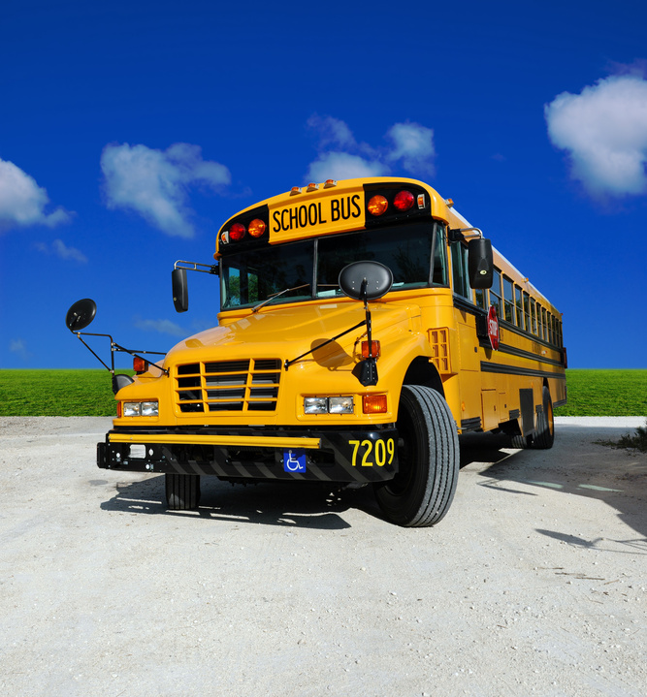 C:\Documents and Settings\2003726\Local Settings\Temporary Internet Files\Content.IE5\MQS7LWF6\MC900364158[1].wmf**

**Rev. 9/15/13**

**NEW: SY 13 14: School Field Trips Process**

**STEP #1: Principal / Designee:   
Submit completed Superintendent’s Regulation 4400-R Field Trip Forms Packet and Checklist in email to FieldTrips@RCSDK12.ORG.  
Note: Please submit paperwork for approval a minimum of three (3) weeks in advance.   
  
Note: Funds are centrally available for “transportation only”. All other expenses (admissions and accommodations, etc.) are already in your school’s TAPU line.**

**STEP #2: CO Administrator & Budget Analyst**

**If field trip request for transportation funds is appropriate and approved, the CO Administrator will work with the Budget Analyst to open your school’s field trip line (5438) and complete transfer of funds. Schools will be notified via email when funds are transferred and receive approved packet where applicable.  
Note: Our goal is to respond to schools within 48 hours of the completed packet being emailed to FieldTrips@RCSDK12.ORG.**

**STEP #3: Principal / Designee:   
School proceeds with processing the details of the Field Trip (i.e. obtain the bus, admission fees, etc.).  
  
Note: First Student has the District contract for field trips. All arrangements are made directly with them at 585-647-9380. The only time the RCSD Transportation Department is contacted is if a wheelchair bus is needed. Wheelchair bus availability is limited, therefore plan accordingly by calling 585-336-4177.**

**Reminders:**

* **Principals / School Leaders are encouraged to use grants and/or parent organizations for support of field trips.**
* **Principals / Schools Leaders please adhere to the Superintendent’s Regulation 4400-R and the Superintendent’s Communication regarding field trips during instructional time.**