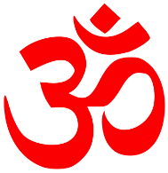**Hinduism**

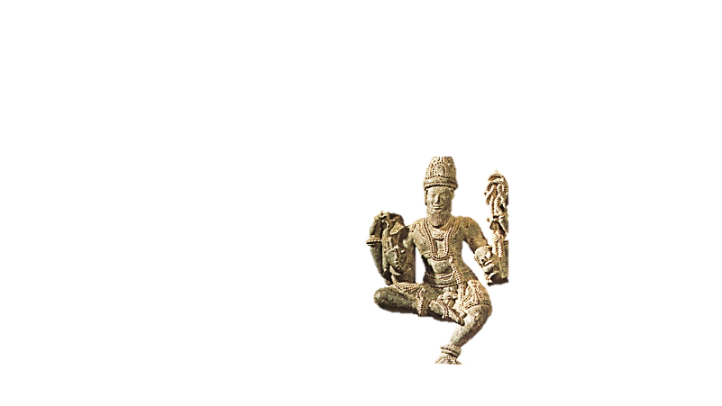

Hinduism, one of the world’s oldest surviving religions, is the major religion of India. It also has followers in Indonesia, as well as in parts of Africa, Europe, and the Western Hemisphere. Hinduism is a collection of religious beliefs that developed over thousands of years. Hindus worship several gods, which represent different forms of Brahman. Brahman is the most divine spirit in the Hindu religion. Hinduism, like Buddhism, stresses that persons reach true enlightenment and happiness only after they free themselves from their earthly desires. Followers of Hinduism achieve this goal through worship, the attainment of knowledge, and a lifetime of virtuous acts. The sound “Om,” or “Aum,” shown above, is the most sacred syllable for Hindus. It often is used in prayers.

This statue represents Brahma, creator of the universe. Brahma, Vishnu, and Shiva are the three main gods of Hinduism. Vishnu is the preserver of the universe, while Shiva is its destroyer.

**Ritual**

Each year, thousands of Hindus make a pilgrimage to India’s Ganges River. The Ganges is considered a sacred site in the Hindu religion. Most Hindus come to bathe in the water, an act they believe will cleanse and purify them. The sick and disabled come in the belief that the holy water might cure their ailments.

**Leadership**

Gurus, or spiritual teachers, play a major role in spreading Hindu beliefs. These holy men are believed to have had the gods’ words revealed to them. Brahmin priests are also religious leaders. They take care of the divine images in the temples and read from the sacred books.

**Celebration**

Each spring, Hindus in India celebrate the festival of Holi. Originally a harvest festival, Holi also symbolizes the triumph of good over evil. The festival recalls the story of Prince Prahlada, who faced death rather than cease worshiping Vishnu. During this joyous celebration, people dance in the streets and shower each other with colored powder and dyed water.

The Vedas are the oldest Hindu scriptures—and they are older than the sacred writings of any other major religion. The following is a verse from the Rig Veda, the oldest of the four Vedas:

**“He who gives liberally goes straight to the gods; on the high ridge of heaven he stands exalted.”**

**--Rig Veda 1.125.5**

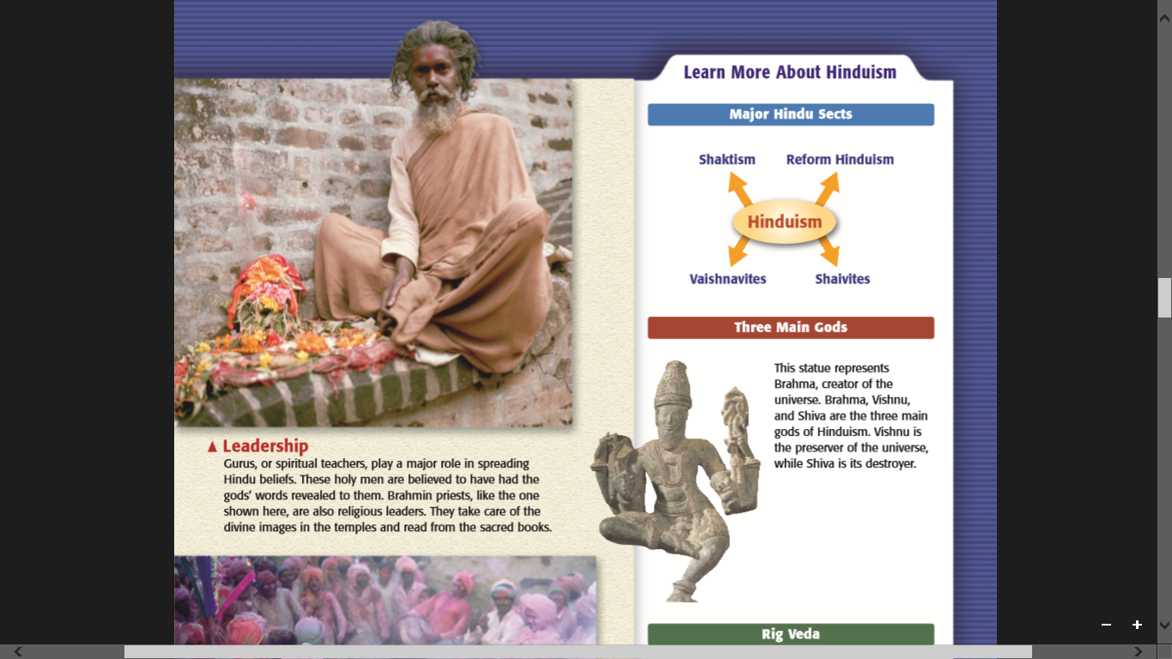

**Major Hindu Sects (Groups)**

**Buddhism**



Buddhism has influenced Asian religion, society, and culture for over 2,500 years. Today, most Buddhists live in Sri Lanka, East and Southeast Asia, and Japan. Buddhism consists of several different sects. A religious sect is a group within a religion that distinguishes itself by one or more unique beliefs.

Buddhists are united in their belief in the Buddha’s teachings, known as the dharma. Because the Buddha is said to have “set in motion the wheel of the dharma” during his first sermon, his teaching is often symbolized by a wheel, as shown above. The Buddha taught that the key to happiness was detachment from all worldly goods and desires. This was achieved by following the Noble Eightfold Path, or the Middle Way, a life between earthly desires and extreme

forms of self-denial.

Many Buddhists believe in rebirth, the idea that living beings, after death, are reborn and continue to exist. Buddhists believe that all living beings possess the potential for spiritual growth—and the possibility of rebirth as humans.

**Worship Practices**

Statues of the Buddha, such as this one in China,appear in shrines throughout Asia. Buddhists strive to follow the Buddha’s teachings through meditation, a form of religious contemplation. They also make offerings at shrines, temples, and monasteries.

**Leadership**

Those who dedicate their entire life to the teachings of the Buddha are known as Buddhist monks and nuns. In many Buddhist sects, monks are expected to lead a life of poverty, meditation, and study. Here, Buddhist monks file past shrines in Thailand. To learn humility, monks must beg for food and money.

One of the most well-known Buddhist scriptures is the Dhammapada, or Verses of Righteousness. The book is a collection of sayings on Buddhist practices. In this verse, Buddhists are instructed to avoid envying others:

**“Let him not despise what he has received, nor should he live envying the gains of others.**

**The disciple who envies the gains of others does not attain concentration.”**

**--Dhammapada 365**

1. 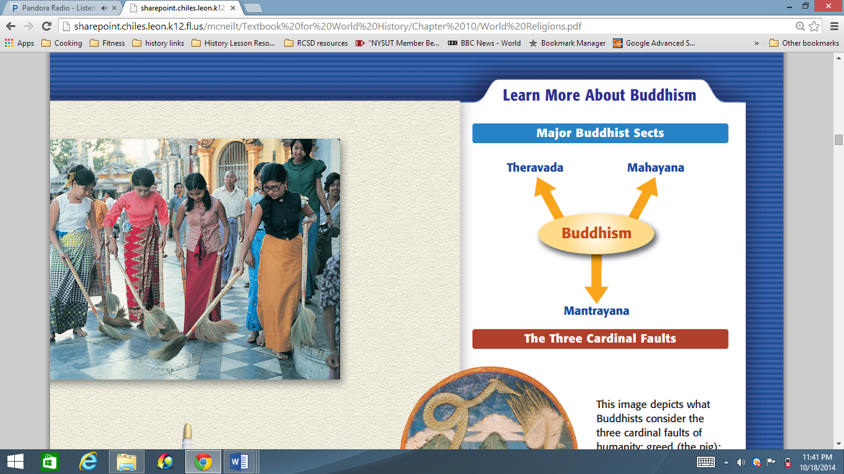 [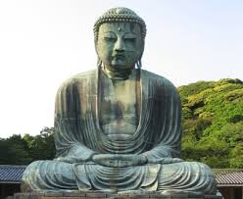](http://www.google.ca/url?sa=i&rct=j&q=&esrc=s&frm=1&source=images&cd=&cad=rja&uact=8&ved=0CAcQjRw&url=http://www.sacred-texts.com/bud/tbc/&ei=YsdFVLSvN7WasQTa8IGYDA&bvm=bv.77880786,d.cWc&psig=AFQjCNEGF2okJkFn8vFhYNlWjg20C3IY1Q&ust=1413945355319878)

**Confucianism**

[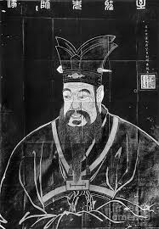](http://www.google.ca/url?sa=i&rct=j&q=&esrc=s&frm=1&source=images&cd=&cad=rja&uact=8&ved=0CAcQjRw&url=http://fineartamerica.com/featured/confucius-granger.html&ei=N6RFVKn3HqPksATqmoKICw&bvm=bv.77880786,d.cWc&psig=AFQjCNEHBKyD8TIaM3IqsD1rW-P0nDC6wQ&ust=1413936365251543)



With no clergy and with no gods to worship, Confucianism is not a

religion in the traditional sense. Rather, it is an ethical system that provides direction for personal behavior and good government. However, this ancient philosophy guides the actions and beliefs of millions of Chinese and other peoples of the East. Thus, many view it as a religion. Confucianism is a way of life based on the teachings of the Chinese scholar Confucius. It stresses social and civic responsibility. Over the centuries, however, Confucianism has greatly influenced people’s spiritual beliefs as well. While East Asians declare themselves to follow any one of a number of religions, many also claim to be

Confucian. The yin and yang symbol shown above represents opposite forces in the world working

together. It symbolizes the social order and harmony that Confucianism stresses.

Celebration

While scholars remain uncertain of Confucius’s date of birth, people throughout East Asia celebrate it on September 28. In Taiwan, it is an official holiday, known as Teachers’ Day. The holiday also pays tribute to teachers. Confucius himself was a teacher, and he believed that education was an important part of a fulfilled life. Here, dancers take part in a ceremony honoring Confucius.

Ritual

A key aspect of Confucianism is filial piety, the respect children owe their parents. Traditionally, filial piety meant complete obedience to one’s parents during their lifetime. It also required the performance of certain rituals after their death. In this 12th-century Chinese painting, a sage instructs a pupil on the virtue of filial piety.

Leadership

Confucius was born at a time of crisis and violence in China. He hoped his ideas and teachings would restore the order of earlier times to his society. But although he was active in politics, he never had enough political power to put his ideas into practice. Nonetheless, his ideas would become the foundation of Chinese thought for more than 2,000 years.

The Analects

The earliest and most authentic record of Confucius’s ideas was collected by his students. Around 400 B.C., they compiled Confucius’s thoughts in a book called the Analects. In the following selection from the Analects, Confucius (the Master) advises people to avoid judging others:

**The Master said: “Don’t worry if people don’t recognize your merits; worry that you may**

**not recognize theirs.”**

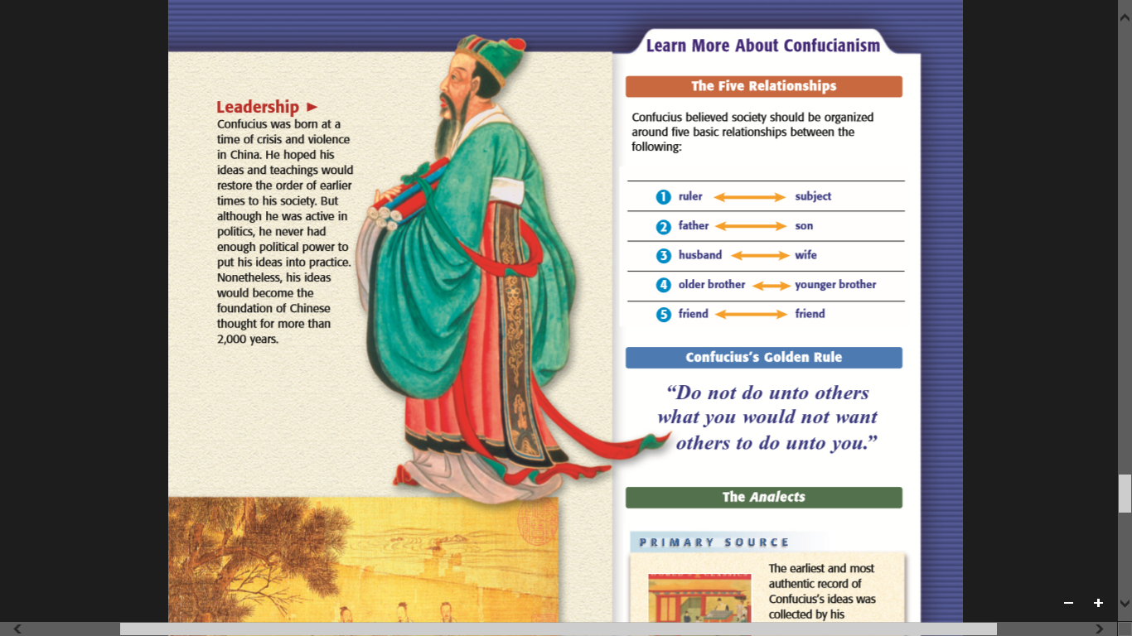**--Analects 1.16**

**Confucius’s Golden Rule**

“Do not do unto others what you would not want others to do unto you.”

-Confucius’s Golden Rule

Confucius believed society should be organized around

five basic relationships between the following:

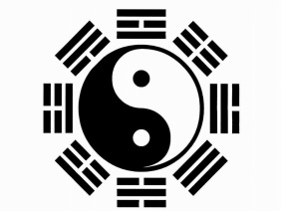**Daoism (also Taoism)**

The second great philosophy to come out of China’s time of trouble was Taoism. Like Confucianism, it tried to give answers to the problems of right living and good government.

**The Founder of Taoism**

According to tradition, the great sage, or wise man, of Taoism was Lao-tzu. He was said to be the author of the *Tao Te Jing* (The Classic of the Way and Its Power). Some modern scholars believe that Lao-tzu was a real man who lived in the late 500’s B.C.E. Others think he was only a legend. Scholars do agree that the Tao Te Jing was actually written over time by many writers.

Old stories of Lao-tzu’s life tell how he came to write the Tao Te Jing. These stories say that Lao-tzu worked as an advisor to the Zhou court for many years. Then he was 90 years old, he tired of government work and decided to leave China. When he came to the Chinese border, a guard recognized him. The guard was upset that the great teacher’s wisdom would be lost of China. He asked Lao-tzu to record his thoughts before leaving. So Lao-tzu sat down and wrote a small manuscript of only 5,000 characters, the Tao Te Jing. The Tao Te Jing preached a return to a simple and natural way of living. For example one passage says:

# **If you do not want your house to be molested by robbers,**

# **Do not fill it with gold and jade.**

**Wealth, rank and arrogance add up to ruin,**

**As surely as two and two are four.**

**The Teachings of Taoism**

Taoism was based on the ancient Chinese idea of the Tao, or “the Way”. Dao was the force that gave order to the natural universe. Taoism taught that people gained happiness and peace by living in harmony, or agreement, with the way of nature.

To the Taoists, nature is full of opposites, like life and death or light and darkness. True harmony comes from balancing the opposite forces of nature, called *yin* and *yang*. Yin means “shadowed” and yang means “sunlit”. In the same way, human life is a whole made up of opposites. It is impossible to have good without bad, beauty without ugliness, or pleasure without pain.

The Taoists taught that people followed the way of nature by living simple lives of quiet meditation. Notice, they said, how nothing in nature strives for fame, power, or knowledge. Similarly, people should avoid feeling self-important or striving for possessions or honors. Instead, they should accept whatever comes, like a blade of grass that bends when the breeze blows.

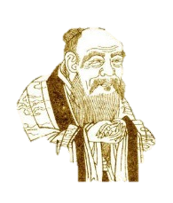The Taoists believed that everyone must discover the Tao for themselves. Too many laws and social rules only got in the way of living naturally and following the Tao. Therefore, the best rulers were those who ruled the least. The Tao Te Jing says, “Governing a large country is like frying a small fish. You spoil it with too much poking”. It also tells rulers, “Be weak. Let things alone”.

Lao-tzu (Laozi)

