Name:_________________________________________ IB 1D motion review

**22.** The velocity-time graph for an object moving along a straight path is shown in Figure P2.22. (a) Find the average accelerations of this object during the time intervals

0 to 5.0 s 5.0 s to 15 s 0 to 20 s.

(b) Find the instantaneous accelerations at

2.0 s________ 10 s________18 s________

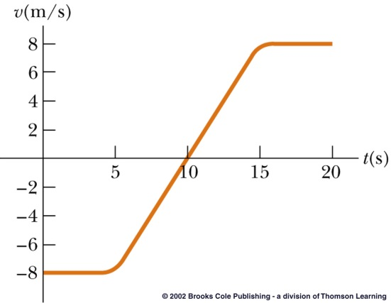

**25.** Jules Verne in 1865 proposed sending men to the Moon by firing a space capsule from a 220-m-long cannon with final speed of 10.97 km/s. What would have been the unrealistically large acceleration experienced by the space travelers during launch? (A human can stand an acceleration of 15*g* for a short time.)

**26.** A truck covers 40.0 m in 8.50 s while smoothly slowing down to final speed   
2.80 m/s. Find its original speed

**32.** A jet plane lands with a speed of 100 m/s and can accelerate at a maximum rate of –5.00 m/s2 as it comes to rest. (a) From the instant the plane touches the runway, what is the minimum time needed before it can come to rest?

(b) Can this plane land on a small tropical island airport where the runway is 0.800 km long?

**48.** A ball thrown vertically upward is caught by the thrower after 2.00 s. Find

(a) the initial velocity of the ball and

(b) the maximum height it reaches.

**49.** A model rocket is launched straight upward with an initial speed of 50.0 m/s. It accelerates with a constant upward acceleration of 2.00 m/s2 until its engines stop at an altitude of 150 m.

(a) What is the maximum height reached by the rocket?

(b) How long after lift-off does the rocket reach its maximum height?

(c) How long is the rocket in the air?

**51.** A student throws a set of keys vertically upward to her sorority sister, who is in a window 4.00 m above. The keys are caught 1.50 s later by the sister’s outstretched hand.

(a) With what initial velocity were the keys thrown?

(b) What was the velocity of the keys just before they were caught?

**63.** Using a rocket pack with full throttle, a lunar astronaut accelerates upward from the Moon’s surface with a constant acceleration of 2.00 m/s2. At a height of 5.00 m, a bolt comes loose. (The free-fall acceleration on the Moon’s surface is about 1.67 m/s2.)

(a) How fast is the astronaut moving at that time?

(b) When will the bolt hit the Moon’s surface?

(c) How fast will it be moving then?

**2.22** (a) From  to ,  
  
 ****.  
  
From  to ,  
  
 ,  
and from  to ,  
  
 .

(b) At , the slope of the tangent line to the curve is . At , the slope of the tangent line is , and at , the slope of the tangent line is .

**2.25** From , we have  so that  which is 

**2.26** (a)  becomes ,  
  
which yields .

(b) 

**2.32** (a) The time required to stop is .

(b) The minimum distance needed to stop the plane is  
  
 .  
  
Thus, the plane cannot stop in 0.8 km.

**2.48** (a) Consider the relation  with . When the ball is at the throwers hand, the displacement  is zero, or . This equation has two solutions,  which corresponds to when the ball was thrown, and  corresponding to when the ball is caught. Therefore, if the ball is caught at , the initial velocity must have been  
  
 .

(b) From , with  at the maximum height,  
  
 .

**2.49** (a) When it reaches a height of 150 m, the speed of the rocket is  
  
 .  
  
After the engines stop, the rocket continues moving upward with an initial velocity of  and acceleration . When the rocket reaches maximum height, . The displacement of the rocket above the point where the engines stopped (i.e., above the 150 m level) is  
  
 .  
  
The maximum height above ground that the rocket reaches is then given by .

(b) The total time of the upward motion of the rocket is the sum of two intervals. The first is the time for the rocket to go from at the ground to a velocity of  at an altitude of 150 m. This time is given by  
  
 .  
  
The second interval is the time to rise 158 m starting with  and ending with . This time is  
  
 .  
  
The total time of the upward flight is then  
  
 .

**2.51** (a) The keys have acceleration  from the release point until they are caught 1.50 s later. Thus,  gives  
  
 ,  
  
or .

(b) The velocity of the keys just before the catch was  
  
 ,  
  
or .

**2.63** (a) At 5.00 m above the surface, the velocity of the astronaut is given by  
  
 .

(b) The bolt begins free-fall with an initial velocity of  at 5.00 m above the surface. When it reaches the surface,  gives  which has a positive solution of . Thus, the bolt hits 6.31 s after it is released .

(c) When it reaches the surface, the velocity of the bolt is  
  
 .