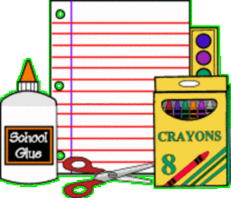 School #46 First Grade

Supply List:

Please **do not** label supplies, as we will be sharing them in our classroom

community. Thank you!

* 2 boxes of pencils
* 2- 24 packs of Crayola cryaons
* 3 packs of Dry Erase Markers
* 2 packs of markers ( one broad line and one thin line marker)
* 1- 12 pack of colored pencils
* 6 glue sticks
* Ziplock bags (1 gallon size box and 1 sandwich size box)
* disenfectant wipes or spray
* 3 boxes of family sized tissues

**\*\*** Each student will need a pair of headphones to use, please, no ear buds-they do not work with our Chromebooks! **Please mark these with your child’s name**



