**Draw a Rotation**

**Copy △*ABC* and point *K*. Then use a protractor and ruler to draw a 140° or whatever degree rotation rotation of △*ABC* about point *K*.**

Step 1 Draw a segment from vertex *A*

**

Step 2 Draw a 140° to point K using segment KA as one side

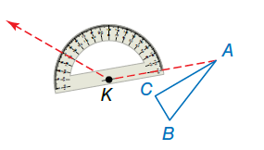

Step 3 Use a ruler to draw *A* such that segments KA’ = KA

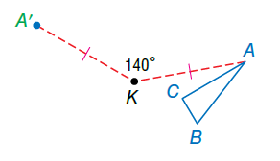

Step 4 Repeat Steps 1–3 for vertices *B*

B and *C* and draw △*A*′*B*′*C*′.

