Name___________________________ Hw 2 on Trig on Sine and Cosine of Complementary Angles Date:
1.) | 
2.) | 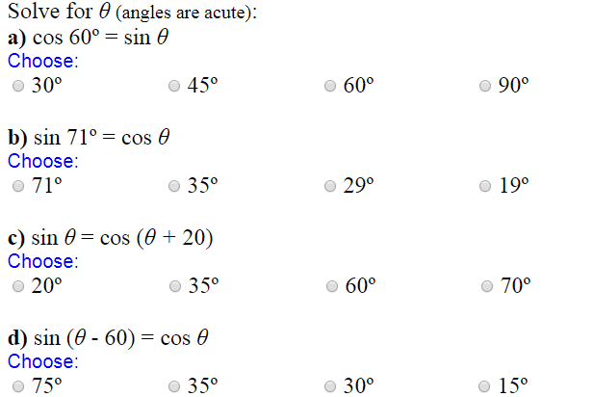
3.) | 