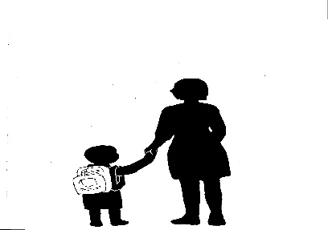**Absence Note 2016-2017**

**(Nota de ausencia) Absence Excuse**

**Please excuse** (Favor de excusar a)

**Grade** (Grado) First Grade

**Teacher** (Maestra) Mrs. Sanchez

**For being absent on** (por faltar el día)

**The reason for the absence is** (razón por la ausencia):

_____ Illness (enfermedad)

_____ Dental/Doctor visit (cita de doctor/dentista)

_____ Missed Bus (autobús me dejó)

_____ Other (otra razón) _________________________________________________________________________

____________________________________________________________________________________________________________

Parent/Guardian Signature (firma de padre/guardián)

_______________________________________________________________________________________________