Name______________________________________ Date__________ Do Now….7 mins

Directions: Take a few minutes to study the photograph and answer the questions that follow:

|  |
| --- |
| 1. What is a good title for the photograph? |
| 1. Who do you think the subjects in the photo are? |
| 1. What do you observe (see) in the photograph? |
| 1. How is this photograph connected to the Great Depression? |

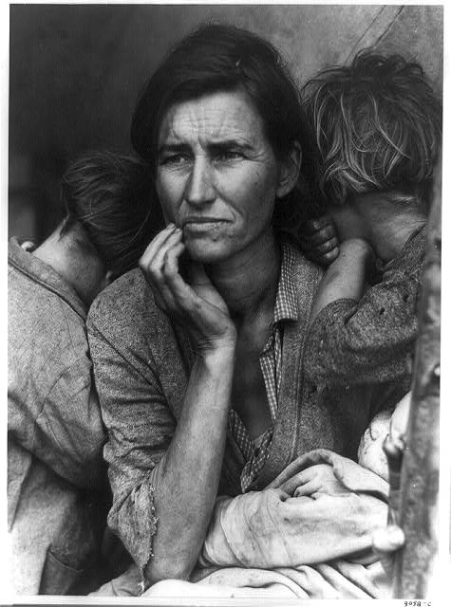

Name______________________________________ Date__________ Do Now….7 mins

Directions: Take a few minutes to study the photograph and answer the questions that follow:

|  |
| --- |
| 1. What is a good title for the photograph? |
| 1. Who do you think the subjects in the photo are? |
| 1. What do you observe (see) in the photograph? |
| 1. How is this photograph connected to the Great Depression? |



**TICKET OUT THE DOOR**

Name:_______________________________________________ 2 minutes

Of the 5 photographs that you have chosen, which one accurately captures the history and stories of the GREAT DEPRESSION? Explain.

**TICKET OUT THE DOOR**

Name:_______________________________________________ 2 minutes

Of the 5 photographs that you have chosen, which one accurately captures the history and stories of the GREAT DEPRESSION? Explain.

**TICKET OUT THE DOOR**

Name:_______________________________________________ 2 minutes

Of the 5 photographs that you have chosen, which one accurately captures the history and stories of the GREAT DEPRESSION? Explain.

**TICKET OUT THE DOOR**

Name:_______________________________________________ 2 minutes

Of the 5 photographs that you have chosen, which one accurately captures the history and stories of the GREAT DEPRESSION? Explain.

**TICKET OUT THE DOOR**

Name:_______________________________________________ 2 minutes

Of the 5 photographs that you have chosen, which one accurately captures the history and stories of the GREAT DEPRESSION? Explain.