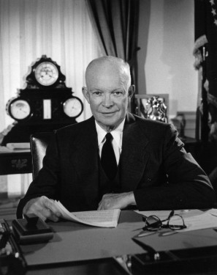HOTA II Name _______________________________________________

**Dwight Eisenhower – Cold War Foreign Policy**

<http://millercenter.org/president/eisenhower/essays/biography/5>

Use the lick above to complete the notes for each area of foreign policy.

|  |
| --- |
| **Foreign Affairs** |
| **Nuclear Diplomacy** |
| **U.S-Soviet Relations** |
| **Covert Action** |
| **Middle East Rivalry** |
| **Indochina** |