**Mauryan Empire**

By 600 B.C., almost 1,000 years after the Aryan migrations, many small kingdoms were scattered throughout India. In 326 B.C., Alexander the Great brought the Indus Valley in the northwest under Macedonian control—but left almost immediately. Soon after, a great Indian military leader, Chandragupta Maurya (chuhn•druh•GUP•tuh MAH•oor•yuh), seized power.

Chandragupta Maurya may have been born in the powerful kingdom of Magadha. Centered on the lower Ganges River, the kingdom was ruled by the Nanda family. Chandragupta gathered an army, killed the unpopular Nanda king,

and in about 321 B.C. claimed the throne. This began the **Mauryan Empire**.

Chandragupta moved northwest, seizing all the land from Magadha to the Indus. Around 305 B.C., Chandragupta

began to battle Seleucus I, one of Alexander the Great’s generals. Seleucus had inherited part of Alexander’s empire. He wanted to reestablish Macedonian control over the Indus Valley. After several years of fighting, however, Chandragupta

defeated Seleucus. By 303 B.C., the Mauryan Empire stretched more than 2,000 miles, uniting north India politically for the first time. (See map on reverse side.)

To win his wars of conquest, Chandragupta raised a vast army: 600,000 soldiers on foot, 30,000 soldiers on horseback, and 9,000 elephants. To clothe, feed, and pay these troops, the government levied high taxes. For example, farmers had to pay up to one-half the value of their crops to the king.

Chandragupta relied on an adviser named Kautilya (kow•TIHL•yuh), a member of the priestly caste. Kautilya wrote a ruler’s handbook called the *Arthasastra* (AHR•thuh• SHAHS•truh). This book proposed toughminded policies to hold an empire together, including spying on the people and employing political assassination. Following Kautilya’s advice, Chandragupta created a highly bureaucratic government. He divided the empire into four provinces, each headed by a royal prince. Each province was then divided into local districts, whose officials assessed taxes and enforced the law.

In 301 B.C., Chandragupta’s son assumed the throne. He ruled for 32 years. Then Chandragupta’s grandson, **Asoka** (uh•SOH•kuh), brought the Mauryan Empire to its greatest heights.

Asoka became king of the Mauryan Empire in 269 B.C. At first, he followed in Chandragupta’s footsteps, waging war to expand his empire. During a bloody war against the neighboring state of Kalinga, 100,000 soldiers were slain, and even more civilians perished.

Although victorious, Asoka felt sorrow over the slaughter at Kalinga. As a result, he studied Buddhism and decided to rule by the Buddha’s teaching of “peace to all beings.” Throughout the empire, Asoka erected huge stone pillars inscribed with his new policies. Some edicts guaranteed that Asoka would treat his subjects fairly and humanely. Others preached nonviolence. Still others urged **religious toleration**—acceptance of people who held different religious beliefs.

Asoka had extensive roads built so that he could visit the far corners of India. He also improved conditions along these roads to make travel easier for hisofficials and to improve communication in the vast empire. For example, every

nine miles he had wells dug and rest houses built. This allowed travelers to stop and refresh themselves. Such

actions demonstrated Asoka’s concern for his subjects’well-being. Noble as his policies of toleration and nonviolence

were, they failed to hold the empire together after Asoka died in 232 B.C.

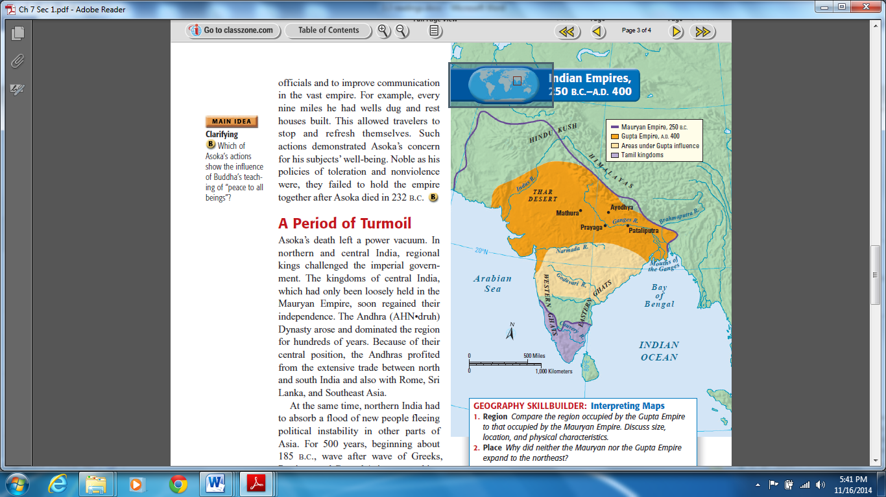

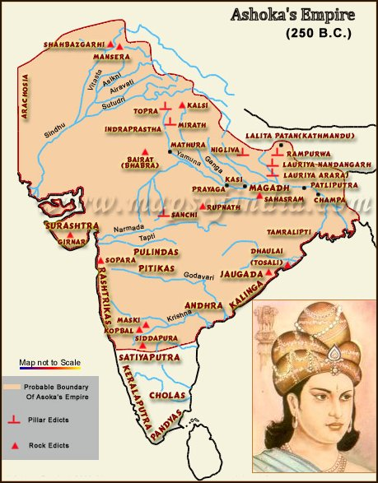

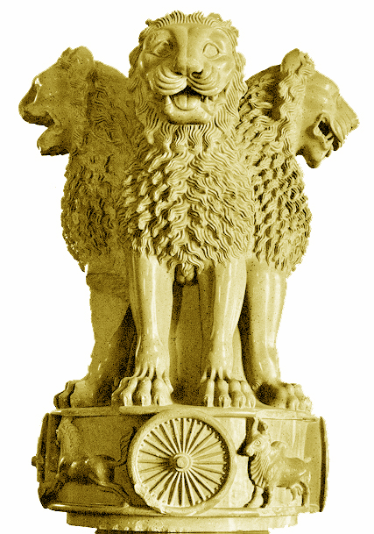

**Qin Dynasty**

In the third century B.C., the **Qin Dynasty** (chihn) replaced the Zhou Dynasty. It emerged from the western state of Qin. The ruler who founded the Qin Dynasty employed Legalist ideas to subdue the warring states and unify his country.

In 221 B.C., after ruling for over 20 years, the Qin ruler assumed the name **Shi Huangdi** (shihr hwahng•dee), which means “First Emperor.” The new emperor had begun his reign by halting the internal battles that had sapped China’s strength. Next he turned his attention to defeating invaders and crushing resistance within China to his rule. Shi Huangdi’s armies attacked the invaders north of the Huang He and south as far as what is now Vietnam. His victories

doubled China’s size. Shi Huangdi was determined to unify China.

Shi Huangdi acted decisively to crush political opposition at home. To destroy the power of rival warlords, he introduced a policy called “strengthening the trunk and weakening the branches.” He commanded all the noble families to live in the capital city under his suspicious gaze. This policy, according to tradition, uprooted 120,000 noble families. Seizing their land, the emperor carved China into 36 administrative districts. He sent Qin officials to control them.

To prevent criticism, Shi Huangdi and his prime minister, the Legalist philosopher Li Su, murdered hundreds of Confucian scholars. They also ordered “useless” books burned. These books were the works of Confucian thinkers and poets who disagreed with the **Legalists**. Practical books about medicine and farming, however, were spared. Through measures

such as these, Shi Huangdi established an **autocracy**—a government that has unlimited power and uses it in an arbitrary manner.

In sharp contrast to the followers of Confucius and Laozi was a group of practical political thinkers called the Legalists. They believed that a highly efficient and powerful government was the key to restoring order in society. They got their name from their belief that government should use the law to end civil disorder and restore harmony. Hanfeizi and Li Si were among the founders of **Legalism**.

The Legalists taught that a ruler should provide rich rewards for people who carried out their duties well. Likewise, the disobedient should be harshly punished. In practice, the Legalists stressed punishment more than rewards. For example, anyone caught outside his own village without a travel permit should have his ears or nose chopped off. The Legalists believed in controlling ideas as well as actions. They suggested that a ruler burn all writings that might encourage people to criticize government.

Shi Huangdi’s sweeping program of **centralization** included the building of a highway network of more than 4,000 miles. Also, he set the same standards throughout China for writing, law, currency, and weights and measures—even down to the length of cart axles. This last standard made sure that all vehicles could fit into the ruts of China’s main roads.

Under Shi Huangdi’s rule, irrigation projects increased farm production. Trade blossomed, thanks to the new road system. Trade pushed a new class of merchants into prominence. Despite these social advances, harsh taxes and repressive government made the Qin regime unpopular. Shi Huangdi had unified China at the expense of human freedom.

Scholars hated Shi Huangdi for his book burning. Poor people hated him because they were forced to work on the building of a huge defensive wall. Earlier, Zhou rulers had erected smaller walls to discourage attacks by northern nomads. Shi Huangdi determined to close the gaps and extend the wall almost the length of the empire’s border. Enemies would have to gallop halfway to Tibet to get around it.

**The Great Wall of China** arose on the backs of hundreds of thousands of peasants. The wall builders worked neither for wages nor for love of empire. They faced a terrible choice: work on the wall or die. Many of the laborers worked on the wall and died anyway, victims of the crushing labor or the harsh winter weather.

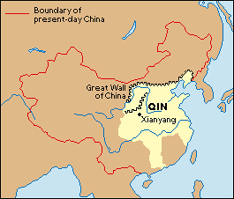

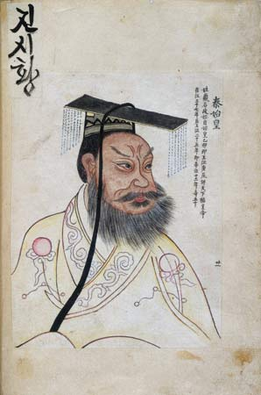

**I. Ancient Rome (Republic)**

Around 600 B.C., an Etruscan became king of Rome. In the decades that followed,Rome grew from a collection of hilltop villages to a city that covered nearly 500 square miles. Various kings ordered the construction of Rome’s first temples and public centers—the most famous of which was the Forum, the heart of Roman political life. The last king of Rome was Tarquin the Proud. A harsh tyrant, he was driven from power in 509 B.C.

The Romans declared they would never again be ruled by a king. Instead, they established a republic, from the Latin phrase *res publica,*which means “public affairs.” A **republic** is a form of government in which power rests with citizens who have the right to vote for their leaders. In Rome, citizenship with voting rights was granted only to free-born male citizens.

In the early republic, different groups of Romans struggled for power. One group was the **patricians**, the wealthy landowners who held most of the power. The other important group was the **plebeians**, the common farmers, artisans, and merchants who made up the majority of the population.

The patricians inherited their power and social status. They claimed that their ancestry gave them the authority to make laws for Rome. The plebeians were citizens of Rome with the right to vote. However, they were barred by law from

holding most important government positions. In time, Rome’s leaders allowed the plebeians to form their own assembly and elect representatives called **tribunes**. Tribunes protected the rights of the plebeians from unfair acts of

patrician officials.

An important victory for the plebeians was to force the creation of a written law code. With laws unwritten, patrician officials often interpreted the law to suit themselves. In 451 B.C., a group of ten officials began writing down Rome’s laws. The laws were carved on twelve tablets, or tables, and hung in the Forum. They became the basis for later Roman law. The **Twelve Tables** established the idea that all free citizens had a right to the protection of the law.

In the first century B.C., Roman writers boasted that Rome had achieved a balanced government. What they meant was that their government had taken the best features of a monarchy (government by a king), an aristocracy (government by nobles), and a democracy (government by the people). Rome had two officials called **consuls**. Like kings, they commanded the army and directed the government. However, their power was limited. A consul’s term was only one year long. The same person could not be elected consul again for ten years. Also, one consul could always overrule, or veto, the other’s decisions.

The **senate** was the aristocratic branch of Rome’s government. It had both legislative and administrative functions in the republic. Its 300 members were chosen from the upper class of Roman society. Later, plebeians were allowed in the

senate. The senate exercised great influence over both foreign and domestic policy.

The assemblies represented the more democratic side of the government. For example, an assembly organized by the plebeians, the Tribal Assembly, elected the tribunes and made laws for the common people—and later for the republic itself.

In times of crisis, the republic could appoint a **dictator**—a leader who had absolute power to make laws and command the army. A dictator’s power lasted for only six months. Dictators were chosen by the consuls and then elected by the senate.

In addition to their government, the Romans placed great value on their military. All citizens who owned land were required to serve in the army. Seekers of certain public offices had to perform ten years of military service. Roman soldiers were organized into large military units called **legions**. The Roman legion was made up of some 5,000 heavily armed foot soldiers (infantry). A group of soldiers on horseback (cavalry) supported each legion. Legions were

divided into smaller groups of 80 men, each of which was called a century. The military organization and fighting skill of the Roman army were key factors in Rome’s rise to greatness.

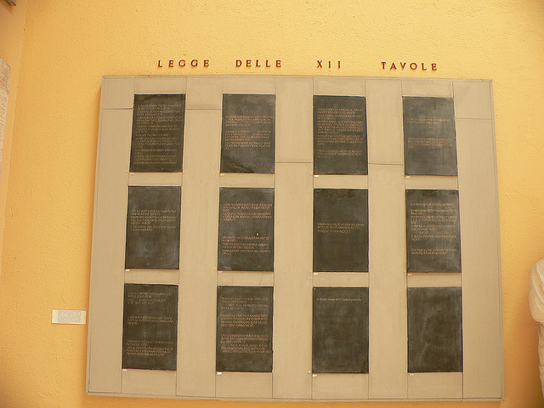

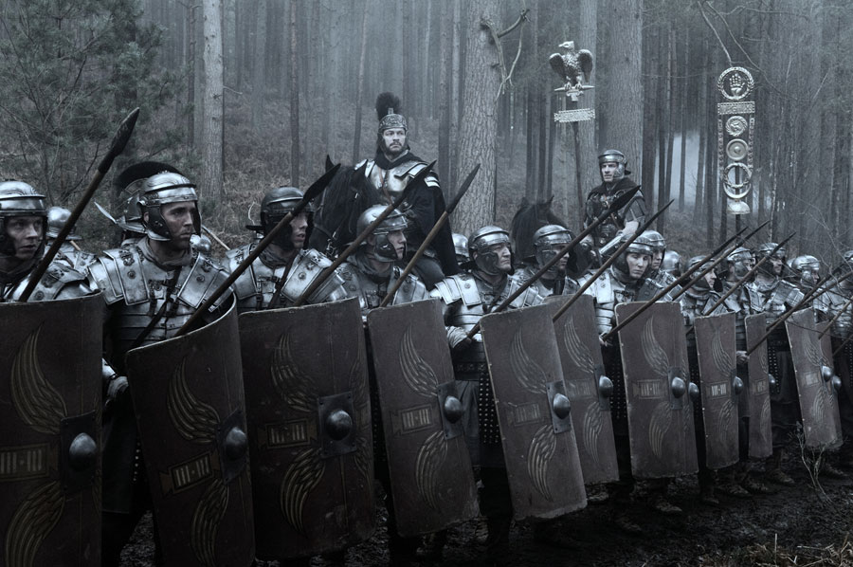

**II. Ancient Rome (Empire)**

For hundreds of years after the founding of the republic, Rome sought to expand its territories through trade and conquest. As Rome enlarged its territory, its republican form of government grew increasingly unstable. Eventually, the Roman Republic gave way to the formation of a mighty dictator-ruled empire that continued to spread Rome’s influence far and wide.

In 46 B.C., **Julius Caesar**, who had the support of the army and the masses, was appointed dictator by the senate. In 44 B.C., he was named dictator for life. Caesar governed as an **absolute ruler**, one who has total power. However, he started a number of reforms. He granted Roman citizenship to many people in the provinces. He expanded the senate, adding friends and supporters from Italy and other regions. Caesar also helped the poor by creating jobs, especially through the construction of new public buildings. He started colonies where people without land could own property, and he increased pay for soldiers.

Many nobles and senators expressed concern over Caesar’s growing power, success, and popularity. Some feared losing their influence. Others considered him a tyrant. A number of important senators, led by Marcus Brutus and Gaius Cassius, plotted his assassination. On March 15, 44 B.C., they stabbed him to death in the senate chamber.

After Caesar’s death, civil war broke out again and destroyed what was left of the Roman Republic. Three of Caesar’s supporters banded together to crush the assassins. Caesar’s 18-year-old grandnephew and adopted son Octavian (ahk•TAY•vee•uhn) joined with an experienced general named Mark Antony and a powerful politician named Lepidus. In 43 B.C., they took control of Rome and ruled for ten years as the Second Triumvirate. Their alliance, however, ended in jealousy and violence

While he restored some aspects of the republic, Octavian became the unchallenged ruler of Rome. Eventually he

accepted the title of **Augustus** (aw•GUHS•tuhs), or “exalted one.” He also kept the title ***imperator****,* or “supreme military

commander,” a term from which *emperor* is derived. Rome was now an empire ruled by one man.

Rome was at the peak of its power from the beginning of Augustus’s rule in 27 B.C. to A.D. 180. For 207 years, peace

reigned throughout the empire, except for some fighting with tribes along the borders. This period of peace and prosperity is known as the ***Pax Romana***— “Roman peace.” During this time, the Roman Empire included more than

3 million square miles. Its population numbered between 60 and 80 million people. About 1 million people lived in the

city of Rome itself.

The Romans held their vast empire together in part through efficient government and able rulers. Augustus was Rome’s ablest emperor. He stabilized the frontier, glorified Rome with splendid public buildings, and created a system of government that survived for centuries. He set up a **civil service**. That is, he paid workers to manage the affairs of government, such as the grain supply, tax collection, and the postal system. Although the senate still functioned, civil servants drawn from plebeians and even former slaves actually administered the empire.

Most people in the Roman Empire lived in the countryside and worked on farms. In Rome and smaller cities, merchants, soldiers, slaves, foreigners, and philosophers all shared the crowded, noisy streets. Here, people from all walks of life came together to create a diverse society.

Slavery was a significant part of Roman life. It was widespread and important to the economy. The Romans made more use of slaves than any previous civilization. Numbers of slaves may have reached as high as one-third of the population.

Most slaves were conquered peoples brought back by victorious Roman armies and included men, women, and children. Children born to slaves also became slaves. Slaves could be bought and sold. According to Roman law, slaves were the

property of their owner. They could be punished, rewarded, set free, or put to death as their master saw fit.

The earliest Romans worshiped powerful spirits or divine forces, called *numina,* that they thought resided in everything around them. Closely related to these spirits were the Lares (LAIR-eez), who were the guardian spirits of each family. They gave names to these powerful gods and goddesses and honored them through various rituals, hoping to gain favor and avoid misfortune.

In Rome, government and religion were linked. The deities were symbols of the state. Romans were expected to honor them not only in private rituals at shrines in their homes but also in public worship ceremonies conducted by priests in temples. Among the most important Roman gods and goddesses were Jupiter, father of the gods; Juno, his wife, who supposedly watched over women; and Minerva, goddess of wisdom and of the arts and crafts. During the empire, worship of the emperor also became part of the official religion of Rome.

During this time of *Pax Romana,* another activity slowly emerged in the Roman Empire—the practice of a new religion known as Christianity. The early followers of this new faith would meet with much brutality and hardship for their beliefs. But their religion would endure and spread throughout the empire, and eventually become one of the dominant faiths of the world.

