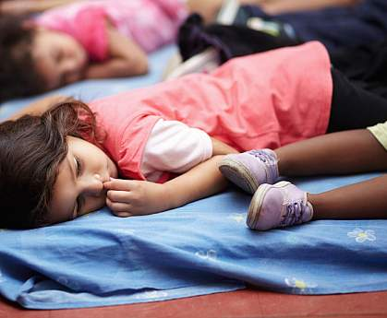 **Naps Can Help Preschool Children Learn**

Classroom naps can enhance memory and support learning in preschool children, a new study showed. The results might help educators make informed decisions about allotting time for naps in preschools.

Studies in adults show that sleep can enhance certain mental functions, including memory, reasoning, and problem-solving. Naps, which can involve lighter sleep stages than overnight sleep, can help strengthen memory in young adults. But while naps are common in young children, their benefits in early childhood haven’t been extensively studied.

Dr. Rebecca Spencer and her colleagues at the University of Massachusetts Amherst have been exploring the relationship between early childhood naps and memory formation. Their latest study was supported in part by NIH’s National Heart, Lung, and Blood Institute (NHLBI). It appeared online on September 23, 2013, in *Proceedings of the National Academy of Sciences*.

The researchers taught 40 preschool children a game called Memory. In the morning, the children learned where 9 or 12 cartoon images were on a grid. After their accuracy reached 75%, their immediate recall was tested. The children either took an afternoon nap (of an average of 1 hour and 15 minutes) or were gently kept awake. After nap time, they were tested again. They were tested once more the following morning.

The researchers found that the children recalled 10% more of the items’ locations following a nap than when they had been kept awake. Significantly, performance on the test remained similar the next morning, showing that the nap was the factor that had strengthened the memories.

The researchers next examined whether the benefits of the nap differed between children who normally took naps and those who didn’t. The effect of the nap was greatest, they found, for those who regularly took naps. This result suggests that certain children might have a greater need for afternoon naps.

To explore how memories might be consolidated during a nap, the team recruited a group of 14 additional children and studied them during their naps using polysomnography—a collection of brain wave and other measures recorded in a sleep laboratory. The team saw a correlation between sleep spindles—distinct bursts of brain activity that can be seen on an EEG—and memory performance. These bursts of activity, the researchers suggest, may represent the stabilization and consolidation of the memory.

“Until now, there was nothing to support teachers who feel that naps can really help young children. There had been no concrete science behind that,” Spencer says. “We hope these results will be used by policy makers and center directors to make educated decisions regarding the nap opportunities in the classrooms.”

— by Harrison Wein, Ph.D. (September 30, 2013, National Institute of Health)