**SPECIAL AREA MENTOR FORMS**

Go to [www.rcsdk12.org/CIT/Resources](http://www.rcsdk12.org/CIT/Resources) and scroll down for Intern Status Report and Intern Report on Mentor forms for:

School Counselors

Library Media Specialists

School Social Workers

School Psychologists

Speech Language Therapists

[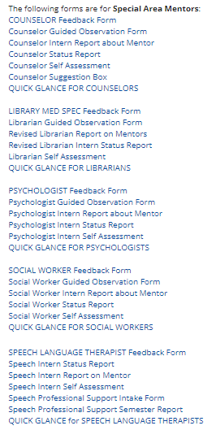](http://www.rcsdk12.org/CIT/Resources)