**The Aztec – Geographic Interaction**

While the Maya were developing their civilization to the south, other high cultures were evolving in central Mexico. Some of the most important developments took place in and around the Valley of Mexico. This valley, where modern Mexico City is located, eventually became the site of the greatest empire of Mesoamerica, the Aztec.

The Valley of Mexico, a mountain basin about 7,500 feet above sea level, served as the home base of several powerful cultures. The valley had several large, shallow lakes at its center, accessible resources, and fertile soil.

According to one of the Aztec legends, the god of the sun and warfare, Huitzilopochtli (wee•tsee•loh•POHCH•tlee), told them to found a city of their own. He said to look for a place where an eagle perched on a cactus, holding a snake in its mouth. They found such a place on a small island in Lake Texcoco, at the center of the valley. There, in 1325, they founded their city, which they named **Tenochtitlán** (teh•NOCH•tee•TLAHN).

By the early 1500s, Tenochtitlán had become an extraordinary urban center. With a population of between 200,000 and 400,000 people, it was larger than London or any other European capital of the time.

Tenochtitlán remained on its original island site. To connect the island to the mainland, Aztec engineers built three raised roads, called causeways, over the water and marshland. Other smaller cities ringed the lake, creating a dense concentration of people in the Valley of Mexico. Streets and broad avenues connected the city center with outlying residential districts.

The canals that intersected with these roadways allowed canoes to bring people directly into the city center. Canoes also brought goods from the farthest reaches of the empire to the economic heart of the city, the huge market of **Tlatelolco** (TLAH•tehl•AWL•koh). Visitors to the market also found a great deal of local agricultural produce on display, including avocados, beans, chili peppers, corn, squash, and tomatoes. Most of the fruits and vegetables sold at the market were grown on **chinampas**, farm plots built on the marshy fringes of the lake. These plots, sometimes called “floating gardens,” were extremely productive, providing the food needed for a huge urban population.

At the center of the city was a massive, walled complex, filled with palaces, temples, and government buildings. The main structure in the complex was the Great Temple. This giant pyramid with twin temples at the top, one dedicated to the sun god and the other to the rain god, served as the center of Aztec religious life.

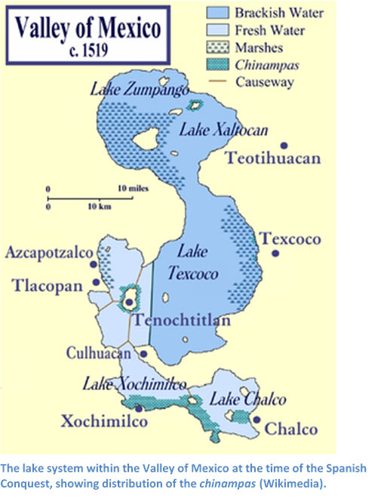 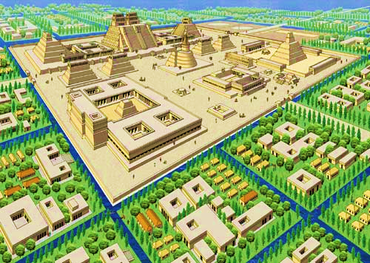

**The Inca – Geographic Interaction**

While the Aztecs ruled in the Valley of Mexico, another people—the Inca—created an equally powerful state in South America. From **Cuzco**, their capital in southern Peru, the Inca spread outward in all directions. They brought various Andean peoples under their control and built an empire that stretched from Ecuador in the north to Chile in the south. It was the largest empire ever seen in the Americas.

The Inca originally lived in a high plateau of the Andes. After wandering the highlands for years, the Inca finally settled on fertile lands in the Valley of Cuzco. By the 1200s, they had established their own small kingdom in the valley.

The Incan social system was based on an age-old form of community cooperation—the ayllu (EYE•loo). The ayllu, or extended family group, undertook tasks too big for a single family. These tasks included building irrigation canals or cutting agricultural **terraces** into steep hillsides. The ayllu also stored food and other supplies to distribute among members during hard times.

The Inca had an ambitious public works program. The most spectacular project was the Incan road system. A marvel of engineering, this road system symbolized the power of the Incan state. The 14,000-mile-long network of roads and bridges spanned the empire, traversing rugged mountains and harsh deserts. The roads ranged from paved stone to simple paths. Along the roads, the Inca built guesthouses to provide shelter for weary travelers. A system of runners, known as chasquis (SHAH•skeys), traveled these roads as a kind of postal service, carrying messages from one end of the empire to the other. The road system also allowed the easy movement of troops to bring control to areas of the empire where trouble might be brewing.

The Temple of the Sun in Cuzco was the most sacred of all Incan shrines. It was heavily decorated in gold, a metal the Inca referred to as “sweat of the sun.” According to some sources, the temple even had a garden with plants and animals crafted entirely from gold and silver. In fact, gold was a common sight throughout Cuzco. The walls of several buildings had a covering of thin gold sheeting.



