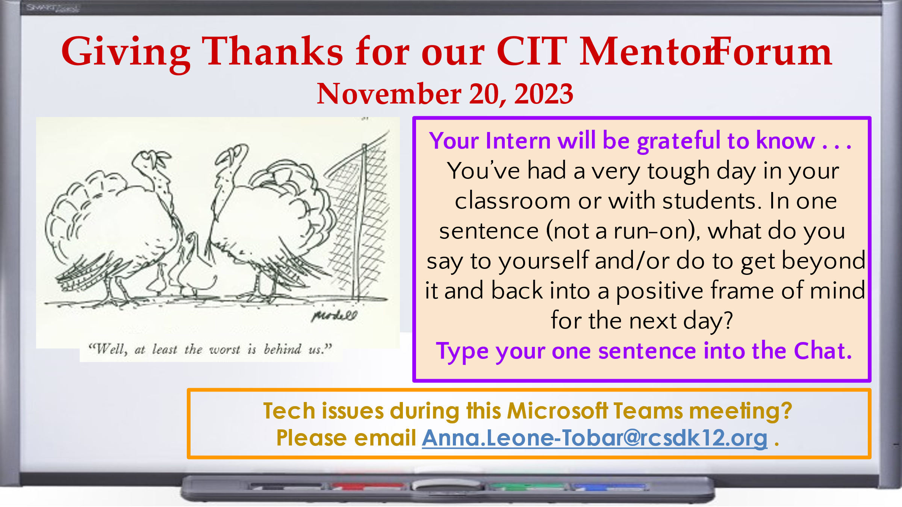CIT Mentor Forum, November 20. 2023

**How Teachers Get Beyond Tough Days in the Classroom**

By [Larry Ferlazzo](https://www.edweek.org/by/larry-ferlazzo) — October 22, 2023  
See <https://www.edweek.org/teaching-learning/opinion-how-teachers-get-beyond-tough-days-in-the-classroom/2023/10>

**Advice from our CIT Mentors in tonight’s Chat:**

This too shall pass.

Today may not have gone as I hoped or expected, but tomorrow is a new day!

Tomorrow is a new day

Tomorrow is another day!

Tomorrow is a new day

Tomorrow is a new day

I email/visit my intern.

Most days are great; there are always bumps in the road!

Just Breath

tomorrow is another day and another fresh start

Tomorrow is a new day

The worst in life can't take the best of me

Tomorrow is a new day.

This too shall pass

What am I going to do tonight to take care of myself?

When I walk out at the day's end I shake my hands like they are wet. Feels like letting go.

Go for a long walk.

I am here for the kids

This isn't easy work, but it is worth it.

Take a deep breath!

Keep breathing

Tomorrow is a brand new day and a fresh start- a re-do

Treat each day as a fresh start. One day isn't the be all, end all.

Try again tomorrow

One day doesn't cancel out a bunch of good days

Tomorrow is a brand new day!

Go to bed early tonight and start fresh tomorrow

Go for a long walk

Fresh start tomorrow

I go home and relax

This is normal!

I'll do better tomorrow

We'll try again tomorrow.

Tomorrow is a new day!

Tomorrow is a new day.

No one wants to be in middle school again.  Try again tomorrow.

Be kind to yourself and take a break tonight, tomorrow is a new day.

Breathe and know tomorrow you can try again

Also see:  
<https://www.edweek.org/teaching-learning/how-to-shake-the-october-blues-and-rediscover-the-joy-in-teaching/2022/10>