World of Inquiry School

School Based Planning Team

October 6, 2016

Minutes

Present:, Nissa Youngren, Sheela Webster, Robert Bond, Kerry Robertson, Ingrid Dickson, Kara Miller, Karen Dingwall,

Ja’Colby Chapman, Bridget Maio, Kim Garlock

Absent: Kamaria Simmons, Kim Garlock, Mike Maloy

Need Elementary Special Ed. Representative, Ingrid to put out a call to all RTA members for nominees.

**Updates:**

* Receiving of new student rep and new staff member, Bridget Maio
* On Sup Conf Day and agenda for Oct 7th. (Work plan, personal goals based on Learning Targets, afternoon is differentiated sessions (Circle, Goal Setting, Math, Technology, Active Management), and planning time
* Early dismissal Dates:
* Early Dismissal Day October 17, 2016 for students

District Scheduled ½ day planning tentative schedule (3 hours)

Monday, Oct. 17th

Monday, Dec. 5th

Tuesday, Jan. 10th

Monday, March 6th

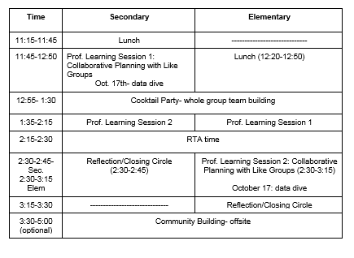

Monday, October 17th Schedule for secondary and elementary:

* + - -maintain letter day
    - –Secondary: periods 1-4 for secondary (leave at 11:00am), next time will be 8-5 backwards (lunches at the end)
    - –Elementary: maintain the morning schedule, (leave at 12:15)
    - -must provide both breakfast and lunch for all students K-12
    - -share proposed schedules for school day and professional development
    - For secondary (proposed): lunch on carts delivered to classrooms, as a Title I school we must serve breakfast and lunch. Lunches will be bagged lunches. Elementary is still a work in progress. Minimizing disruption to instruction.
* **Review of Design Task Teams**
* Health Advisory: K-12, broaden scope to include k-12
* Griffin Pride: include a component to include organizing secondary staff meetings
* Safe and Supportive: No change
* EL Com becomes EL Event Com
* PD; no change
* Elementary High Readiness: refining mission, Sheela, Ingrid, et al will work on it
* No tech committee
* Steering Com: refine role
* Vertical Planning: tasks will be integrated into early dismissal days, disbanded
* Outward Bound: Broaden support, increase fundraising
* SWMM, keep all three levels
* School Service Com: No change
* SLC Committee postponed until next meeting
* **Title I Funds**

Discussion and explanation of funds from Title I

Approved by unanimous vote

* **Future Agenda:**

SLC follow-up

Early Dismissal review

REOC Uniform Change

* SCEP
* Calendar-went home for the year in bags K-6, mailed for 8th-12th, will be mailed for 7th grade. Includes all events for staff and families for the year including professional learning and PTC events. Theme- “Conceive, Believe, Achieve”