***Some Notes & Tips for the Mentor-Intern-Administrator Scenarios***

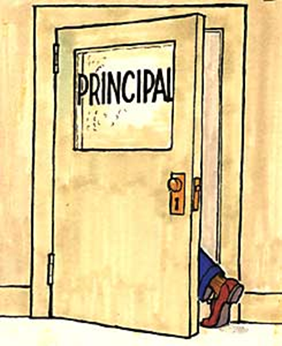***CIT Mentor Forum, March 18, 2024***

**Breakout Room Instructions and Sample Scenarios here:**[**Mentor-Intern-Administrator Scenario Breakout Room Instructions**](https://docs.google.com/document/d/15dYWXjWTn05sU2p9BTLBnlGwhEh7S3hmCl2MWR4YGyI/copy)

**See full Padlet of CIT Mentor Suggestions here:** [**https://rcsdk12.padlet.org/1266650/CITMENTORADMIN**](https://rcsdk12.padlet.org/1266650/CITMENTORADMIN)**.**

**Review information in *Mentor Handbook, page 37 and*** [*Slide 13: Mentoring Models*](https://drive.google.com/file/d/1csy9SkZNr7o87gQiR08qWyHKgaG1DIkJ/view?usp=drive_link)***.***

**GENERAL NOTES** on Mentor-Admin situations:

* **The vast majority of our Mentor interactions with Administrators are respectful and constructive.**
* Very important to make the monthly contact/email to Admin to keep communications open.
* Don’t do anything that, if your Intern found out about it, would make your Intern feel that you betrayed your Intern’s trust.
* Share with the Intern that you will be communicating with the Admin; share the reason, the limitations, and the content of any additional communication with Admin.
* Avoid discussing Admin with your Intern via email or text.
* Try to include Interns in meeting with Admin if at all possible. Your first role in those settings is as a listener, maybe taking notes when appropriate.
* Focus on the legitimate classroom practice issue raised by Admin. Don’t try to strategize how to “satisfy” the Admin. Meet the student or instructional need.

**When Admin tells you to “fix” the Intern:**

* Avoid “Defending” the Intern.
* “Thank you for sharing this. I will address it with [the Intern].”
* “Have you shared this concern with [the Intern]?

**When Admin asks you to share information.**

* “I am required to maintain confidentiality in my work with my Intern.”
* “I am obligated to address any concerns you share with my Intern, but I also must preserve confidentiality with my Intern.”

**When Admin wants to share information with you “off the record,” to be kept from your Intern:**

* Remind Admin (immediately!) that anything shared with you must be shared with your Intern.
* If something is shared with you inappropriately, the goal should be to restore full transparency. If unsure, consult with the Director or an experienced mentor colleague.

**–More on Back–**

**When Admin should tell Intern directly:**

* “Have you shared this with [the Intern]?”
* “You may wish to share this directly with [the Intern].”
* “It would be helpful for you to share this with [the Intern]. It would be valuable for [the Intern] to hear it from you.”
* “It would be more appropriate for you to share that directly with [the Intern].”
* “I would be happy to sit with you and [the Intern] to discuss this further.”

**When Admin addresses issues that may not be appropriate (interpersonal, social, “fitting in”):**

* “Do you feel this is affecting the Intern’s performance in the classroom? How so? I can focus on that.”
* “I can address any concerns related to classroom performance or work with students.”

**When to get RTA involved:**

* Contract issue, building safety, conditions issue, discipline/evaluation issue.
* Keep “intern” out of “line of fire.”
* Never discourage Intern from contacting RTA. Try to avoid Intern being the “lightning rod.”

**Some ideas for proactive communication with Admin:**

* Again, very important to make the monthly contact/email to Admin to keep communications open.
* In monthly email, using “we” and “us” to frame interactions.
* Be clear that in order to meet your obligation to maintain trust and confidentiality with your Intern, anything the Admin shares must be shared with the Intern.

**When dealing with Admin, we will not always react “perfectly” in the moment …**

* Understand the Stress Response: Fight, Flight, Freeze, Fawn.
* Hindsight/Regret/Self-incrimination is less important than Reflection.
* You have earned some Grace. You’re human.
* It may be necessary to repair a breach of confidentiality. Reach out for help with this when needed.

