**VALUE SHADING**

Name __________________________________________________________Date ____________Period ____

1. Use a pencil to create 5 values going from the darkest dark to white with 3 grays in-between in the boxes below.

|  |  |  |  |  |
| --- | --- | --- | --- | --- |
|  |  |  |  |  |

2. Use a pencil to create 5 values blending smoothly from the darkest dark to white with 3 grays in-between in the box below.

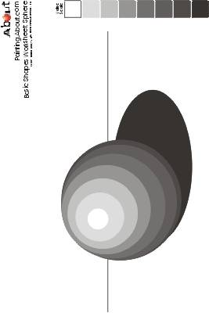

3. Use the value shades from step 1 to create this sphere.

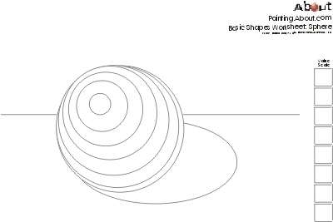

EXAMPLE

*Images:* [***http://tinyurl.com/3u9wsv2***](http://tinyurl.com/3u9wsv2) ***and*** [***http://tinyurl.com/572mwb***](http://tinyurl.com/572mwb)