**Hinduism**

In about 1500 B.C., the **Aryans**, whose homeland was probably somewhere between the Caspian and Aral seas, crossed over the northwest mountain passes into the Indus River Valley of India. Though they left almost no archaeological record, their sacred literature, the **Vedas** (VAY•duhz), left a picture of Aryan life. The Vedas are four collections of prayers, magical spells, and instructions for performing rituals.

**Caste System**

When they first arrived in India, Aryans were divided into three social classes: **Brahmins** (priests), **warriors**, and **peasants or traders**. The class that an Aryan belonged to determined his or her role in society. **Non-Aryan laborers or craftspeople** *(shudras)* formed a fourth group. Later, in the 15th century A.D., explorers from Portugal encountered this social system and called these groups **castes** (kasts).

As time went on, the four basic castes gradually grew more complex—with hundreds of subdivisions. People were born into their caste for life. Their caste membership determined the work they did, the man or woman they could marry, and the people with whom they could eat. Cleanliness and purity became all-important. Those considered the most impure because of their work (butchers, gravediggers, collectors of trash) lived outside the caste structure. They were known as **“untouchables,”** since even their touch endangered the ritual purity of others.

**Beliefs**

Hindus share a common worldview. They see religion as a way of liberating the soul from the illusions, disappointments, and mistakes of everyday existence. Sometime between 750 and 550 B.C., Hindu teachers tried to interpret and explain the hidden meaning of the Vedic hymns. The teachers’ comments were later written down and became known as the **Upanishads** (oo•PAHN•ih•shahdz).

The Upanishads are written as dialogues, or discussions, between a student and a teacher. In the course of the dialogues, the two explore how a person can achieve liberation from desires and suffering. This is described as **moksha**(MOHK•shah), a state of perfect understanding of all things. The teacher distinguishes between **atman**, the individual soul of a living being, and **Brahman**, the world soul that contains and unites all atmans.

When a person understands the relationship between atman and Brahman, that person achieves perfect understanding (*moksha*) and a release from life in this world. This understanding does not usually come in one lifetime. By the process of **reincarnation** (rebirth), an individual soul or spirit is born again and again until *moksha* is achieved. A soul’s **karma**—good or bad deeds—follows from one reincarnation to another. Karma influences specific life circumstances, such as the caste one is born into, one’s state of health, wealth or poverty, and so on.

**Hinduism and Society**

Hindu ideas about karma and reincarnation strengthened the caste system. If a person was born as an upper-caste male—a Brahmin, warrior, or merchant—his good fortune was said to come from good karma earned in a former life. However, a person who was born as a female, a laborer, or an untouchable might be getting the results of bad deeds in a former life. With some exceptions, only men of the top three varnas could hope to achieve *moksha* in their present life. The laws of karma worked with the same certainty as the world’s other natural laws. Good karma brought good fortune and bad karma resulted in bad fortune.

Together, the beliefs of Hinduism and its caste structure dominated every aspect of a person’s life. These beliefs determined what one could eat and the way in which one ate it, personal cleanliness, the people one could associate with, how one dressed, and so on. Today, even in the most ordinary activities of daily life, Hindus turn to

their religion for guidance.

**Buddhism** [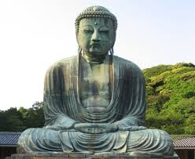](http://www.google.ca/url?sa=i&rct=j&q=&esrc=s&frm=1&source=images&cd=&cad=rja&uact=8&ved=0CAcQjRw&url=http://www.sacred-texts.com/bud/tbc/&ei=YsdFVLSvN7WasQTa8IGYDA&bvm=bv.77880786,d.cWc&psig=AFQjCNEGF2okJkFn8vFhYNlWjg20C3IY1Q&ust=1413945355319878)

Buddhism developed out of the same period of religious questioning that shaped modern Hinduism and Jainism. The founder of Buddhism, **Siddhartha Gautama (c. 563–483 B.C.),** , was born into a noble family that lived in Kapilavastu, in the foothills of the Himalayas in Nepal. To make sure the boy would be a great king and world ruler, his father isolated him in his palace. Separated from the world, Siddhartha married and had a son.

Siddhartha never ceased thinking about the world that lay outside, which he had never seen. When he was 29, he ventured outside the palace four times. First he saw an old man, next a sick man, then a corpse, and finally a wandering holy man who seemed at peace with himself. Siddhartha understood these events to mean that every living thing experiences old age, sickness, and death and that only a religious life offers a refuge from this inevitable suffering. Siddhartha decided to spend his life searching for religious truth and an end to life’s suffering. After many years, he achieved an understanding of the cause of suffering in this world. From then on, he was known as the **Buddha**, meaning “the enlightened one.”

**Beliefs**

The Buddha preached his first sermon to five companions who had accompanied him on his wanderings. That first sermon became a landmark in the history of the world’s religions. In it, he laid out the four main ideas that he had come to understand in his enlightenment. He called those ideas the **Four Noble Truths**:

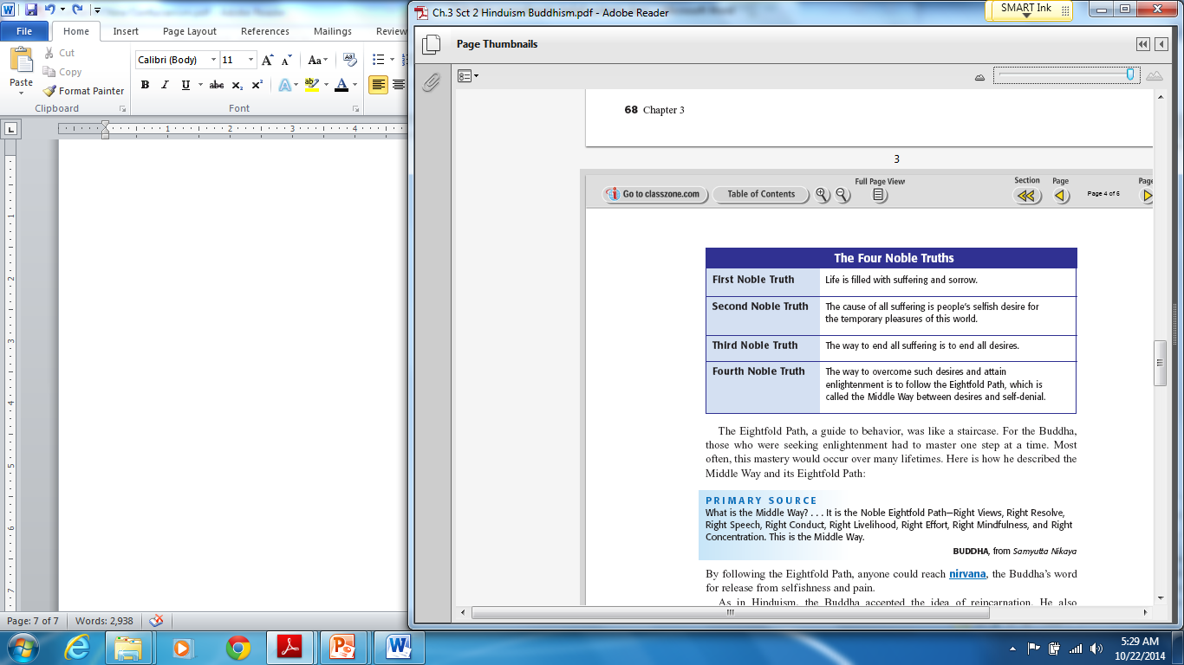

**The Eightfold Path**, a guide to behavior, was like a staircase. For the Buddha, those who were seeking enlightenment had to master one step at a time. Most often, this mastery would occur over many lifetimes. Here is how he described the **Middle Way** and its Eightfold Path:

**What is the Middle Way? . . . It is the Noble Eightfold Path—Right Views, Right Resolve, Right**

**Speech, Right Conduct, Right Livelihood, Right Effort, Right Mindfulness, and Right Concentration.**

**This is the Middle Way.**

**-BUDDHA, from *Samyutta Nikaya***

By following the Eightfold Path, anyone could reach **nirvana**, the Buddha’s word for release from selfishness and pain.

As in Hinduism, the Buddha accepted the idea of **reincarnation**. He also accepted a cyclical, or repetitive, view of history, where the world is created and destroyed over and over again. However, the Buddha rejected the many gods of Hinduism. Instead, he taught a way of enlightenment. Like many of his time, the Buddha reacted against the privileges of the Brahmin priests, and thus he rejected the caste system. The final goals of both religions—*moksha* for Hindus and nirvana for Buddhists—are similar. Both involve a perfect state of understanding and a break from the chain of reincarnations.

**69**

**Buddhism and Society**

Because of his rejection of the **caste system**, many of the Buddha’s early followers included laborers and craftspeople. He also gained a large following in northeast India, where the Aryans had less influence. The Buddha

reluctantly admitted women to religious orders. He feared, however, that women’s presence would distract men from their religious duties.

**Buddhism in India**

During the centuries following the Buddha’s death, missionaries were able to spread his faith over large parts of Asia. Buddhist missionaries went to Sri Lanka and Southeast Asia in the third century B.C. Buddhist ideas also

traveled along Central Asian trade routes to China. However, Buddhism never gained a significant foothold in India, the country of its origin. Several theories exist about Buddhism’s gradual disappearance in India. One theory states that Hinduism simply absorbed Buddhism. The two religions constantly influenced each other. Over time, the Buddha came to be identified by Hindus as one of the ten incarnations (reappearances on earth) of the god Vishnu. Hindus, therefore, felt no need to convert to Buddhism.

Nonetheless, despite the small number of Buddhists in India, the region has always been an important place of pilgrimages for Buddhists. Today, as they have for centuries, Buddhist pilgrims flock to visit spots associated with the Buddha’s life. These sites include his birthplace at Kapilavastu, the fig tree near Gaya, and the site of his first sermon near Varanasi. Buddhists also visit the *stupas,* or sacred mounds, that are said to contain his relics. The pilgrims circle around the sacred object or sanctuary, moving in a clockwise direction. They also lie face down on the ground as a sign of humility and leave flowers. These three actions are important rituals in Buddhist worship.

**Trade and the Spread of Buddhism**

As important as missionaries were to the spread of Buddhism, traders played an even more crucial role in this process. Along with their products, traders carried Buddhism beyond India to Sri Lanka. Buddhist religion was also brought southeast along trade routes to Burma, Thailand, and the island of Sumatra. Likewise, Buddhism followed the Central Asian trade routes, called the Silk Roads, all the way to China. From China, Buddhism spread to Korea—and from Korea to Japan. The movement of trade thus succeeded in making Buddhism the most widespread religion of East Asia. Throughout human history, trade has been a powerful force for the spread of ideas.

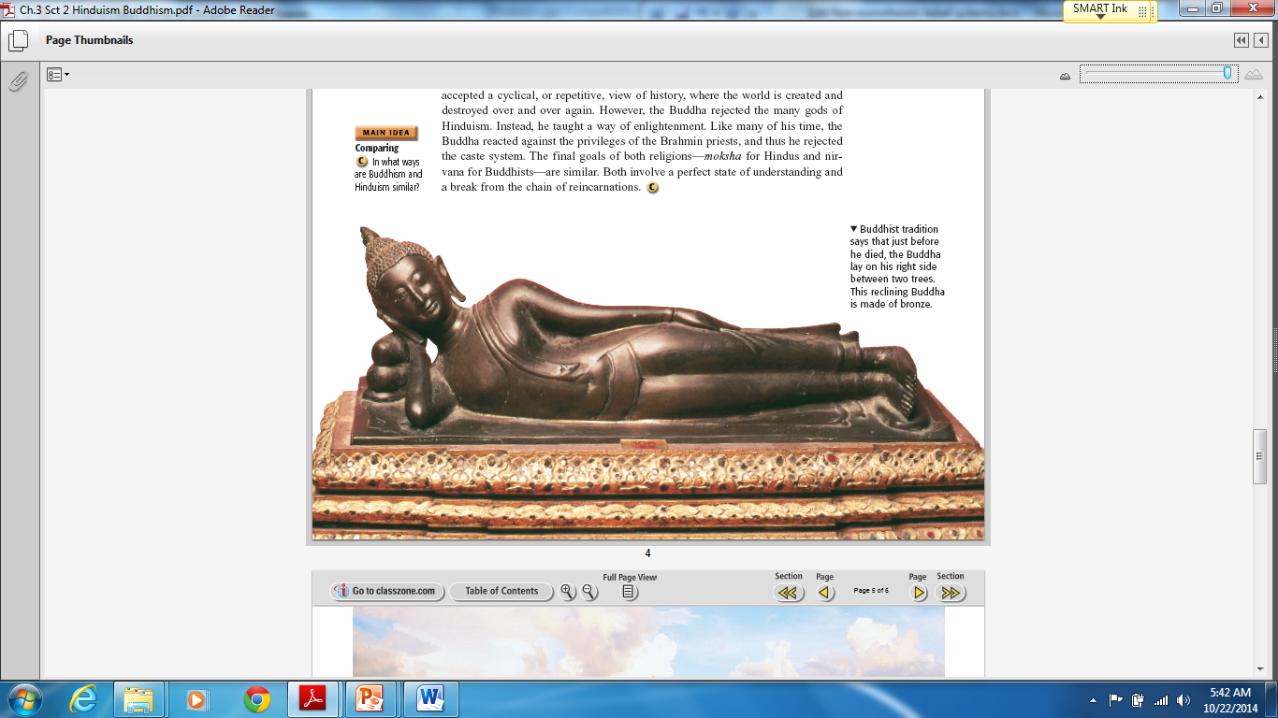

**Confucianism**

[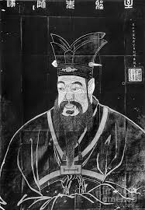](http://www.google.ca/url?sa=i&rct=j&q=&esrc=s&frm=1&source=images&cd=&cad=rja&uact=8&ved=0CAcQjRw&url=http://fineartamerica.com/featured/confucius-granger.html&ei=N6RFVKn3HqPksATqmoKICw&bvm=bv.77880786,d.cWc&psig=AFQjCNEHBKyD8TIaM3IqsD1rW-P0nDC6wQ&ust=1413936365251543)

Toward the end of the Zhou Dynasty, China moved away from its ancient values of social order, harmony, and respect for authority. Chinese scholars and philosophers developed different solutions to restore these values.

China’s most influential scholar was **Confucius** (kuhn•FYOO•shuhs). Born in 551 B.C., Confucius lived in a time when the Zhou Dynasty was in decline. He led a scholarly life, studying and teaching history, music, and moral character. Confucius was born at a time of crisis and violence in China. He had a deep desire to restore the order and moral living of earlier times to his society.

Confucius believed that social order, harmony, and good government could be restored in China if society were organized around **five basic relationships**. A code of proper conduct regulated each of these relationships. For example, rulers should practice kindness and virtuous living. In return, subjects should be loyal and law-abiding.

Three of Confucius’s five relationships were based upon the family. Confucius stressed that children should practice **filial piety**, or respect for their parents and ancestors. Filial piety, according to Confucius, meant devoting oneself to one’s parents during their lifetime. It also required honoring their memory after death through the performance of certain rituals.

**Ziyou [a disciple of Confucius] asked about filial piety. The Master said: “Nowadays**

**people think they aredutiful sons when they feed their parents. Yet they also feed**

**their dogs and horses. Unless there is respect, where is the difference?”**

**-CONFUCIUS,** *Analects* 2.7

**Government**

Confucius said that education could transform a humbly born person into a gentleman. In saying this, he laid the

groundwork for the creation of a **bureaucracy**, a trained **civil service**, or those who run the government.

According to Confucius, a gentleman had four virtues: “In his private conduct he was courteous, in serving his master he was punctilious [precise], in providing for the needs of the people he gave them even more than their due; in exacting service from the people, he was just.” Education became critically important to career advancement

in the bureaucracy.

Confucius wanted to reform Chinese society by showing rulers how to govern wisely. Impressed by Confucius’s wisdom, the duke of Lu appointed him minister of justice. According to legend, Confucius so overwhelmed people by his kindness and courtesy that almost overnight, crime vanished from Lu. When the duke’s ways changed, however, Confucius became disillusioned and resigned. Confucius spent the remainder of his life teaching. His students later collected his words in a book called the ***Analects****.* A disciple named **Mencius** (MEHN•shee•uhs) also spread Confucius’s ideas.

Confucianism was never a religion, but it was an **ethical system**, a system based on accepted principles of right and wrong. It became the foundation for Chinese government and social order. In addition, the ideas of Confucius spread beyond China and influenced civilizations throughout East Asia.