* Animal Walks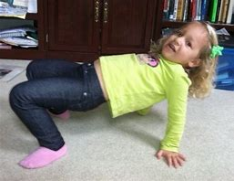

**Crab Walk** | Start by sitting down with your knees bent, feet on floor. Lean backwards and place your hands on the ground. Push through hand and feet- You should look like a “table top” now. Now walk sideways, while holding your bottom off the ground and your back straight.

**Bear Walk** | Start in the standing position. Bend over and put both hands on the ground. Now, walk forward with the same leg and arm. So, move your right arm and right leg forward, then the left leg and arm at the same time, then repeat. For additional challenge, try keeping your legs and arms straight.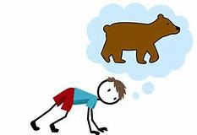

**Frog Jumps** | Start in the squatted position. Place your hands on the floor in between your knees. Using your feet, jump forward and land with your hands and feet on the ground.

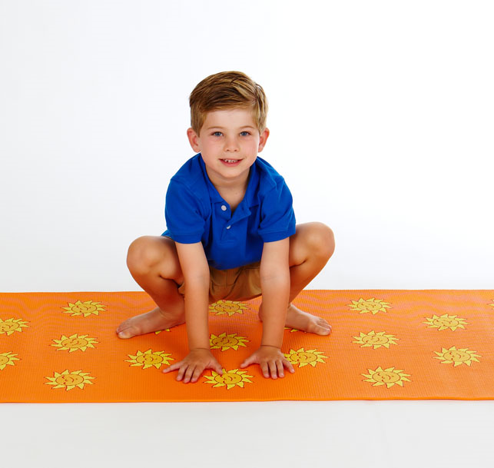

**Alligator Push-ups** | Have your child lay on their belly and push up into a plank with their hands and toes. As they walk have them push up with their hands while trying to keep their bodies as straight as possible.

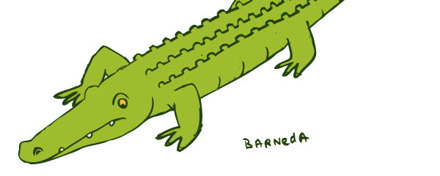

**Snake slither** | Have your child lay on their belly and put their hands to their sides. Wiggling their hips and shoulders side to side, have them try to move forward across the floor without using their hands.

* 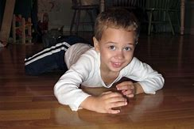

**Donkey Kicks** | Starting in the standing position, lean over and put both hands and both feet on the ground. When the area around you is clear, jump with your legs and kick behind you, leaving your hands on the ground.

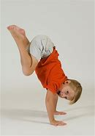

**Spider on the wall |** Starting near a cleared wall space, go down onto hands and knees with feet towards wall. Place feet on wall and walk feet up while placing weight through hands with elbows straight. Looks like a handstand with feet on a wall.

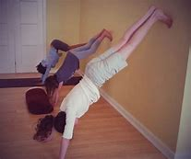

* Practice Jumping jacks
* Use chalk outside and create hopscotch board, a “road” to walk on (balance bEam)
* Visit a variety of playgrounds/Parks
* Practice walking the perimeter of the playground (as long as not near road or parking lot) to work on walking on narrow surface- like balance beam
* Play basketball with peers or family members in non-competitive atmosphere
* Play catch with tennis ball or other soft textured ball
* Use a balloon and play volleyball
* Core Strengthening exercises
  + Superman- lie on stomach and lift neck, arms and thighs off of floor 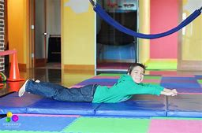
  + Bridge- lie on back with knees bent and feet on floor, lift bottom off floor and hold for 5 seconds. Repeat 10 times.

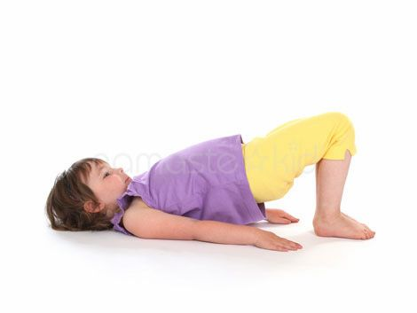

* + Plank |Lie on stomach on the floor with hands flat on the floor at shoulder level and toes on the floor. On the count of 3, push up on hands to straighten arms and lift whole body all the way to his toes off of the floor- try to hold for 30 seconds..

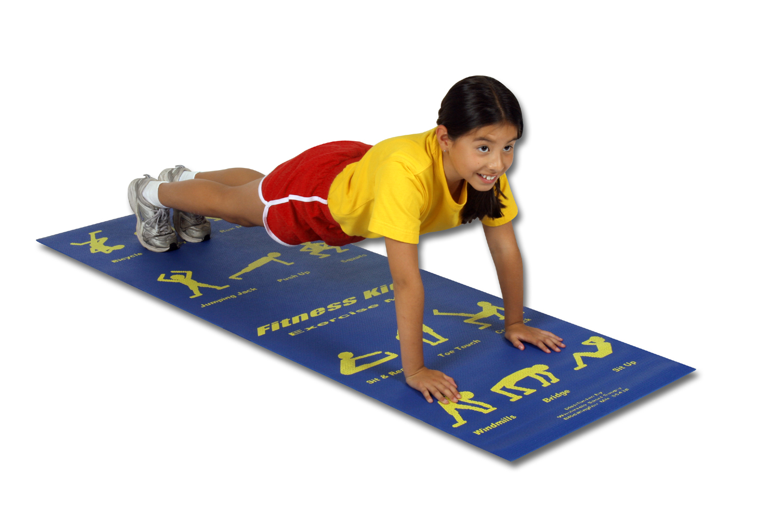

FUN JUMP ROPE GAMES

## **Snake in the grass**

## Two people hold the ends of the rope, making sure it’s flat on the ground. Shake the rope so it looks like a snake, while the kids jump over it. If your foot touches the rope, it’s your turn to shake it!

## **Jump the Mountain**

Use a long [double dutch jump rope](https://www.buyjumpropes.net/double-dutch-jump-ropes/), with a person on each end holding it slightly above the ground. Children line up in front of the rope and jump over one at a time. After all have made the jump over, the rope is raised slightly and again everyone jumps over the rope. Steadily raise the rope so that it's higher and more challenging to jump over.

**Important:** It's very important that the rope is held loosely so that if a child does hit the rope they don't trip.

## **Jump the River**

This game is similar to "jump the mountain", but instead of trying to jump high, the goal is to jump further and further distances. Start with two long [double dutch jump ropes](https://www.buyjumpropes.net/double-dutch-jump-ropes/), with a holder at each end keeping the ropes at ground level and about 6" apart (the "river"). Children line up in front of the rope and jump over one at a time. Slowly widen the distance between the ropes to make the jump more challenging.

**Note:** To help children who cannot jump as far, make one end of the "river" skinnier by holding the rope handles on that side closer together. Have more advanced jumpers jump on the wide end.

Websites to check out:

<https://www.youtube.com/user/CosmicKidsYoga>

<https://ensemble.monroe2boces.org/Playlist/BrainGym?destinationID=BW6VdpJeyEuEcqIGVxo_5w&pageIndex=3&pageSize=10>

<https://theinspiredtreehouse.com/activities-index/>

<https://www.pinkoatmeal.com/>

|  |
| --- |
|  |