**MATCH CHEAT SHEET FOR PSYCHOLOGISTS FOR 504s**

Medical Management and Assistive Technology for Children

[MATCHTeam@rcsdk12.org](mailto:MATCHTeam@rcsdk12.org)

**REFERRALS**

* General education students may be referred for AT evaluations, but without a documented learning disability qualifying them for a 504, equipment cannot be provided by the MATCH Team. **\*\*\*The equipment recommendation should NOT drive the 504!**
* Assistive Technology should be considered for any student with a disability-no referral is necessary to consider Tier 1-2 supports.

When considering a referral to the Assistive Technology team:

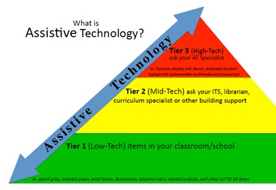

Tier 3 includes laptop, word processor, tablet, augmentative communication device—high tech equipment. It also MAY include service recommendation.

Tier 2 supports could be book on CD, school owned Chromebooks/tablets, pencil grips, special paper, visual schedules.

Tier 1 supports should be tried PRIOR to referral and results documented on the referral form.

**MEETINGS**

* List equipment under *ASSISTIVE TECHNOLOGY DEVICES*
* RCSD policy: laptops, computers, word processors, tablets (high tech devices) MUST have a MATCH recommendation to be ***added*** to a 504. ** “ACCESS to” one of these devices CAN be added without MATCH and indicates THE BUILDING provides/has this access (Tier 1-2).

MATCH provides BUILDING provides

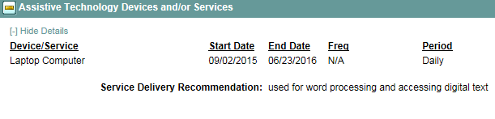 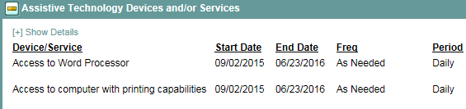

* RCSD policy: AT Service or AT Consultation MUST have a MATCH recommendation to be ***added*** to a 504. This service should be listed under **Support to Staff on Behalf of the Student**.
* If the student has a device already on a 504, please use the ***Assistive Technology Device Review*** form to note whether a device will be continued or discontinued. NOTE IN SUMMARY IF REMOVED!

*All forms are found on MATCH website:* [*http://www.rcsdk12.org*](http://www.rcsdk12.org) *>Departments> MATCH*