Relief Photo Unit

Assignment #1

Use the internet to find examples of images that use the following:  
1. Contrast

2. rule of thirds

3. point of views

4. proximity

You should have 4 different photos in all. Please label each images with the type of technique used.

Save the file using YOUR FIRST & LAST name as the title. Email it to me by next class. Anne.niederpruem@rcsdk12.org

Please keep it to one page☺ (resize images)

\*\*\*SEE MY EXAMPLE ON THE NEXT PAGE\*\*\*\*

Example of assignment #1

Ms. Niederpruem 4B

1. Contrast 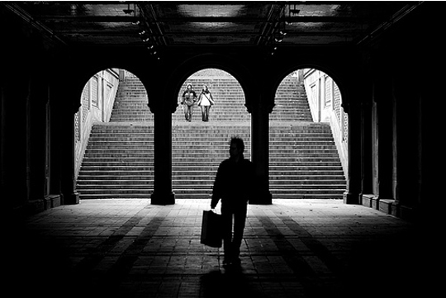
2. Rule of thirds 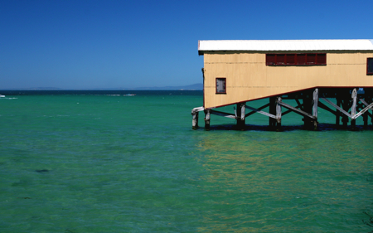
3. Unique point of view 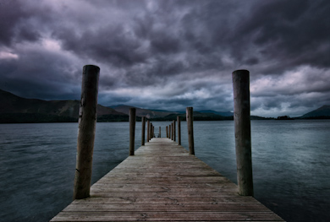
4. Proximity 