|  |
| --- |
| **Ancient Greece** |
| |  |  |  |  | | --- | --- | --- | --- | |  |  |  |  |   http://www.pbs.org/empires/thegreeks/img/shared/tiny.gif  One major reason why ancient Greece was dominated by small **city-states** and independent towns, rather than by one all-powerful king, is its geography. The country's mountainous terrain, many isolated valleys, and numerous offshore islands encouraged the formation of many local centers of power, rather than one all-powerful capital.  Another key factor influencing the formation of city-states rather than kingdoms was the Mediterranean. Such a calm and easily navigable sea provided the Greeks with an opportunity to found new colonies in times of crisis and overpopulation. It also appealed to their sense of heroism and adventure. Starting in the 8th century BC, **colonies** were eventually founded all over the Mediterranean, from Naples in Italy, to Marseilles in France, Cyrene in Northern Africa, Byzantium, close to the Black Sea, and numerous cities all along the western coast of modern-day Turkey. These colonies remained in contact with their mother cities, and acknowledged their 'blood ties' with them, but in most other respects they soon acted independently of them.  Located in the southern part of Greece known as the Peloponnesus (PEHL•uh•puh•NEE•sus), Sparta was nearly cut off from the rest of Greece by the Gulf of Corinth. In outlook and values, Sparta contrasted sharply with the other city-states, Athens in particular. Instead of a democracy, Sparta built a military state.  The **Persian Wars**, between Greece and the Persian Empire, began in Ionia on the coast of Anatolia. Greeks had long been settled there, but around 546 B.C., the Persians conquered the area. When Ionian Greeks revolted, Athens sent ships and soldiers to their aid. The Persian king Darius the Great defeated the rebels and then vowed to destroy Athens in revenge.  Eventually, several Greek city-states formed an alliance called the Delian (DEE•lee•uhn) League. (The alliance took its name from Delos, the island in the Aegean Sea where it had its headquarters.) League members continued to press the war against the Persians for several more years. In time, they drove the Persians from the territories.  As Athens grew in wealth, prestige, and power, other city-states began to view it with hostility. Ill will was especially strong between Sparta and Athens. Many people thought that war between the two was inevitable. Instead of trying to avoid conflict, leaders in Athens and Sparta pressed for a war to begin, as both groups of leaders believed their own city had the advantage. Eventually, Sparta declared war on Athens in 431 B.C.  When the **Peloponnesian War** between the two city-states began, Athens had the stronger navy. Sparta had the stronger army, and its location inland meant that it could not easily be attacked by sea. Pericles’ strategy was to avoid land battles with the Spartan army and wait for an opportunity to strike Sparta and its allies from the sea.  The Peloponnesian War severely weakened several Greek city-states. This caused a rapid decline in their military and economic power. In the nearby kingdom of Macedonia, King **Philip II** took note. Philip dreamed of taking control of Greece and then moving against Persia to seize its vast wealth. Philip also hoped to avenge the Persian invasion of Greece in 480 B.C.  Although Philip planned to invade Persia next, he never got the chance. At his daughter’s wedding in 336 B.C., he  was stabbed to death by a former guardsman. Philip’s son Alexander immediately proclaimed himself king of  Macedonia. Because of his accomplishments over the next 13 years, he became known as **Alexander the Great**. |  |  |

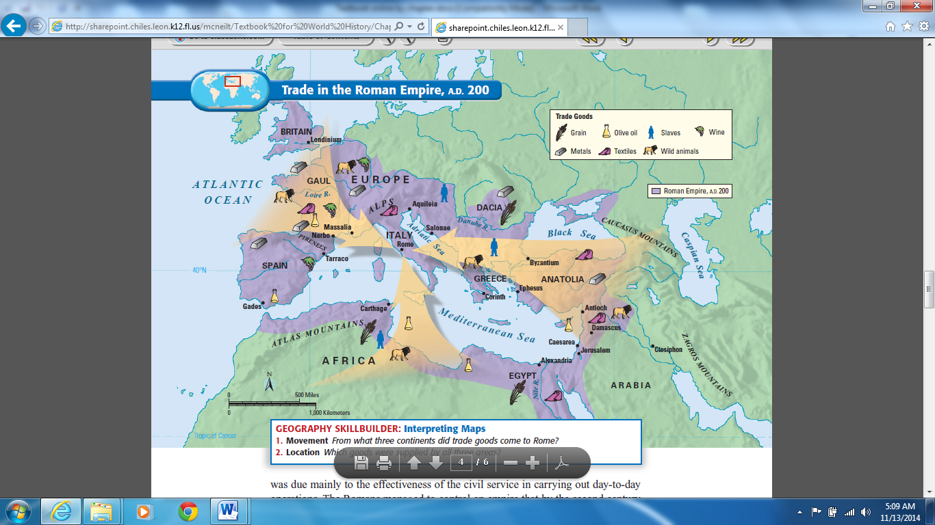**Ancient Rome**

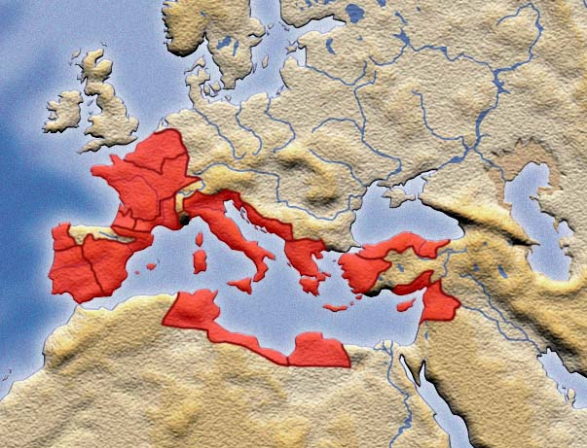

**44 B.C.**

For hundreds of years after the founding of the republic, Rome sought to expand its territories through trade and conquest. Roman power grew slowly but steadily as the legions battled for control of the Italian peninsula. By the fourth century B.C., the Romans dominated central Italy. Eventually, they defeated the Etruscans to the north and the Greek citystates to the south. By 265 B.C., the Romans were masters of nearly all Italy

Rome had different laws and treatment for different parts of its conquered territory. The neighboring Latins on the Tiber became full citizens of Rome. In territories farther from Rome, conquered peoples enjoyed all the rights of Roman

citizenship except the vote. All other conquered groups fell into a third category, allies of Rome. Rome did not interfere with its allies, as long as they supplied troops for the Roman army and did not make treaties of friendship with any other

state. The new citizens and allies became partners in Rome’s growth. This lenient policy toward defeated enemies helped Rome to succeed in building a long-lasting empire. For more than two centuries after 265 B.C., Roman power spread far beyond Italy.

Rome’s location gave it easy access to the riches of the lands ringing the Mediterranean Sea. Roman merchants moved by land and sea. They traded Roman wine and olive oil for a variety of foods, raw materials, and manufactured goods from other lands. However, other large and powerful cities interfered with Roman access to the Mediterranean. One such city was Carthage. Once a colony of Phoenicia, Carthage was located on a peninsula on the North African coast. Its rise to power soon put it in direct opposition with Rome.

In 264 B.C., Rome and Carthage went to war. This was the beginning of the long struggle known as the **Punic Wars**. Between 264 and 146 B.C., Rome and Carthage fought three wars. Rome’s victories in the Punic Wars gave it dominance over the western Mediterranean. The Romans then went on to conquer the eastern half. By about 70 B.C., Rome’s Mediterranean empire stretched from Anatolia in the east to Spain in the west.

Rome’s increasing wealth and expanding boundaries brought many problems. The most serious were growing discontent among the lower classes of society and a breakdown in military order. These problems led to a shakeup of the republic—and the emergence of a new political system. After several civil wars, Rome became an empire with one powerful leader.

Rome had a vast trading network. Ships from the east traveled the Mediterranean protected by the Roman navy. Cities such as Corinth in Greece, Ephesus in Anatolia, and Antioch on the eastern coast of the Mediterranean grew wealthy. Rome also traded with China and India. A complex network of roads linked the empire to such far-flung places as Persia

and southern Russia. These roads were originally built by the Roman army for military purposes. Trade also brought Roman ways to the provinces and beyond.

**Mayan Civilization**

While the Olmec were building their civilization along the Gulf Coast in the period from 1200 B.C. to 400 B.C., the Maya were also evolving. They took on Olmec influences, blending these with local customs. By A.D. 250,

Maya culture had burst forth in a flourishing civilization.

In its heyday from about A.D. 300 to 900, the Maya civilization boasted hundreds of cities across a vast swath of Central America. Now archeological sites, these once-flourishing cities extended from Chichén Itzá in the northern Yucatán to Copán, about 400 miles to the south in modern-day Honduras. Each bore ceremonial centers where theocratic rulers practiced a complex religion based on a host of gods, a unique calendar, and ceremonies that featured a ball game and human sacrifice. The ancient Maya also mastered astronomy, mathematics, art and architecture, and a glyph system of writing on stone, ceramics, and bark paper.

Although the Maya city-states were independent of each other, they were linked through alliances and trade.

Cities exchanged their local products such as salt, flint, feathers, shells, and honey. They also traded craft goods like cotton textiles and jade ornaments. While the Maya did not have a uniform currency, cacao (chocolate) beans sometimes served as one.

As in the rest of Mesoamerica, agriculture—particularly the growing of maize, beans, and squash—provided the basis for Maya life. For years, experts assumed that the Maya practiced slash and burn agriculture. This method involves farmers clearing the land by burning existing vegetation and planting crops in the ashes. Evidence now shows, however, that the Maya also developed more sophisticated methods, including planting on raised beds above swamps and on hillside terraces.

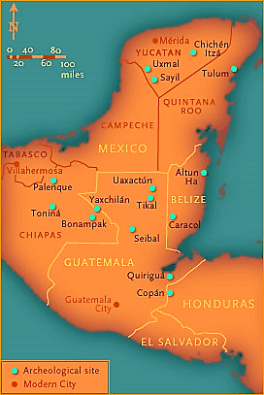

Successful farming methods led to the accumulation of wealth and the development of social classes. The noble class, which included priests and the leading warriors, occupied the top rung of Maya society.

Below them came merchants and those with specialized knowledge, such as skilled artisans. Finally, at the bottom, came the peasant majority. The Maya king sat at the top of this class structure. He was regarded as a holy figure, and his position was hereditary. When he died, he passed the throne on to his eldest son. Other sons of the ruler might expect to join the priesthood.

<http://www.pbs.org/wgbh/nova/mayacode/map-nf.html>