Name _________________________________ Date _____________

Algebra 1 PTech

Warm Up

1. Express in simplest form: 

2. Which expression represents  in simplest form?

Name _________________________________ Date _____________

Algebra 1 PTech

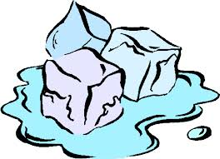Cool Down

In a science fiction novel, the main character found a mysterious rock that decreased in size each day. The table below shows the part of the rock that remained at noon on successive days.

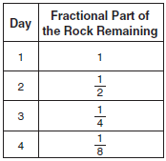

Which fractional part of the rock will remain at noon on day 7?

Name _________________________________ Date _____________

Algebra 1 PTech



Unit 6 Lesson 3

Extra Credit

To receive credit for this assignment, it must be printed out!

A radioactive substance has an initial mass of 100 grams and its mass halves every year. Complete the table and answer the following questions.

a) b) Determine a formula, based on part a for

|  |  |
| --- | --- |
| Number of years that have passed since 2014 | Mass Remaining (grams) |
| 0 | 100 |
| 1 |  |
| 2 |  |
| 3 |  |
| 4 |  |

the mass remaining (M) after each year (y).

c) Using your formula from part b, how many grams will remain after 8 years? Show the work that leads to your answer.