**World of Inquiry School**

**SBPT Minutes**

**January 25, 2018**

Facilitator: Jessica Flanders Time Keeper: Jamila Suhail Secretary: Robert Bond

Members Present: Sheela Webster, Yousuf George, Gina Porretta-Baker, Robert Bond, Eman Muthana, Nissa Youngren, Nancy Resto, Jessica Falander, Jamila Shail, Jessica Aldinger< Kim Garlock, Nicole McCoy, Kerry Robertson

Absent: None

Agenda:

Review and Approval of minutes from Dec Meeting: Minutes approved with changes

Review of Parent Engagement Funds\Webster:

* As a FOCUS school we have received additional funds for parent engagement ($12,816)
* Sara from Camp Corey asked for Family Camp ($9000), two days, one night, and up to 100 people, meals included, must incorporate mission and vision, include literacy piece (Carol Dweck), must include parent/guardian and children, first come first serve, transportation included
* High School Agendas discussion (Garlock is it necessary?)
* Unknown if this fund will be a reoccurring or a one time use
* Approved by SBPT

SLC Data Share-Out :

* Elementary: Grade Level percentage report
* High School: Pie chart and Notes from SLC Data Analysis Protocol
* SLC Crew: HOWL Rubric needs to be rolled out , families seemed happy, overall percentages were higher

Seventh Grade Recruitment Event Share-Out

* Moved from Sat to Tuesday, 171 new families signed compact, this number does not include the current 6th graders, overall success, elementary, middle school, and high school teachers present, student, and current families.
* Y.G.: perhaps more student input might be better
* District Level Event feedback: kids and family revisited

February Events

* Hijab Day: EM: 15 schools and 2 colleges, Feb 1, event during breakfast and lunch, district recognized event now, supported by Supt.,
* Black Lives Matter: KR: entire week 12-16, District wide event on the 16, but due to Bald for Bucks WOIS will focus on 12-15, with the 15th being our primary focus. We will be using the 13 BLM principles to focus class lessons. Circles during lunches for high school based on the principles. Jan 30 will be secondary PD for BLM. Working on way to communicate information to elementary teachers (perhaps a morning or afternoon meetings), Sara Oliveri working with Ilene Graham to develop materials for WOIS parents/guardians
* Bald for Bucks: The entire school will be going to St. John Fisher on Feb 16. Drew Fox, Donna Enright, her intern, and Sheela Webster are developing a plan for this event. Tentative time is 10-1. Eat lunch there. Nurse will be on site. More information will be sent out shortly.(Last day before break)

February 2nd Half Day Professional Development Plan:

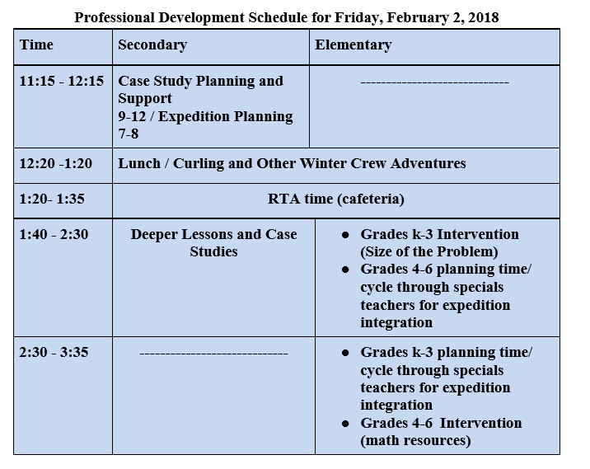

Upcoming Proposal for Focused Committee Work for Second Semester: Kim and Sheela

* Goal is to have this work done before end of school year, representatives from all constituencies, develop clear processes for each committee
* Uniform Committee (similar to cell phone policy committee): Administrative team will develop process for selecting members of committee
* Secondary Teacher and Student Handbook Revision Committee: Crew Crew will be working on it after feedback from secondary staff

Agenda for February Meeting:

School Wide Fundraising calendar

Budget, staffing, interview committee

Hijab Day Reflection