Draw a Translation

Construct the line parallel to a given line through a given point .

Step 1: Draw circle : Center , radius .

Step 2: Draw circle : Center , radius .

Step 3 Label the intersection of circle and circle as .

Step 4 Draw .

*Note:* Circles and intersect in two locations. Pick the intersection so that points and are in opposite half-planes of line .



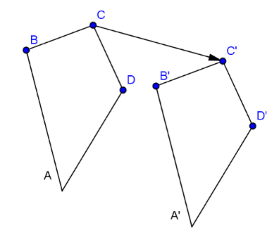  
Therefore, the figure to the right, quadrilateral , has been translated the length and direction of vector . Notice that the distance and direction from each point is the same.