Name _________________________________ Date _____________

Algebra 1 PTech

Warm Up

1. Which statement regarding correlation is *not* true?

|  |  |
| --- | --- |
| 1) | The closer the absolute value of the correlation coefficient is to one, the closer the data conform to a line. |
| 2) | A correlation coefficient measures the strength of the linear relationship between two variables. |
| 3) | A negative correlation coefficient indicates that there is a weak relationship between two variables. |
| 4) | A relation for which most of the data fall close to a line is considered strong. |

2. A study compared the number of years of education a person received and that person's average yearly salary. It was determined that the relationship between these two quantities was linear and the correlation coefficient was 0.91. Which conclusion can be made based on the findings of this study?

|  |  |
| --- | --- |
| 1) | There was a weak relationship. |
| 2) | There was a strong relationship. |
| 3) | There was no relationship. |
| 4) | There was an unpredictable relationship. |

3. As shown in the table below, a person’s target heart rate during exercise changes as the person gets older.

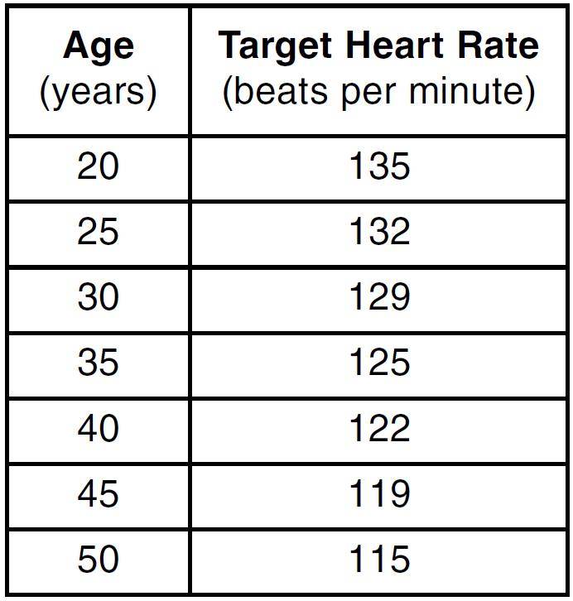

Which value represents the linear correlation coefficient, rounded to the *nearest thousandth*, between a person’s age, in years, and that person’s target heart rate, in beats per minute?

|  |  |
| --- | --- |
| 1) |  |
| 2) |  |
| 3) | 0.998 |
| 4) | 1.503 |

Name _________________________________ Date _____________

Algebra 1 PTech

Cool Down

The residual plots from two different sets of bivariate data are graphed below.

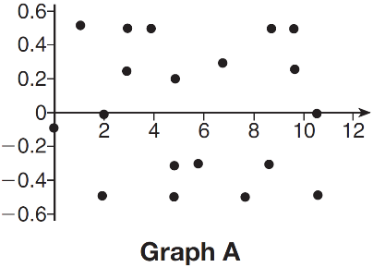 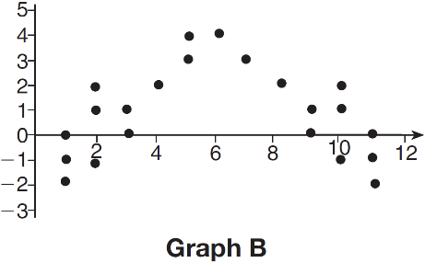

Explain, using evidence from graph *A* and graph *B*, which graph indicates that the model for the data is a good fit.