Literary Terms for Short Stories and Novels ____________________________________________________

1. **Plot** – The sequence of events in a story. Plot consists of rising action, climax, falling action, and resolution.
2. **Foreshadowing** – The dropping of important hints or clues to prepare the reader for what is to come and to help him/her anticipate the outcome.
3. **Irony** – When the opposite of what is expected to happen, happens.
4. **Setting** – The time and place that the story takes place.
5. **Protagonist** – The main or leading character in a piece of literature. This character is not *always* the “hero.”
6. **Antagonist** – The force, usually the person, who contends with or opposes the protagonist.
7. **Theme** – A statement that expresses the basic meaning of a literary work. This is the main message about life.
8. **Mood** – The feeling created by a piece of writing.
9. **Tone** – The feeling conveyed by the *author’s attitude* toward his subject and the particular way in which he writes about it**.**

**10. Symbol –** Any object, person or action which signifies something more abstract or general.

**11.**  **Flashback –** An action that interrupts to show an event that happened at an earlier time period.

**12.** **Characterization –** The personality a character displays. Methods of characterization include: the character’s thoughts and feelings, appearance, actions, and what others say about the character.

**13.** **Exposition –** The part that helps the reader to make clear, or explain the background or situation in which the work is set.

**14.** **Rising Action –** The events that lead to the turning point in the story.

**15.** **Climax –** The highest point of intensity in the story. This is usually the turning point in the story.

**16.** **Falling Action –** The events that follow the climax.

**17.** **Resolution –** The outcome of the story. The ending.

[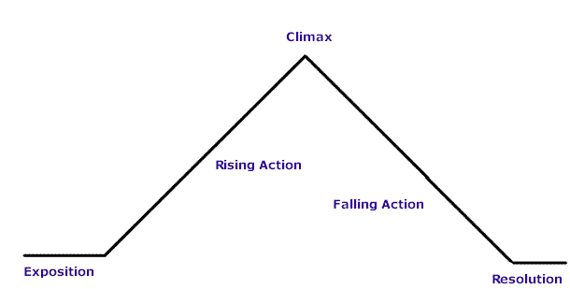](http://www.google.com/url?sa=i&rct=j&q=&esrc=s&frm=1&source=images&cd=&cad=rja&docid=OcrGDKt-bjE7iM&tbnid=c4stPFg6_zH4vM:&ved=0CAUQjRw&url=http://staff.fcps.net/tcarr/shortstory/cinderella.htm&ei=JHVAUv74HcLE4AP2sIGYDQ&bvm=bv.52434380,d.dmg&psig=AFQjCNFEz8N_Oy2elaSalFEBJWeQgfmc1Q&ust=1380042399093633)

**18. Point of View –** The author’s choice of a narrator for his/her story.

**A.**) **First Person –** The narrator (“I”) is a character in the story who can reveal only his thoughts and feelings and what he sees, hears, and is told by other characters.

**B.**) **Third Person –** The narrator is an outsider who sees into the mind of one of the characters.

**C.) Omniscient –** The narrator is an all-knowing outsider who can enter the minds of one or all of the characters.

**19. Conflict –** Events in the plot that show the struggle between opposing forces. There are five basic types of conflict:

1. Person vs. Person 2. Person vs. Self

3. Person vs. Society 4. Person vs. Nature

5. Person vs. Fate