Global History Review I

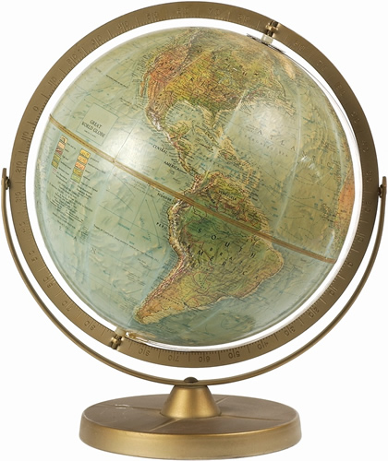

Review Unit #1

Beginning Fundamentals

Physical Earth – Terms

- Latitude: lines that measure how far something is north or south of the Equator
- Longitude: lines that measure how far something is east or west of the Prime Meridian
- Equator: 0 degrees Latitude - it divides the Earth between North and South
- Prime Meridian: 0 degrees Longitude - it (along with the International Dateline) divides the Earth between East and West
- International Dateline: 180 degrees Longitude - divides one day from another
- Hemispheres: half of the Earth (Example: Northern Hemisphere or Eastern Hemisphere)

Physical Features

- Islands: isolate cultures from other cultures - such as Japan
- Mountains: a barrier to travel – separate cultures - such as the Himalayas between China and India
- Deserts: a barrier to travel – separate cultures - such as the Sahara in Africa
- Rainforests: a barrier to travel – separate cultures - such as the Amazon Rainforest in Brazil
- Rivers: transportation routes – sometimes through barriers - such as the Nile through the Sahara
- River Valley: great place to begin a civilization in ancient times - such as the Tigris-Euphrates valley
- Plains: flat fertile lands – good for farming – often attract invaders - such as the Steppes of Russia
- Ice: prevents sea trade for much of the year – such as in Russia in earlier times
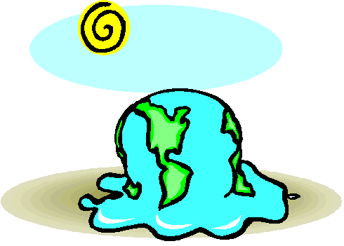

Elements of Culture

Culture: the way of life of a group of people

- Society: the type of people in a culture (ex: race, nationality, religious identity)
- Art: the expression of a culture’s ideas (ex: dance, music, architecture)
- Geography: the land, location, and resources of a culture (ex: physical features, climate, raw materials)
- Language: the communication system of a culture (ex: alphabet-writing, speech, symbols)
- Religion: the organized beliefs and rituals of a culture (ex: ceremonies, holidays, forms of worship)
- Economy: the way a culture gets the things it needs (ex: agriculture, hunting, manufacturing, trade)
- Politics: the government and laws of a culture (ex: leadership, rules, protection, services)
- Customs: the traditions of a culture (ex: holidays, clothing, celebrations)

- Cultural Diffusion: the mixing of two or more cultures together – sometimes forming a new culture

- Cultural Diversity: to coexistence of elements of a variety of cultures within a single culture

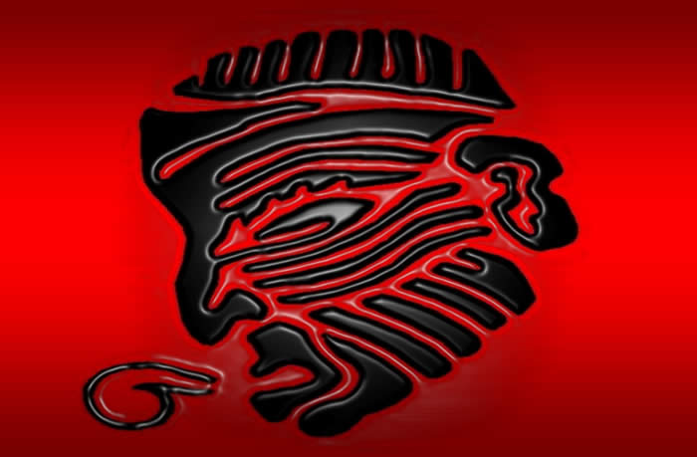

Time Management

- Decade: a period of 10 years
- Century: a period of 100 years
- B.C. - the time Before Christ on a timeline
- A.D. - Anos Domini - “In the Year of our Lord"
- C.E. - Common Era – Term now used to replace “A.D.” - (B.C.E. replaces “B.C.” [before common era])

Review Unit #2

Early Man and River Civilizations

Early Man

- Hunters and Gatherers: During the Paleolithic Stage (Old Stone Age) people wandered behind herds of animals in search of food. The men generally hunted – the women generally gathered berries, nuts, roots, etc.

- Migration: - Current evidence points to the earliest people having lived in Africa.
- They migrated (moved) to other places in the world.
- Native Americans migrated across a land bridge from Asia to North America.

- Cultural Diffusion: - As people migrated and settled together, their ideas mixed.
- Trade also caused cultural diffusion.
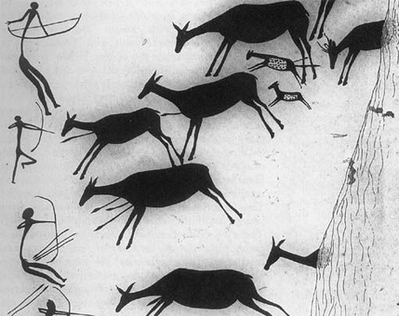

Neolithic Revolution

- Neolithic Revolution: The change from hunting and gathering to herding and planting.

- Results of Neolithic Revolution:

  - Permanent Villages - People built homes and settled together in permanent villages.
  - New Technology - People had the time to develop new tools and ideas to meet their needs.
  - Specializations of jobs - Less people were needed to produce food. Some people took on new roles (jobs).

- Civilizations: - As villages became more developed, some turned into civilizations.
- Civilizations can be identified by having certain things:
- Urban areas (cities)
- A writing system
- organized economy
- An organized government (laws)

River Valley Civilizations

Why river valleys were great locations to start a civilization:

- Irrigation: water for crops and human use
- Annual Flooding: supplied fertile soil for crops each year
- Transportation: allowed for trade and cultural diffusion
- Food Supply: fish and other items – land animals came near to drink

4 main river valley civilizations:

River Civilization
Nile Egypt
Tigris-Euphrates Sumer (Mesopotamia)
Indus India
Huang He (Yellow) China

Important Information

- Fertile Crescent: area of fertile soil in the desert Middle East – from Sumer to the coast of the Mediterranean Sea
- Cuneiform: writing system used in Sumer – wedge shaped symbols
- Hieroglyphics: writing system used in Egypt – picture symbols
- Hammurabi’s Code of Laws: first written set of laws in history – based on the “eye for an eye” principle
- Mohenjo Daro and Harappa: two main urban centers (cities) of India’s river valley civilization
- “Middle Kingdom”: what the Chinese called their land (they thought it was the center of life)

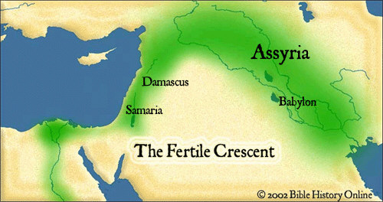

Review Unit #3

Classical Civilizations

Classical Civilizations: Civilizations that were so well organized that they were able to create many things that we still use today.

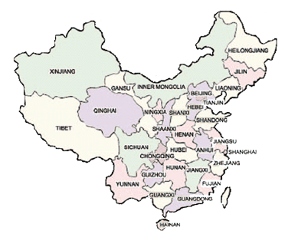

CHINA

- Dynasty: a line of rulers from the same family. They continue to rule as long as they have the Mandate of Heaven.

- Mandate of Heaven: belief that the Emperor was given the right to rule from the gods (similar to European Divine Right)

- Han Dynasty: 1st major Dynasty of China
- Civil Service System: required examinations for government positions. Exams based on teachings of Confucius
- Confucianism: - directed Chinese social life for hundreds of years
- Based on teachings of Confucius
- Everyone should use good moral behavior
- Have good educational system – to help have good government officials
- Government officials should rule by setting a good example of behavior for the people
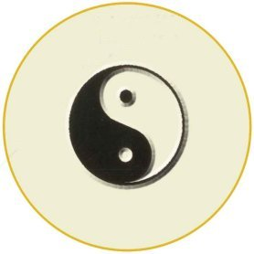
- Technology: paper, rudder, wheel barrow

INDIA

Maurya Empire 1st major empire in India

- Centralized Government: One of the first empires to run a government of communities from one central location
- Bureaucracy: system used within an organized government (officials, procedures, rules, etc.)

GREECE

- City-States: - Because of it’s mountainous geography and numerous islands; Greece did NOT form one large Empire. It was a collection of small City-States. Each was run like a small nation. Athens and Sparta were the most powerful. Athens became the most important.

- Democracy: A form of government – citizens share the power to make decisions - Began in Greece (Athens)

- Alexander the Great: Took over most of the “known world” Spread Greek culture (cultural diffusion) to Egypt, Persia, and India

- Hellenistic Culture: A result of Alexander the Great mixing Greek culture with the cultures from Egypt, Persia, and India

- Contributions: - Classical architecture: straight lines, basic shapes (square, rectangle, triangle) and columns for support

Review Unit #4

Belief Systems

ANIMISM
- Belief: Every living and non-living thing has a spirit. A very traditional concept in history. Worshipping of ancestors.
- Location: Still found in some traditional societies of the world – often associated with traditional African culture.

SHINTOISM
- Belief: Spirits of Kami dwell in many forms of the natural world
- Location: a traditional belief system of Japan

HINDUISM
- Reincarnation: belief that the soul is reborn in the body of another person or thing.
- Caste System: - people are born into different Castes (social classes)
  - they may be born into a higher (if they are good) or lower (if they are bad) Caste in the next life
- Ganges River: the holy river of Hinduism. Worshipers bathe in the river to free themselves from sin.
- Location: Began in India. Is mainly in India still today.

BUDDHISM
- Basic beliefs: all people suffer – ending desires will end the suffering
- Nirvana: by leading the right kind of life, eventually one can reach a state of ultimate awareness – Nirvana
- Location: began in India - spread to China, Japan, and Southeast Asia

CONFUCIANISM
- based on the teachings of Confucius
- people should lead a good, moral life
- education should be the way people advance in society
- government officials should be well educated and good role models

TAOISM
- begun by Lao Tzu
- followers must follow Tao (the way)
- follow the way of nature – don’t go against the way of nature

JUDAISM
- Beliefs: monotheism – only one God God will send a messiah (savior) Good behavior will be rewarded in Heaven
- Sacred Texts: Torah – laws and history of the Jews Ten Commandments – rules of behavior

Review Unit #5

Empires 1

TANG

- Location: China
- Contributions:
  - first use of paper money
  - porcelain: hard shiny pottery
- Japan studied the Tang Dynasty and copied much of the Chinese culture (language, Buddhism, etc.)
- The Silk Road began as a trading route between China and the west…eventually spread to the Middle East

GUPTA

- Location: India
- Hinduism and the Caste System flourished (became stronger) under Gupta rule
- The Gupta Empire was one of India’s “Golden Age”
- Contributions:
  - Guptas were good at Math
  - created the concept of “Zero” – and the decimal system
  - created the numbers we use today – Arabic Numerals (“Arabs” took them and introduced them to the Europeans)

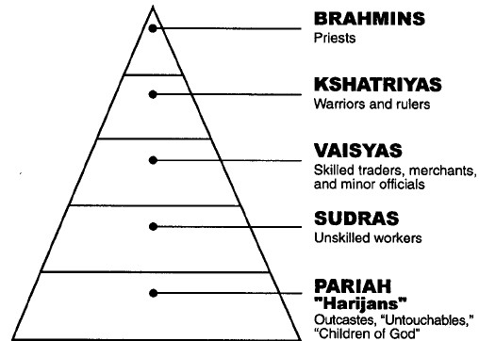

BYZANTINE

- Location: the “Eastern” half of the old Roman Empire
- Great Leader: Justinian – created Justinian’s Code - a written set of laws
- Its Church: Changed from Roman Catholic to Eastern Orthodox “Greek” was the official language
- Its importance:
  - The Byzantine Empire preserved much of the old Greek and Roman culture while barbarians destroyed Rome
  - It was “in between” the invaders from Asia and the rest of Europe
  - it spread learning and culture to Russia and influenced Russian life a great deal

MUSLIM

- Location:
  - Middle East Spread throughout the Middle East, Northern Africa, and into India as Muslims spread the religion of Islam
  - Arabs were great fighters
  - Muslims (Arabs) tolerated Judaism and Christianity (they were “of the book”) - but others had to convert
- Muslims: Arabs who worshipped the religion of Islam (Later - anyone who worshiped Islam)
- “Golden Age”: a time of peace (no more expansion) and great learning
- they preserved Greek and Roman learning (they got it from contact with the Byzantine Empire)
- created algebra
- developed advanced medical knowledge and practices
- Great astronomers and scientists
- Location: began in the Middle East – spread all over the world (Diaspora) – Israel is the Jewish homeland

CHRISTIANITY
- Beliefs: monotheism God did send a messiah (Jesus Christ) Jesus was the son of God Faith in God will be rewarded (Heaven)
- Sacred Texts: Bible
- Location: began in Middle East – spread by the Roman Empire throughout Europe (then on to rest of the world

ISLAM
- Beliefs: monotheism Five Pillars of Faith (pray 5 times a day, charity, pilgrimage, Ramadan fasting, believe in Allah)
- Sacred Texts: Quran (Koran)
- Location: begun in Middle East (Mecca) by Mohammed - dominates the Middle East area today
- Philosophy: using reason to understand why things happened.
- Socrates, Plato, and Aristotle were great Greek philosophers
- Knowledge: Greeks pioneered much thinking in medicine, science, math, and literature.

ROME

- Republic: Began in Rome A form of government - citizens elect representatives to make decisions for the people

- The Empire: Expanded beyond Italy to include most of Western Europe and the lands surrounding the Mediterranean Sea.

- Pax Romana: Time of peace and prosperity for the Empire (Its Golden Age)

- Contributions: - Roman Law: Twelve Tables: a written set of laws for all citizens to follow
- Arch: replaced Greek columns for support in architecture
- Latin language: used throughout the empire
- Organization: The Romans kept people in the empire organized: common language, laws, money system

Review Unit #6
Middle Ages
(Medieval Period)

DARK AGES

- Fall of the Roman Empire:
  - Roman Empire split into 2 parts
    - Western Europe – Fell into the “Dark Ages”
    - Eastern Europe – Became the Byzantine Empire
  - Without Rome’s organization – Western Europe fell apart:
    - - unorganized - uneducated - poor
  - There was no centralized government - each local area was run on its own (Barbarian tribes)
- Roman Catholic Church:
  - became the only organized institution in Europe at this time
  - had a hierarchy (People→Priest→Bishop→Arch Bishop→Pope)
  - had Church rules that everyone in Europe (Christians) followed
  - heresy – speaking out against the Church
  - excommunication – being kicked out of the Church
- Frankish Kingdom:
  - Franks became a an organized and powerful Kingdom state
    - Began Feudalism - a local organizing system with power based on land ownership
  - An important leader was Charlemagne (became the 1st Holy Roman Emperor)

FEUDALISM

- Feudalism:
  - it was based on the ownership of land – as well as binding obligations between Lords and Vassals
  - a system that helped to get Europeans organized again (though essentially only at the local level)
  - social: everyone was placed into a certain social class (Nobles, Merchants, Peasants) – and they had to stay there
  - political: the Lord made all of the rules and acted as judge and jury (he was the government)
  - economic: everyone got what they needed through feudalism - each person gave things and received things
  - manorialism – the basis for feudal economy – based on the self-sufficient manor (land that a Lord owned)
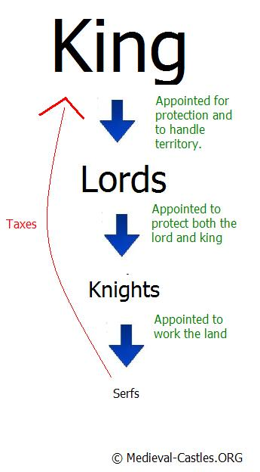

CRUSADES

- Crusades:
  - holy wars fought between Christians and Muslims – for control of the “Holy Lands” (Jerusalem)
  - they are important because they helped Europeans to:
- become better educated → 1. Learned Muslim ideas 2. found old “Greek and Roman” learning
- increased their wealth → were introduced to new trade products (cotton, silk, spices, coloring dyes, foods)
  - they helped end Feudalism
- New trade created new markets (towns) → many serfs ran away from manors to live in the new towns

IMPORTANT MEDIVAL EVENTS

- Battle of Tours: Christians stopped the Muslim invasion of Europe (stopped them in France – Muslims kept Spain)

- Battle of Hastings: Normans (William the Conqueror) defeated the Anglo-Saxons
  - the mixing of Norman culture with Anglo-Saxon culture created a new culture → English

- Hundred Years War: England vs. France
  - the longbow was first used → ended the Knights on horseback as the main way of fighting in feudalism
  - cannons (gunpowder) was introduced to European warfare → castles were no longer useful for defense

- Black Death: a form of plague (disease) that spread quickly and killed many Europeans
  - helped bring about the end of Feudalism
    - serfs became scarce → Lords paid money for their work (many then bought their freedom)

Review Unit #7

Renaissance

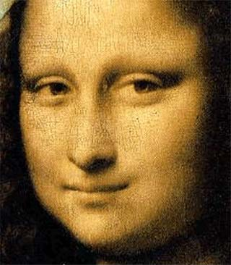

THE RISE OF CAPITALISM

What Europeans received on the Crusades dramatically changed Europe:

  - LEARNING:
    - new Muslim ideas (much of it came from Chinese ideas)
    - old Greek and Roman learning (preserved by Byzantine and Muslim Empires)
  - TRADE:
    - new trade products from Middle East and Asia created new markets and increased wealth in Europe
    - Middle Class: businessmen, craftsmen, merchants
- Ranked between land owning Nobles and the Peasants
    - Guilds: organizations of tradesmen and artists
- They regulated their trade or art (set prices, hours, standards)
    - Capitalism: economic system that replaced feudalism
- Based on using money – not land – for wealth
    - Commercial Revolution: there was a dramatic change in the economy – from the land based Feudal
Economy → to a money based Capitalism economy (market system)
    - The Hanseatic League formed to promote and protect trade for northern European cities
    - Italian city-states (Venice–Genoa–Naples) dominated trade between the Middle East and Europe

RENAISSANCE
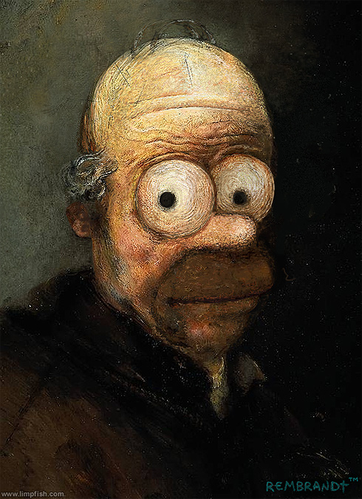

- Renaissance: a “rebirth” of ancient learning (Greek and Roman), as well as culture, that had disappeared during
The dark ages

- Italy: Renaissance began in Italy: Great location for trade→trade created wealthy people (Patrons)→ used wealth to
Sponsor great art
    - Medici Family: Bankers from Florence → great sponsors of the Renaissance
    - Florence: center of the Renaissance movement (because of the Medici family support)
    - Pope: located in Rome – also a great sponsor of Renaissance art

- Humanism: the new way of thinking during the Renaissance
  - less about religious themes (more about Man on Earth – not God in Heaven)
  - more about everyday, real life situations (secular – non religious)

- Art: less religious themes - people were more lifelike - scenes were more about everyday situations (humanism!)
  - perspective: a new technique used to make scenes look more 3 dimensional (depth)
  - Leonardo da Vinci: a “Renaissance Man” (could do many things well) painted the “Mona Lisa” and
the “Last Supper”
  - Michelangelo: painted the ceiling of the “Sistine Chapel” and sculpted “David”

- Literature: less about religious themes - stories were written to entertain people (humanism!)
  - Renaissance literature began to be written in the vernacular (everyday local language of the people)
  - Shakespeare: wrote great stories and plays about everyday human situations
  - Machiavelli: wrote The Prince – about how a ruler should rule over his people (rule by fear – not love)
  - Dante: Italian writer that wrote in Italian – not Latin – wrote the Divine Comedy

- Printing Press: invented by Johann Gutenberg
  - Books became more available (cheaper too!)
  - More people began to learn how to read
  - Ideas spread very quickly
  - Judged by many historians to be the most significant technological development in history
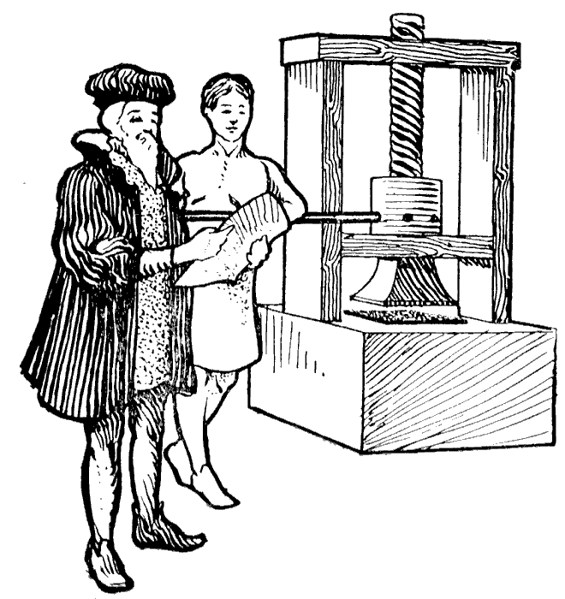

Review Unit #8

Empires 2

TOKUGAWA EMPIRE

- Japanese Feudalism: Traditional Japan was governed by shogunate (similar to European feudalism)
  - EMPEROR – symbolic leader Shogun– military ruler (actual leader) sammurai – warriors
  - BUSHIDO – term for Japanese Code of Conduct
  - Tokugawa – name of the Shogun family that controlled Japan for almost 300 years

- Japanese isolationism:
  - Japan’s island location caused its culture to be isolated from other cultures for many centuries
  - When new technologies allowed foreigners to reach Japan – Japan’s leaders began a policy of isolationism – they chose to remain isolated from other cultures

MONGOL EMPIRE

- Location: Came out of central Asia to take over China – spread empire west to Middle East (largest land empire ever)
- Khans: leaders of the Mongols
  - Genghis Khan spread and created the empire
  - Kublai Khan – made the empire stable and prosperous
- Silk Road: trade route linking China and the Middle East → Mongols made it safe and prosperous
- Marco Polo: European explorer/trader that traveled to China→ his stories later inspired European explorers to sail to the East

MING DYNASTY

- Re-established Chinese rule in China after the Mongol Empire
- Re-established ethnocentrism in China – the belief that their culture was better than all others

AFRICAN TRIBAL EMPIRES

- Empires: GHANA – MALI – SONGHAI
- Traditional Life:
  - Family→Clan→Tribe
  - Oral Tradition: The history of the tribe was passed down by “word of mouth”
- Mansa Musa: great Mali leader – converted to Islam
- Trade: Arabs crossed the Sahara and traded salt to the Africans for Gold (Arabs introduced Islam as well)

MESOAMERICAN EMPIRES

Empires: MAYA – AZTEC – INCA
Maya: Yucatan Peninsula area of Mexico Great thinkers→architecture (pyramid temples), Science (365 day calendar)
Aztecs: Central Mexico Great warriors
Incas: Great organizers → ran an organized governmental bureaucracy - road builders

♦ These civilizations were considered to be advanced civilizations for the western hemisphere

OTTOMAN EMPIRE

Location: Turkish Muslims took over parts of the old “Muslim” empire and the old “Byzantine” empire
Sulieman the Magnificent: was their great Sultan (leader)
Impact: They blocked Europeans from traveling (for trade) to the East (forcing them to look for an all-water route – essentially
starting the Age of Discovery period for Western Europeans)

Review Unit #9

Global Trade

CHINA
- Technology:
  - rudder (help steer ships)
  - compass (determine direction you are going)
- Zheng He: great Chinese explorer -sailed as far away as Africa
- Results:
  - Chinese ethnocentrism (belief that their culture was better than anyone else’s) caused exploration to end
    - they thought that no-one else had anything they wanted – so why keep exploring?

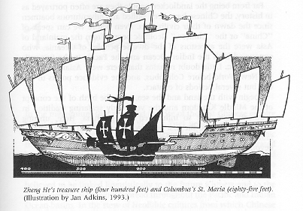

EUROPE

Technology:

got rudder and compass from the Chinese
  - got astrolabe (shows location), astronomical tables, and lanteen sail (to sail against the wind) from the Arabs
  - created good maps and good ships (Caravel) themselves
- Why they explored:
  - The 3 G’s: Gold, Glory, and God
    - Gold: get rich
      - trade with other nations (wanted to find an all-water route to Asia)
      - discover gold, silver, and other rich materials
    - Glory: become famous
      - become the first to do or find something
      - create honor, land, and power for your nation
    - God: spread religion (Christianity) to the natives

- Effects on Europeans:
  - trade increased (people got richer)
  - commercial activity increased – new markets and a business classes of people were created
- Mercantilism: economic policy of European nations at this time (use colonies to help the home nation get rich)
  - European nations became the most powerful nations on Earth
- Effects on the rest of the world:
  - their land was taken away from them (to make colonies) by the Europeans
  - many of the native people died
    - killed fighting the Europeans
    - diseases
  - they were forced to learn European cultural ways
- Significant Explorers:
  - Vasco da Gama: first to sail around Africa to India
  - Christopher Columbus: tried to sail to India by going West – accidentally “discovered” a new world
for the Europeans
  - Ferdinand Magellan: his crew were the first to sail around the world
- Important Terms:
  - Imperialism: the act of powerful nations taking over weaker regions and totally dominating their culture
  - Colonialism: the political relationship between a powerful “mother country” and its weaker “colony”
  - Mercantilism: the economic relationship between a mother country and a colony – the colony helps make money for the mother country – they provide free raw materials and a market for finished goods
  - Triangle Trade: trading system between Europe, Africa, and the new world – made money for Europeans
  - Columbian Exchange: the world-wide exchange of products and ideas after the discovery of the new world

CASE STUDY: Spanish Imperialism:
- Conquistadors: Spanish military leaders – Cortez defeated the Aztecs – Pizarro defeated the Inca
- Spanish success: 1) better weapons (gunpowder) 2) help from other native tribes 3) European diseases killed millions
- Encomienda System: Spanish govt. gave Spanish colonist permission to use natives as forced labor (slaves) on plantations
- Roman Catholic Church: played an important role as a link between the poor peasants and the Spanish government
- New culture: the mixing of Native American, European, and African cultures created a new “Latin American” culture
- Social Classes: the important social identity was based on race – not wealth. Europeans had the most power

Review Unit #10

The Reformation

PRE-REFORMATION

- Roman Catholic Church: had been the most powerful organization throughout Europe since the fall of the Roman Empire
  - until this time – no one dared to question the power and actions of the Church
  - The Church had influence over the people:
    - Spiritually: it controlled access to Heaven – people had to do what the Church told them to do
    - Politically: The Church had influence over Kings and Queens in Europe – laws too
    - Economically: The Church collected a tithe (like a tax) – 10% of all members’ wealth

THE REFORMATION

- Martin Luther: German monk who wrote 95 Theses (arguments) against the Roman Catholic Church – starting the Reformation

- Protestants: people who agreed with Luther’s ideas and joined in his “protest” against the Church
(Christians in Europe became divided into Roman Catholics or Protestants)

- What they were protesting about:
  - that the Church was more interested in making money than in saving people’s souls
    - it sold indulgences (pieces of paper that forgave people’s sins)
  - that the Church was too involved in secular (non-church related) issues - such as politics
  - that Church officials claimed to be the only source of religious truth – only they could interpret God’s word

- Protestant beliefs:
  - people could be saved by just having faith in God – not in any other ways
  - people didn’t need the Church’s interpretation of God’s word – they could read the Bible for themselves

- John Calvin: another Protestant leader – introduced the idea of Predestination (your fate [Heaven or Hell is predetermined for you)

COUNTER-REFORMATION

- Council of Trent: meeting of Church officials to plan on how to fight the Reformation
- Counter-Reformation: the Church’s attempt to get their members (hence money and power) back
- St. Ignatious Loyola: began the Jesuits (an order of Monks) – traveled Europe teaching discipline and learning to Catholics
- Spanish Inquisition: the Church in Spain actually used torture to persuade non-Catholics to become Catholic

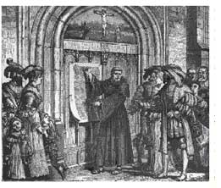

REFORMATION EVENTS

- Henry VIII: took England away from the Roman Catholic Church and created the Anglican Church (made himself the head of this church)
- Defeat of the Spanish Armada:
  - Spain’s navy (Philip II) invaded England (Elizabeth I) in order to force them to become Catholic again.
  - Spain lost – lost its position as most powerful nation in the world
  - England won – began its claim as the most powerful nation in the world
- Thirty Years War: war between the Northern nations of Europe (Protestant) vs. the Southern nations of Europe (Catholic)

RESULTS

- new churches began in Europe – more important: there was no longer just one Church in Europe
- the Roman Catholic Church lost much of its power and control of European affairs – Kings and Queens gained power
- people began to question many of the long standing beliefs they had been thinking about for many years
- the power and concept of the individual increased – people began to believe they had choices in their lives

Review Unit #11

Absolutism

TERMS
- Divine Right: the European belief that God chose who could be King or Queen
(similar to Chinese Mandate of Heaven)
- Monarchy: a type of government run by a King or Queen - they inherit their power from a family member
- Absolutism: when a monarch rules with total power (absolute power) – they do whatever they want to – they don’t consider the needs of their people

INFLUENTIAL WRITERS
- Niccolo Machiavelli: wrote a book called The Prince – said rulers should rule by having their subjects
fear them – not love them
- Thomas Hobbes: wrote a book called The Leviathan – said people were naturally unorganized and
simple – they needed strong leaders

ABSOLUTE MONARCHS

You should know:

1. where they were from
2. one thing they did for their nation
3. how that thing affected their nation

Akbar the Great:

1. INDIA

2. He developed one of India’s “Golden Ages” - a time of peace and wealth

3. The Golden Age made a peaceful and prosperous life for Indians of that time

Ferdinand and Isabella

1. SPAIN

2. They sponsored the voyages of Columbus

3. The discoveries of Columbus brought great wealth and power to Spain

Charles V
1. SPAIN
2. Led resistance against the invading Ottoman Empire
3. Kept Western Europe out of control of the Ottoman Empire (kept it Christian – not Muslim)
- Philip II
1. SPAIN
2. Spent Spain’s newly acquired wealth defending Catholicism in Europe during the Reformation and
Counter-Reformation
3. Spain lost its power and became a weaker nation again

Louis XIV:
1. FRANCE
2. Taxed the poor people - but not the rich people - used the tax money to build the Palace of Versailles
3. Put too much economic pressure on the poor people - many people starved
- Peter the Great:
1. RUSSIA
2. He tried to westernize (modernize) Russia
3. Western artists, scientists, and teachers came and taught Russians how to be more modern.

CASE STUDY: England

(why it was different from other nations)
- Magna Carta: a document that limited the powers of the Kings and Queens in England
- Parliament: originally a committee of Nobles created to keep an eye on the King’s actions

English Civil War:

King Charles I vs. Parliament - fighting for control of power in England

Parliament won (gained more powers than they had before)

Charles I executed – monarchy was abolished

Oliver Cromwell (leader of Parliament) took over - The Commonwealth ran England for a few years

The “Restoration”: the monarchy was restored temporarily after the “Commonwealth” did not work out too well

Glorious Revolution: Restored dynasty did not work out – William and Mary asked to the throne – only under the assumption that Parliament now had more power than the monarchy – supported by the English Bill of Rights

Today: Great Britain has a Limited Constitutional Monarchy

the Monarchy’s powers are limited by a written constitution

Parliament has all of the real power now

Global History Review II

Review Unit #12

Age of Revolutions

SCIENTIFIC REVOLUTION

- Scientific Method: a process used to answer scientific questions
  - it helped bring into question the common acceptance that God caused everything to happen.
  - Question the Church and Ancient philosopher, such as Aristotle, as the answer to all .
- Copernicus and Galileo:
  - proved the Sun was the center of the Solar System (Heliocentric Theory)
  - this proved that the church could be wrong about something (the Church had said the Earth was the center)
  - Persecuted for beliefs.
- Heliocentric Theory: “sun-centered” theory - it raised the question, “If the Church could be wrong about this issue,
could it be wrong about other issues?” - such as divine right?
Geocentric theory - or that the earth was the center of the solar system was wrong.

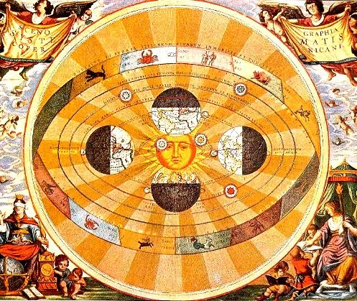

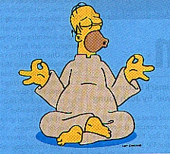

AGE OF ENLIGHTENMENT

A time when people were enlightened (exposed) to new ideas and ways of thinking - especially about politics

- Age of Reason: people used reason to guide them in their decisions (this comes from the scientific approach to learning)

- Enlightenment thinkers:
  - John Locke:
    - all people have certain rights
    - governments should protect people’s rights
    - if the government does not – people can overthrow the government

  - Other Enlightenment thinkers:
    - Jean Jacques Rousseau:
    - 1.There is a social contract between people and govt.
    - 2. the majority should rule.
    - Barron de Montesquieu: there should be a separation of powers –executive, judicial, legislative and Checks and Balances.
    - Voltaire: Personal freedoms, religious tolerance and freedom of the press and speech.
    - wrote plays and stories that poked fun of nobility and absolute government.
    - His work is responcible for the first Amendment for the United States Constitution.
    - Ceasar Beccaria – stop the practice of torture and rights for prisoners.
    - Mary Wollstonecraft – championed womans rights and mother to Frankenstien author Mary Shelley.

Their influence: the ideas expressed by Enlightenment thinkers got people to consider changing their governments (from Monarchies to Republics)

POLITICAL REVOLUTIONS

Political Revolutions: when people began to change their kind of government (from Monarchies to Republics)
- American Revolution:

  - American colonies broke away from Great Britain
  - They followed John Locke’s ideas (Britain was not protecting the colonists’ rights)
  - first time a modern nation ended a monarchy and started a Republic
(became an example to people in other monarchies)
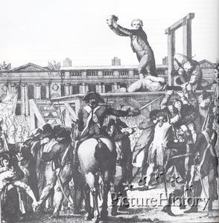
- French Revolution:

  - poor peasants were tired of the King (Louis XVI) taxing them and not taxing the rich nobles
  - they revolted and executed many nobles (reign of terror) – including King Louis XVI and his wife Marie Antoinette
  - overthrowing (and executing) a King was a big step in Europe – it motivated other people to think about doing it
  - Robespierre created a dictatorship and the Reign of Terror.
  - the new government was weak and was later taken over by Napoleon Bonaparte

- Latin American Revolutions:
  - Latin Americans were tired of being controlled by the Spanish, Portuguese, and French (mostly the Spanish)
  - they were inspired by the success of the American and French Revolutions
  - Toussaint L’Overture – leads fist revolution against Napoleans France and wins. Dies in a French cell.
  - their revolutions were led by Simon Bolivar and Jose de San Martin.

Review Unit #13

Reactions to Political Revolutions

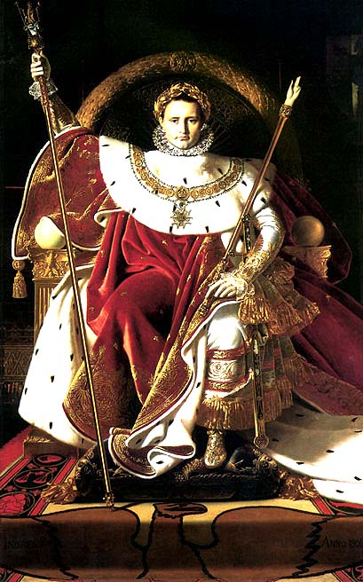

NAPOLEON BONAPARTE
- the new government of France (after the Revolution) was weak – Napoleon took it over and made himself Emperor
- he made France strong again
  - improved the economy
  - created public education
  - created the Napoleonic Code (set of laws for everyone to follow)
  - built a huge army
- used the huge army to take over most of Europe
- spread the seeds of the French Revolution (democracy) to other areas of Europe
- was finally defeated and banished to a far away island (St. Helena) and died there

CONGRESS OF VIENNA
- a meeting of European leaders
  - Conservative: to reorganize Europe the way it was before Napoleon took over
    - put borders back the way they were
    - reinstall kings and Queens that had been in power
  - Balance of Power: don’t let any one nation in Europe get so powerful again

1848: there were many small revolutions all over Europe that year

NATIONALISM

Nationalism is the act of creating a nation.
Nations are blindly following a King… there are a common language, customs, history, religion that you share with your fellow citizens.

- Unifying Nationalism: when people that have common binds decide to come together to form a new nation
- 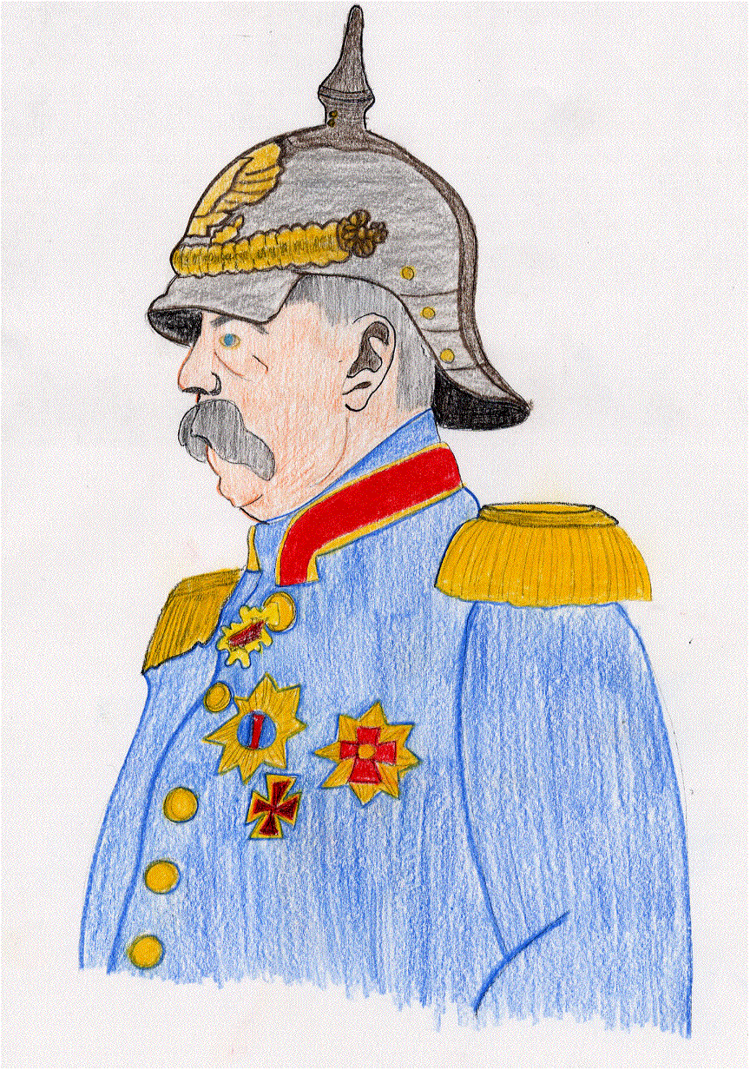
  - GERMANY: organized by Otto von Bismarck
  - ITALY: organized by Giuseppe Garibaldi
- Separating Nationalism: when different ethnic groups within a nation want to form their own – separate nations
  - AUSTRIA: Hungarians, Serbs, Germans, and other small ethnic groups wanted their own nations
- Independence Nationalism: when a colony wants independence from another power
  - LATIN AMERICA: wanted freedom from Spanish, Portuguese and French control
If you already have a nation – nationalism is the pride (patriotism) you have for that nation

RUSSIA
- was not affected by the revolutionary ideas that were sweeping the rest of Europe at this time
- freed their serfs (finally) in the middle of the 1800’s - This created a huge peasant class that was very poor

LATIN AMERICA
- after the revolutions – not much changed
  - the Europeans left
  - rich land owners became the new leaders (they paid the military to support them)
  - poor peasants remained poor peasants - the revolution had little affect on them
  - rural (out in the country) gang leaders called caudillos terrorized peasants and controlled large rural areas
  - The Roman Catholic Church continued to try to keep peace between the strong (caudillos and landowners) and the weak (peasants)

Mexican Revolution (1910-1930)

  - Causes:
    - Wealth was all going to a small upper class.
    - Separation of the rich and poor classes is the most common cause for revolution.

Review Unit #14

Industrial Revolution

TERMS
Agricultural Revolution: a change in the way food was produced (sometimes called the Agrarian Revolution)
Industrial Revolution: a change in the way things were made
- Domestic System: making products by hand – in a home – by one person
- Factory System: making products by machine – in a factory – using many people

AGRICULTURAL REVOLUTION
New Methods: new machines, enclosed fields, crop rotation, better animal breeding
Results: - More food was produced for people – using less workers
- More food caused the population to grow
- Ex-farm workers moved out of the country and into the cities – for new jobs in the factories

INDUSTRIAL REVOLUTION
5 Things a Nation should have to be successful industrially:
- Capital (Investment money) - Labor Force (workers) - Raw Materials
- Transportation System (Rivers, Canals, Railroads, Harbors) - Market for selling products
Great Britain was very successful industrially – because it had a lot of the above items

EFFECTS ON SOCIETY
BAD - Urbanization – too many people moved to the cities– too fast! → overcrowded, unsafe, unhealthy
- Poor Working Conditions – unsafe machinery and buildings, long work hours, low pay, child labor
GOOD - Improved Transportation – Faster and safer
- Rising Standard of Living – in general, more people had jobs, with regular pay, and could buy more things than before

REACTIONS TO THE INDUSTRIAL REVOLUTION
Laissez-Faire:
- based on AdamSmith’s book The Wealth of Nations
- belief that governments should NOT interfere with business activities
- less regulation and laws is good for business
Liberalism vs. Conservatism:
- two different views about how society should work
- Conservatism:
  - Society should try to preserve the old ways of doing things
  - favored the old Monarchies
  - wanted Nobles and the govt. to control business decisions

- Liberalism:
  - As times change – societies should change
  - supported the new Republics
  - Laissez-Faire (no govt. involvement in business)
Social Darwinism:
- based on Charles Darwin’s book On the Origin of Species
  - outlining the “theory of evolution” (survival of the fittest)
- Social Darwinism: Darwin’s survival ideas applied to social ideas:
  - In business: do what ever you have to do to survive
  - War: weed out the weaker nations
  - Race relations: used to justify racism → which then increased
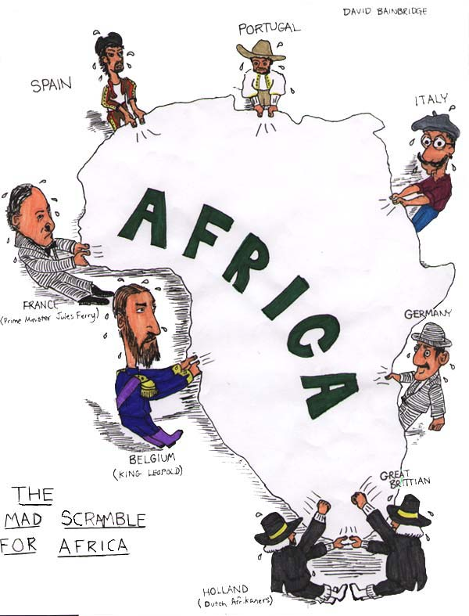
Social Reforms:
- Sadler Report: Report on the abuses of child labor → said it was NOT a good thing for society
- Child Labor: Laws were passed to get the kids out of the factories – and into public schools (which began then)
- Trade Unions: organized workers to demand better working conditions (less hours, better pay, safer conditions)
- Suffrage: extending the right to vote: first to all men – then to women as well
The Arts:
- Romanticism: art based on emotion – the dreams of revolution – fantasy, imagination, past glories
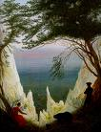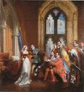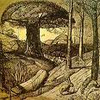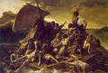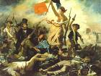

- Realism: art meant to show how the world really was – even the harsh realities of industrial revoluitionary life. – the works of Charles Dickens, photos
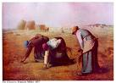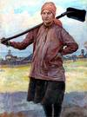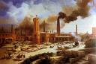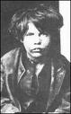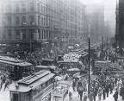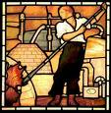

Impressionism: a reaction against Realism – looking to future dreams – based on an artist’s impression of real life.

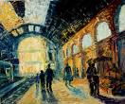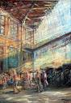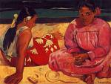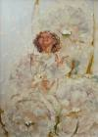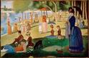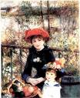

Global Migration: large groups of people moved from some places on Earth to others
Reasons: overpopulation, poor living conditions, poor working conditions, oppressive governments, better transportation
    - Leader (Diaz) brutally suppressed all opposition
  - Revolution led by Zapta (leader of southern Native Americans) – “Poncho” Villa (northern bandit)
  - Results:
    - Rebels won – more rights and land to workers and women
    - New Constitution: first Latin American country to give good changes to the common people
    - More Mexican control of trade and industry (not foreign [Spanish] control)

Review Unit #15
Imperialism
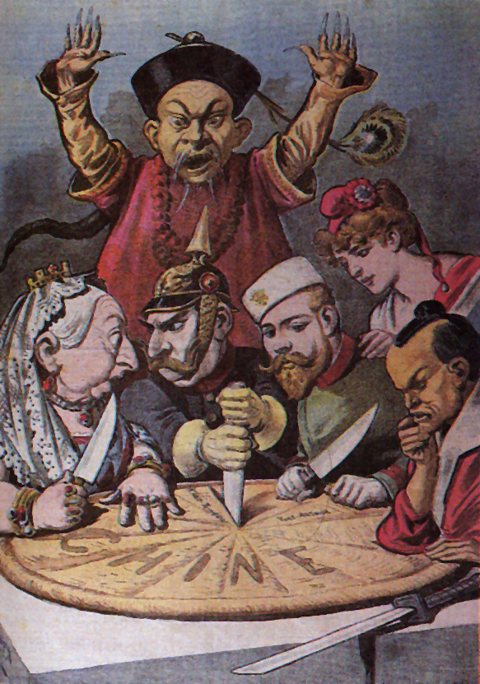
EUROPEAN IMPERIALISM

Africa – “Scramble for Africa” 1870’s–1914
European nations looking for 1. Raw Materials 2. Markets for their products 3. Soldiers for army 4. Labor
- “Boer War” : Dutch settlers (Boers) vs. British for control of Southern Africa

India – Was a British colony - run by the British East India Company
- Sepoy Mutiny: a rebellion of Indian soldiers in the British Army (Sepoys lost)
- Jewel in the Crown – Britian largest colony, added 1 million soldiers to army.

China – China had resisted foreigners for centuries - were ethnocentric (thought their culture was better than others)
- Opium War : Britain vs. China Britain won – British imported opium for tea… created a demand for trade. This forced China to open up to trade.
- “Spheres of Influence” : selected areas of China where only certain foreign powers could trade
- Taiping Rebellion : Chinese citizens fought with their own government against the influx of foreigners (millions died)
- Boxer Rebellions : Chinese citizens fought foreign armies to get foreigners out of China (lost)

REASONS FOR EUROPEAN IMPERIALISM

Nationalistic – taking over other nations added to your nation’s power
- “Social Darwinism” : it was “natural” for strong nations to take over weaker ones (If you didn’t, someone else…)

Political (military) – colonies were important locations to set up overseas military bases
- colonies helped provide power and security

MAIN REASON → Economic – get raw materials for industry - establish new markets for trade products

NEGATIVE EFFECTS ON NATIVE PEOPLE

- Land and materials were stolen.
- Natives forced to adapt to European cultural or ways. (laws, religion, language, etc.)
- Local traditions were not considered and history was lost.
- Local economies had to change to meet European needs

POSITIVE EFFECTS ON NATIVE PEOPLE

- New technologies were introduced
- Health and medical care improved
- Western educational ideas spread

Review Unit #16

The World Wars
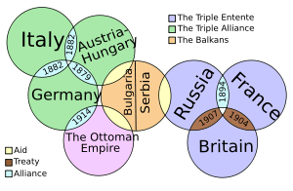

WORLD WAR I

Causes: Countries had gained great armies through eh advances in the Industrial Revolution.
- National Rivalries: Competitive relationships between European powers - “Balance of Power” - Imperialism in Africa
- Militarism: new industrial technologies encouraged nations to create and stockpile more and more weapons
- Alliances: to balance the power – nations joined sides with other nations to protect one another
- Assassination: Archduke Ferdinand’s assassination sparked the alliances into starting World War I 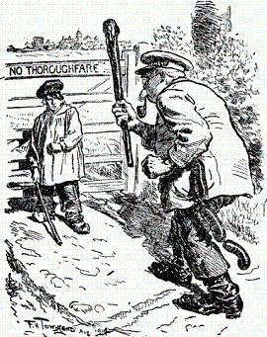

Warfare: - Trench Warfare: fighting took place in “trenches” (long ditches that hardly moved throughout the war)
- Propaganda: organized information created to sway public opinion on an issue – both sides used it
Results: - Treaty of Versailles: Severely punished Germany → it indirectly led to some of the causes of World War II
- League of Nations: created to keep peace in the world – ended up being very ineffective
- New Europe: many of the old “Empires” and “Kingdoms” broken up → beginning of modern national states

BETWEEN THE WARS
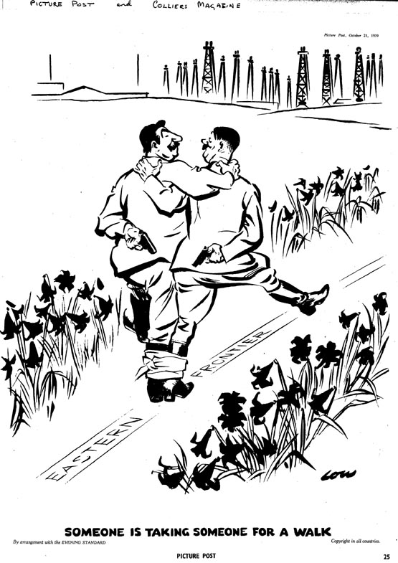

Hitler’s rise to power:
- Germany’s poor economic situation caused them to look for a strong leader
- Hitler made promises to the people:
- Jobs (1. in the Army 2. in the factories making military supplies) ← against the Versailles Treaty!
- Get their Pride back (1. get Germany’s land back 2. build up the Army again)
Hitler’s Germany:
- Totalitarian Government – a type of government with total control of all parts of life (learning, art, literature, etc.) People have no rights … such freedom of speech, freedom of press, freedom of religion etc. It is the opposite of a democracy.
- Fascism: a type of government that is totalitarian – and – very nationalistic ( a lot of national pride)
- Nazi Ideas – Nazi’s were the political party that Hitler controlled and helped him control Germany
- wanted to develop the Aryan race
- wanted to expand German territory throughout Europe
- used extensive propaganda to spread their ideas and control the people
- The Holocaust – an event taking place during WWII – Jews and other minorities were concentrated and many killed
- Genocide – the mass killing of a race or culture of people
- Hitler’s plan:
1. Harass and torment the Jews – maybe they would leave on their own
2. Concentrate them – placed in concentration camps – separated them from “Germans”
3. The “Final Solution” – extermination in mass numbers

WORLD WAR II

In Europe: The focus of the European part of WWII was Allies against Germany
- Causes
- German Aggression: Germany kept reclaiming lands lost after WWI (Rhineland, Austria, Sudetenland, Poland)
- Appeasement: Britain and France kept allowing Hitler to take lands – because they did not want another war
- The War
- Mobil Warfare: blitzkrieg (lightning war), air war, naval war
- Modern Technology: effective use of airplanes and tanks, rockets introduced, development of atomic bomb
- Key Events: Battle of Britain, German invasion of USSR, Involvement of US, D-Day
- Results
- Germany: was divided up by the Allies – German officials tried at Nuremberg Trials
- End of the system of European colonies around the world (Europeans did not want to fight to defend them)
- United Nations was created (to replace the ineffective League of Nations)
- The Cold War began – U.S. and the U.S.S.R., former allies, turned on one another

In Asia: The focus of the Asian part of WWII was Allies against Japan
- Causes
- Japanese Imperialism: Japan needed more raw materials - Korea, China, S.E. Asia --> Pearl Harbor attack
- The War
- Japanese abuses: Nanking and Korea – abuse against citizens Bataan – “Bataan Death March” abused prisoners of war
- “Island Hopping”: How the Allies approached Japan - Taking an island and forcing Japan to withdraw towards Japan
- The Atomic Bomb was used on Hiroshima and Nagasaki Japan – ending WWII
- Results
- The U.S. occupied Japan for 7 years - helped them rebuild - made them create a democratic style of government

JAPANESE IMPERIALISM

1600’s – Japan had chosen a policy of isolationism
1800’s:
- Treaty of Kanagawa – American Matthew Perry forced Japan to open up to trade
- Meiji Restoration - Japan chose to end isolationism → become more “westernized” (more industrial and militaristic)
- Japan began to Imperialize – Because they need more raw materials for their industry and military
  - Sino-Japanese War: China vs. Japan Japan took some areas of China
  - Russo-Japanese War: Russia vs. Japan Japan won – first time an Asian nation defeated a European power

Review Unit # 17A Communism in the USSR

ORIGINS OF COMMUNISM

Karl Marx: wrote The Communist Manifesto – it described how Communism (socialism) should work
Communism: a combination of economic Socialism and political Totalitarianism - sometimes called a Command Economy

COMMUNISM IN THE USSR
Russian Revolution: in 1917, Russians revolted against the Czar’s rule – they changed to a Communist government
- Causes: - Life for peasants under the Czar was terrible
- Many Russians were angry with the Czar for getting Russia involved with WWI
- Bolsheviks (Russian Communist Party) offered “Bread, Land, and Peace”
Lenin’s USSR: Union of Soviet Socialist Republics - A bunch of Republics that were united by workers in a socialist economy
- NEP: Lenin’s “New Economic Policy” - Lenin realized the young nation needed some elements of capitalism in order to effectively get socialism (communism) started
Stalin’s USSR: - Stalinism – all aspects of Soviet rule were directed by Stalin and devoted towards his rule
- Totalitarian State: the government had total control of all aspects of life (art, education, music, jobs, etc)
- Collectivization: Stalin’s plan to improve agricultural production à collect farmland into one common farm
- 5 Year Plan: Stalin’s plan to improve industrial production
- Purges: How Stalin got rid of anyone that was a threat to his power à execution or concentration camps
- WWII: first signed a non-aggression pact with Germany (they split Poland) - later attacked by Germany

THE COLD WAR
Origins: after WWII – mutual distrust between the U.S. and the USSR – political differences - economic differences
- the 2 sides: US – capitalism – democracy – NATO vs. USSR – communism – totalitarian – Warsaw Pact
In the USSR: - after World War II – Soviets “kept” control of eastern European territory they liberated from the Germans
- these satellite nations formed the Eastern Bloc behind the “Iron Curtain” (Warsaw Pact military alliance)
Major Events: Marshall Plan/Truman Doctrine – Berlin Airlift – Space Race – Berlin Wall – Cuban Missile Crisis – Détente

Fall of the USSR
Causes: - a younger Mikhail Gorbachev replaced a series of older generation leaders
- introduced reforms: Glasnost – “openness” to new ideas from outside Perestroika –“restructuring” govt.
- Poor Economy: too much sacrificing “butter for guns” The govt. spent too much on military – not enough on the people
- too much support of “satellite” nations
- Challenges to Communism by protesters - Hungary (1956) - Czechoslovakia (1968) Poland/Solidarity (1989)
- republics of USSR broke up: first had industrial strikes - some republics declared independence (became new nations)

New nations:
- Russia became the largest and most influential of the newly independent nations (the old Republics)
- Boris Yeltsin became the new democratically elected leader
- the transition from a socialist to a capitalist economy was difficult – much poverty exists - the economy is struggling
- with-in Russia – the region of Chechnya is trying to break away into an independent nation – Russia won’t let it
- Yeltsin has since been replaced by Vladimir Putin

COMMUNISM IN CHINA

The Chinese Republic: - the government of China before communism came to power
- it had replaced the dynasties in China (they were letting too many foreigners in)
- it was begun by Sun Yixian After he died, Jaing Jieshi replaced him as head of the Nationalists

Rise of Communism: - Communism was attractive to the peasant classes (the same as in Russia!)
- Communism in China was led by Mao Zedong
- The Nationalists defended their rule from the Communists in the Chinese Civil War
- Mao led the Communists on The Long March
1. to train as fighters 2. to learn Communism 3. to recruit supporters
- the war had to stop as Japan invaded during WWII - after, the Communists defeated the Nationalists
- China became Communist (People’s Republic of China) - the Nationalists fled to Taiwan

Mao’s China: - Great Leap Forward: Mao’s attempt to improve the economy in China - it failed
- Cultural Revolution: Mao’s attempt to strengthen Communism in China - it failed
(Red Guard [Student supporters], Little Red Book, anti-intellectuals)

Deng’s China: - Deng Xioping replaced Mao Zedong - he saw China needed to change from Mao’s strict ways to survive
- Deng introduced economic reforms - but NOT political changes
- allow some private ownership (capitalism) - some foreign companies in China
- Deng crushed a student demonstration against Communism in Tiananmen Square

Recent China: - today China is run by Hu Jintao (2003)
- Hong Kong was given back to China from Great Britain in 1997 (it’s capitalist ways influence southern China)
- a major focus of China is to reduce the population growth rate (they try to limit families to 1 child)

COMMUNISM IN OTHER PLACES

Korea: - North was Communist – South was not
- Korean War: North invaded the South
- South supported by the United Nations
- neither side won (stalemate)

Vietnam - Vietnam had been a French colonial possession
- Under HoChi Minh the French were driven out
- The French divided Vietnam before they left: North was communist - South not
- North attacked the South - the South was supported by the United States– unsuccessfully. North won – took over

Cuba: had been a Spanish colony – turned over to the U.S. after Spanish American War – became an American play land (1950’s)
- Communist rebels led by Fidel Castro took over and made Cuba communist (1959) American interests were forced out
- Cuban Missile Crisis: Soviets put nuclear missiles in Cuba (1962) America demanded their removal
- the closest the world has come to a nuclear war (US vs. USSR)
- Fidel Castro still runs communist Cuba – but its failing economy leads some to believe communism may not last there
Review Unit #18

Post WWII Nationalism

Following WWII – many European colonial possessions were challenged by native populations

AFRICA
Nationalist movement: - many African colonies demanded independence after WWII - some came peacefully, others not
- Gradualism – the policy of granting colonies independence as they became ready to run them
- Ghana – peaceful transition under Kwame Nkrumah
- Kenya – violent transition under Jomo Kenyatta

Continued economic ties: many former colonies continued an economic connection with their previous colonial power
- British Commonwealth – an economic alliance between Great Britain and its former colonies

Political Instability: new African nations are plagued with problems concerning the stability of their political systems (govt.)
- Ethnic Rivalries: tribal identities often come in conflict with one another within a nation
      - Nigeria: many Civil wars have taken place because tribes can not agree on a govt.
      - Rwanda: acts of genocide by Hutu tribe against Tutsi tribe (became refugees in other nations)

The Apartheid Issue: Apartheid : the official government policy of separating races of people in a nation
- the most famous example took place in the nation of South Africa
- the minority white populations ruled over the majority black population
- led by Nelson Mandela – the African National Congress (ANC) pushed for reform
- Bishop Desmond Tutu organized international pressure on South Africa’s white government to change
- President F.W.DeKlerk (white) began changes to eventually allow blacks to vote
- 1994 – Nelson Mandela elected President of South Africa – Apartheid ended

INDIA
British Colonial Rule: India had been a British colony for many years – run by the British East India Company
- the “Sepoys” (Indian soldiers in the British army) revolted in the Sepoy Mutiny

Nationalist Movement: The Indian National Congress (Hindus) and the Muslim League (Muslims) pushed for independence
- led by Mohandas Gandhi, Indians used non-violent methods to get independence
      - passive resistance: peaceful ways of protesting against something (marches, boycotts, strikes)
      - civil disobedience: breaking a law on purpose – to get attention for your cause

Independence: Great Britain granted Independence to India in 1947 à BUT – only if India was divided up!
- India needed to be partitioned (divided) because the Hindus and Muslims could not get along together
Hindus: got the middle section – which became the modern nation of India
Muslims: got a section in the West and one in the East – became West Pakistan and East Pakistan
(In 1971 East Pakistan won a war with West Pakistan – it became the independent Bangladesh)

Recent News: - India remained non-aligned (did not take sides) in the Cold War
- India, Pakistan, and Bangladesh are all fighting an overpopulation struggle
- Disagreements over control of the region of Kashmir could lead to a destructive (nuclear) war between
India and Pakistan
SOUTHEAST ASIA
Vietnam: Had been part of French Indo-China - fought the French and defeated them (Battle of Dienbienphu)
- North became communist (under HoChi Minh) - invaded the democratic South (later supported by U.S.)
- north won à today Vietnam is one communist nation

Cambodia: The communist Khmere Rouge – led by Pol Pot – committed acts of genocide against its own people (intellectuals)

Myanmar: Aung San Suu Kyi has led demonstrations against the oppressive military government there – she’s been arrested
Review Unit # 19 Recent World Conflicts

POLITICAL HOTSPOTS

Korea: Conflict between the North (Communist) and the South (Democratic)

Taiwan: Communist China claims the island and threatens to take over the Democratic island nation of Taiwan (U.S. supported)

Chechnya: The tiny region of Chechnya wants to break away from Russia and form its own nation - Russia does not agree

Kashmir: India and Pakistan are fighting over control of Kashmir. Each side has nuclear weapons, and vows to use them

Tibet: what began as an ethnic conflict against Buddhist has turned into a pro-independence movement for Tibetans against China

Afghanistan: United States forces are trying to secure and support the new democratically elected government

ETHNIC HOTSPOTS

Balkan Mts.: Ethnic Serbs were killing (genocide) ethnic Muslims in Bosnia and other areas. NATO and UN forces are there

Northern Ireland: Irish Catholics are angry that British led Protestants still control Northern Ireland. IRA has used terrorism.

The “Kurds”: nomadic Kurds living in various Middle Eastern nations (Iraq, Iran, Turkey, Syria) are often treated with violence

THE MIDDLE EAST

Palestine Issue: - Jewish Israelis and Muslim Arabs (Palestinians) are fighting over control of the same piece of land
- the Jews claim the land was promised to them by God, and that it’s their homeland – they were kicked out
of the land by the Romans nearly 2000 years ago - they call the land Israel
- the Arabs moved in when the Jews were kicked out – they say it belongs to them because they have been living
there for the last 2000 years - they call the land Palestine – they are supported by neighboring Arab nations
- Zionism: a movement begun by worldwide Jews in the 1800’s to get their homeland back
- following WWII ( in part because of the Holocaust) – an international effort to create a Jewish state in Palestine
began - Britain’s Balfour Declaration began the process of allowing this to happen
- In 1947 the U.N. partitioned Palestine – some land went to Jews of the world – some reserved for Palestinians
- 1948 Jews declared the independent nation of Israel– Arab nations attacked Israel in support of the Palestinians
- there have been a total of 4 Arab/Israeli wars - Israel has never lost
- PLO: Palestine Liberation Organization – used terrorism to get Palestinian land back – Yassir Arafat was leader
- In 1979 Egypt became the first Arab nation to recognize Israel’s right to exist à Camp David Accords signed
- Today: they try peace attempts – radicals on both sides often disrupt the peace process
• Palestinians: want a self governing nation
• Israelis: want to live peacefully and securely

Iranian - Islamic Fundamentalists – led by Ayatollah Khomeini – overthrew the Shah of Iran in 1979
Revolution: - they also overtook the American Embassy – taking Americans hostage
- an Islamic Fundamentalist state was created – traditional Muslim laws and practices replaced secular ones

Iran/Iraq War: - begun over a border dispute (access to Persian Gulf) - Iran also wanted to spread the fundamentalist movement
- after 8 years (1980-1988) nothing much accomplished by either side – except mass deaths of soldiers

Persian Gulf - 1990 – Iraq – under Saddam Hussein – invaded Kuwait 1. access to deep water port 2. Kuwait’s oil reserves
War: - United Nations Coalition Forces (led by the U.S.) drove Iraq out of Kuwait
- Saddam Hussein was left in power – remained a threat to peace in the region and the world

U.S./Iraq War: - U.S. led attack on Iraq to remove Saddam Hussein from power
- Hussein captured – his government toppled
- stabilization of the new nation will be a difficult task
Review Unit #20 World Economic Issues

ECONOMIC SYSTEMS
Market Economy: A business owned by private citizens – the “market” makes the decisions – Great Britain, Japan
(often called capitalism or free market)
Command Economy: business owned by the “people” (through the govt.) – govt. officials make the decisions – Cuba, N. Korea
(often called socialism or communism)
Mixed: uses some of both Market and Command (govt. often controls “big” businesses and influences major economic decisions)

INTERNATIONAL TRADING AGREEMENTS
NAFTA: (North America Free Trade Agreement) attempting to make trade easier between Canada, Mexico, and the United States
OPEC: (Organization of Petroleum Exporting Countries) - many of the oil producing nations of the world
- they control how much oil is produced à which controls the price of oil on the world market
European Union: (EU) - attempts to make trade and commerce easier between member nations of Europe

NORTH vs. SOUTH
North: nations in the northern hemisphere are generally more industrial, wealthy, and modern
South: nations in the southern hemisphere are generally less developed, poorer, and more traditional
- they are often called developing nations (they used to be called Third World Nations)
- little modern technology - often dependent on a single cash crop - international debt
- lack of industry (no capital, poor raw materials, few “skilled” workers, unstable government)

International Assistance Organizations: provide economic assistance to developing nations: UNICEF, World Bank, IMF, WHO

RISE OF ASIAN ECONOMIC COMMUNITY

Re-emergence of Japan: - After WWII – Japan had been destroyed physically and economically
- U.S. occupied Japan and helped it rebuild - also provided it a market for its cheap industrial goods
- Japanese developed their own industrial style
      - copied good industrial ideas from other nations
      - developed and improved their own concepts 1. employee teamwork 2. robotics
- the Japanese government often provided economic assistance (tariffs, embargoes) to industries
- over the years Japan developed a favorable balance of trade with the United States
( they sold more to us than they bought from us)

Asian Tigers: - the name given to rapidly developing nations in Asia
- many have followed the Japanese industrial model
    - Taiwan
    - South Korea
    - Hong Kong
    - Singapore

The future?: - who will be the future economic players in Asia? The World?
- signs point to China and the nations of Southeast Asia (Indonesia, Vietnam, Malaysia)

Review Unit #21 Global Issues

THE UNITED NATIONS
United Nations: Organized after WWII to 1. Keep peace in the world and 2. Assist developing nations with problems
General Assembly: made up of all UN member nations - have general discussions about world issues
Security Council: 15 nations at a time–5 of which are permanent members(allies of WWII) - authorizes use of force or sanctions

TRADITION vs. MODERNIZATION
Many cultures face conflict as modern ways begin to replace traditional values
- Japan: while they readily accept modern, especially western ways, they still strive to keep more traditional values
- Middle East: the influx of western values has collided with traditional religious laws and customs
GLOBAL MIGRATION
As in the past, groups of people sometimes pack-up and move from their homeland to other areas of the world
Reasons: Economic Opportunity: trying to find a way to make more money, get ahead in the world, economic security for family
Civil Unrest: some people leave to get away from areas of violence (Rwanda for example)
Political Oppression: some leave in order to get more political freedoms

STATUS OF WOMEN AND CHILDREN
Women: - women in many traditional cultures are often treated as inferior to men
- women in many Muslim cultures are often restricted in their actions
Children: - many children are forced to work in terrible working conditions as nations begin to industrialize
- Infanticide: killing of children at birth or a very early age – often because of traditional or economic reasons

SCIENCE AND TECHNOLOGY
Green Revolution: changing the way traditional community’s farm–introduction of modern agricultural technologies (more food!)
Information Age: Computers and the Internet now provide volumes of information in a very quick time
Space Age: much space technology has been used in the commercial world – satellites help predict weather, monitor the Earth, assist in navigation, and speed communication
Medical Technology: we can live longer lives now: 1. better prevention of sickness 2. Better cures for those that get sick

GLOBAL PROBLEMS
In addition to the following definitions – every student should know a place where the problem is taking place – a cause of the problem – an effect the problem has on the place – and a possible solution to the problem

Terrorism: the organized hurting, scaring or killing of innocent people in order to get attention for a cause
Nuclear Proliferation: the spreading of nuclear weapons, technology, or materials – often illegally
Nuclear Safety: some nations don’t operate nuclear facilities safely. Construction and maintenance need to be regulated
Acid Rain: Chemically polluted rain that destroys plant and animal life
Urbanization: people moving into cities too quickly – the cities can’t keep up with building homes or providing services
Overpopulation: some places on Earth have too many people for the amount of livable land they have
Endangered Species: some animals and plants are close to becoming extinct
Deforestation: destruction of the rainforest
Desertification: the spreading of a desert into arable lands
Epidemics: the spread of diseases – often uncontrollably
Pollution: disposing of waste into the environment (air, land, water mainly)
World Hunger: in some places, some people do not get enough nourishment to maintain their health – or their life

