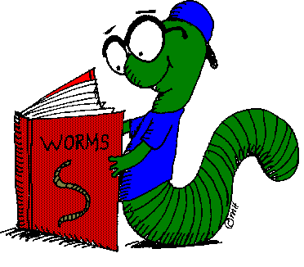
Weekly Book Metalog

Name____________________________________________

Week of_________________________
Weekly Independent
Reading Score
Monday | Tuesday | Wednesday | Thursday | Friday

4 = I am on task and reading silently during sustained silent reading time. I filled out my book log without reminders from my teacher.
3 = I am on task and reading silently during sustained silent reading time. I filled out my book log with a reminder from my teacher.
2 = I am on task and reading silently for some of the time. I started to fill out my book log.
1 = I am not on task, but I did read a little. My mind was wandering and I did not fill out my book log.
0 = I did not participate in sustained silent reading today.

Monday Title_____________________________________ Today, I read from page ______ to _______
_____________________________________________________________________________________________________________________________________________________________________________________________________________________________________________________________________________________________________________________________________________________________________________________________________________________
Tuesday Title_____________________________________ Today, I read from page ______ to ______
_____________________________________________________________________________________________________________________________________________________________________________________________________________________________________________________________________________________________________________________________________________________________________________________________________________________
Wednesday Title_____________________________________ Today, I read from page _______ to_______
_____________________________________________________________________________________________________________________________________________________________________________________________________________________________________________________________________________________________________________________________________________________________________________________________________________________
Thursday Title_____________________________________ Today, I read from page_______ to _______
_____________________________________________________________________________________________________________________________________________________________________________________________________________________________________________________________________________________________________________________________________________________________________________________________________________________
Friday Title_____________________________________ Today, I read from page _______ to ______
____________________________________________________________________________________________________________________________________________________________________________________________________________________________________________________________________________________________________________________________________

