World of Inquiry High School 58 National School Change Award – Fordham University
200 University Avenue National Excellence in Urban Education Award San Diego State University
Rochester, New York 14605 National Blue Ribbon Award – US Department of Education

World of Inquiry School
Crew Compact
School Commitment:
The World of Inquiry School will provide a rich learning environment for all students. The environment will challenge their thinking, promote learning by doing, and encourage life-long learning so that young people will be engaged, collaborative citizens. School leadership will focus on a combination of student learning, progress, and school community building. The Expeditionary Learning Schools model will guide the instructional program which will be provided by highly qualified teachers. We will embrace and cultivate relationships with our families and community to help our children succeed. The WOIS is a community of high expectations.

Parent Commitment:
I will have my child arrive at school every day ready to learn. I will provide my child with the support to be emotionally prepared to face the demands of school. I will ensure that my child will wear “crew wear”/uniforms daily, complete all homework assignments, and work collaboratively with adults and peers. I will be a full partner in my child’s education by attending student led conferences and exhibitions that celebrate and honor my child’s learning and work. I will be a member of the World of Inquiry School Crew and will hold high expectations from myself, child and school.

Student Commitment:
I will come to school every day ready to learn. I will nourish my body with sleep and proper nutrition. I will complete all my homework assignments. I will participate fully in my classes, crew advisory teams and learning expeditions. I will be a good citizen in my school and community by being respectful to my peers and teachers at all times. I will wear the full uniform daily. I will resolve problems in a productive way. I will be a part of a learning community that works in cooperative groups and respects each other’s opinions. I will be a crew member who believes we are a community of high expectations.

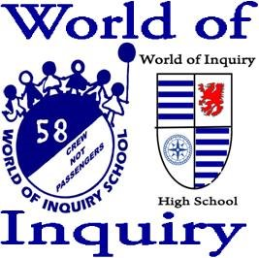
Principal Signature: ___________________ _____________________________________________________

Parent Signature: __________________________________________________________________________

Student Signature: _________________________________________________________________________

Student ID#: ______________________________________________________________________________

