Name _________________________________ Date _____________
Algebra 1 PTech

Warm Up

1. Let f be the function represented by the graph below.
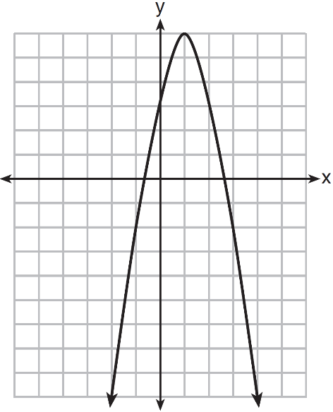
Let g be a function such that 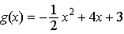. Determine which function has the larger maximum value. Justify your answer.

2. The table below represents the residuals for a line of best fit.

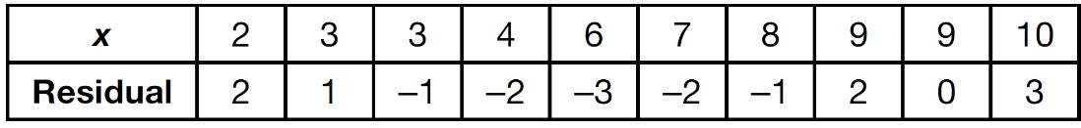

Plot these residuals on the set of axes below.

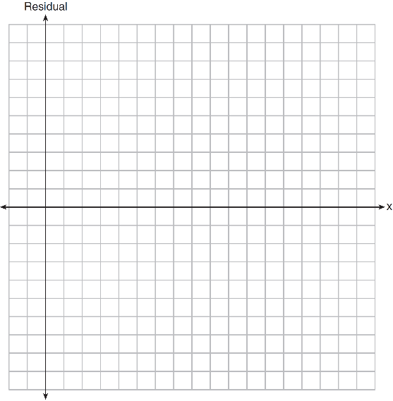
Using the plot, assess the fit of the line for these residuals and justify your answer.

Name _________________________________ Date _____________
Algebra 1 PTech

Cool Down

1. A student was given the equation to solve by completing the square. The first step that was written is shown below.

The next step in the student’s process was . State the value of c that creates a perfect square trinomial. Explain how the value of c is determined.

2. On the axes below, graph .

If , how is the graph of translated to form the graph of ? If , how is the graph of translated to form the graph of ?

Name _________________________________ Date _____________
Algebra 1 PTech
Unit 11 Lesson 8
Homework

1. The formula for the area of a trapezoid is 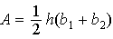. Express in terms of A, h, and . The area of a trapezoid is 60 square feet, its height is 6 ft, and one base is 12 ft. Find the number of feet in the other base.

2. Let and . On the set of axes below, draw the graphs of and .
Using this graph, determine and state all values of x for which .

