Name _________________________________ Date _____________
Algebra 1 PTech

Warm Up

On the set of axes below, graph the following system of inequalities and state the coordinates of a point in the solution set.

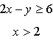

Name _________________________________ Date _____________
Algebra 1 PTech

Cool Down

A company manufactures bicycles and skateboards. The company’s daily production of bicycles cannot exceed 10, and its daily production of skateboards must be less than or equal to 12. The combined number of bicycles and skateboards cannot be more than 16. If x is the number of bicycles and y is the number of skateboards, graph on the accompanying set of axes the region that contains the number of bicycles and skateboards the company can manufacture daily.

Name _________________________________ Date _____________
Algebra 1 PTech
Midterm Review
HW #3

Show all work for each question – including multiple choice. An answer alone with no work shown will not receive any credit.

1. The number of calories burned while jogging varies directly with the number of minutes spent jogging. If George burns 150 calories by jogging for 20 minutes, how many calories does he burn by jogging for 30 minutes?
1) | 100
2) | 180
3) | 200
4) | 225

2. The ninth grade class at a local high school needs to purchase a park permit for $250.00 for their upcoming class picnic. Each ninth grader attending the picnic pays $0.75. Each guest pays $1.25. If 200 ninth graders attend the picnic, which inequality can be used to determine the number of guests, x, needed to cover the cost of the permit?
1)
2)
3)
4)

3. Which equation represents the line that passes through the point and has a slope of ?
1)
2)
3)
4)

4. What is the solution of the system of equations and ?

5. Write an algebraic expression that represents 15 less than x divided by 9?
6. What is the value of the expression when and ?

7. What is the solution of the inequality ?

8. State a point that is in the solution to the system below and state a point that is not in the solution to the system below.
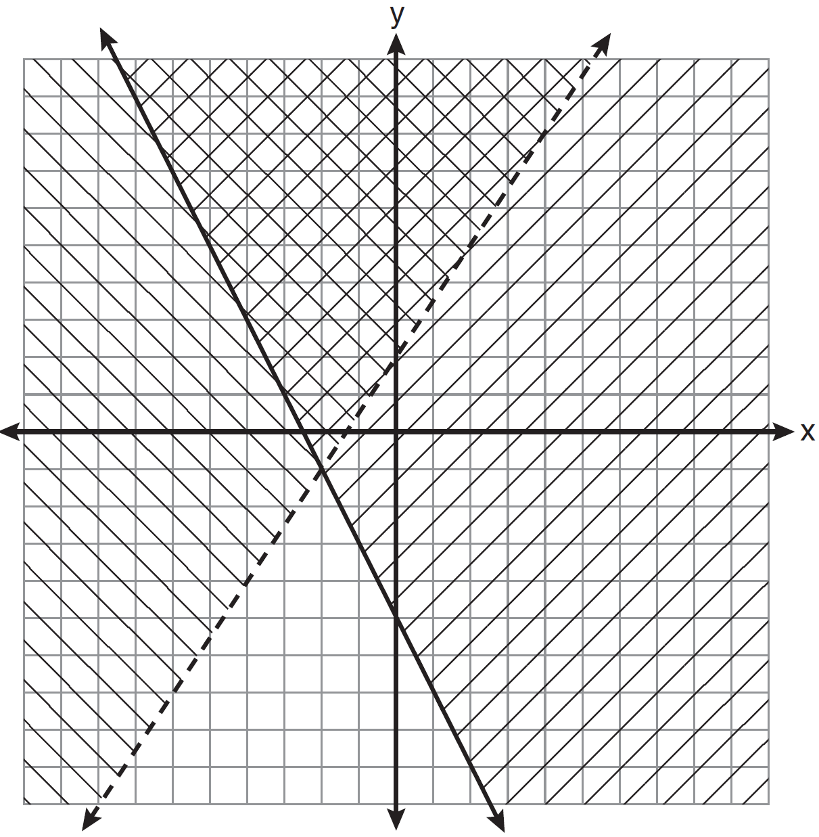

9. Solve for c in terms of a and b:

10. Solve for m: 