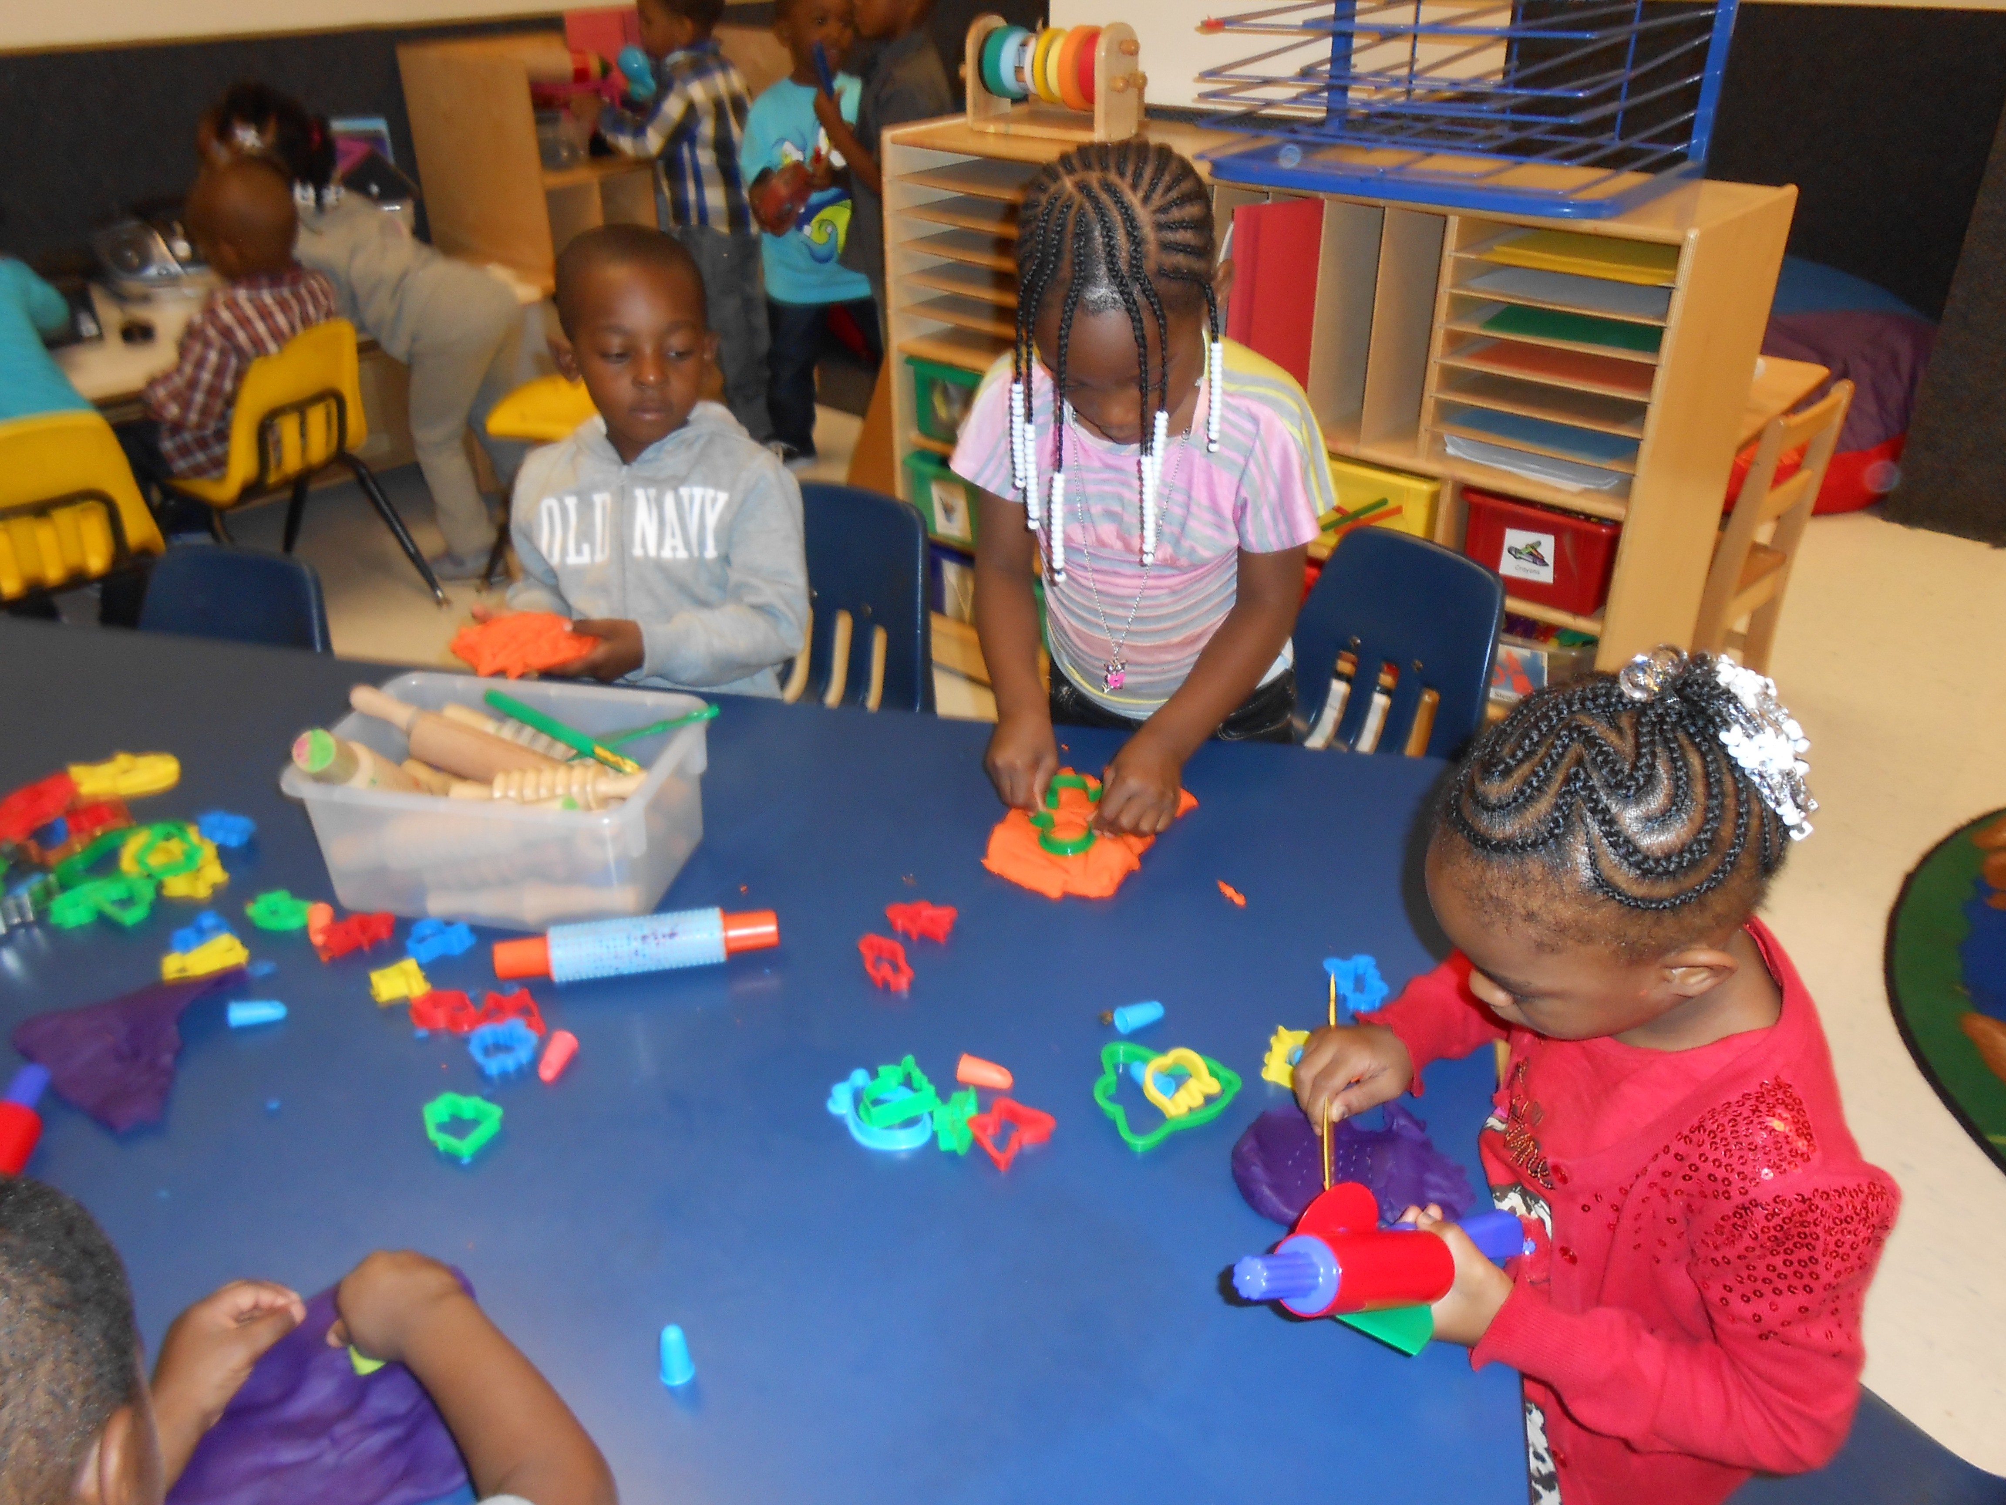
Continual Reminders;
- Please send your child with weather appropriate clothing every day
- A zip up coat for outside when it is below 70
- Sneakers with socks and loose fitting clothing that CAN get dirty for inside play, and projects in the room
- An extra change of clothes in case of a spill or accident
- If you have the time and would like to volunteer in the class, call me!
- My contact information; 263-4283 then ask for me or for Rainbow Fish, Christine.cook@rochesterymca.org
Schedule
Swimming- Thursdays
All Day students-Kid’s Gym- Tuesdays, Thursdays and every other Friday (socks required!)
Newsletters monthly in the middle of the month
Important upcoming dates-
Open House- October 9, in the classroom from 4:30-6:00. Families are invited to come in with their child and explore the classrooms!
October 14- Students who regularly leave at 12 have NO school.
Rainbow Fish News
September 2013
These last couple of weeks have felt like a whirlwind here in Rainbow Fish. If you still have not sent in the paper labeled ‘Important Information about your child,’ then we still need that back. In the time that children have been in school we have seen children begin to get used to the routine in the classroom. We have also seen children begin to build relationships with the adults and other children in the room. Everyone will be sent home a class list with pictures of each child’s face and their names on it. This will hopefully help you in talking with your child about who they sit next to, play with and talk to during the day. The staff in the class insists that children learn each other’s names. This will help as they continue friendships in the year or even when there is an argument and a student needs help from a teacher. At small group time we have been looking at the different areas in the classroom. Children have many opportunities to play in the areas of the room, but at small group time we can concentrate on where to find things and where to put them away. As we looked at the areas, the adult in the group reinforces vocabulary to help build more words for your child to use. Thank you to all parents who made sure that your child has a swimsuit so that we could all be ready to swim! All the children did well meeting the swim teachers this week and are looking forward to their time at the pool. Please be sure that your child has socks and sneakers daily. We play on the playground where there are wood chips on the ground each day unless it rains.
P.S. Thank you to the parents who send their children on the bus. I know it has taken some patience, but we are ready now.
P.P.S. We have already had some volunteers in the room. If your schedule allows, any family member is welcome.

