Continual Reminders;
- Please send your child with weather appropriate clothing every day
- A zip up jacket for outside and as the cold weather comes in a hood or hat with mittens or gloves.
- Sneakers with socks and loose fitting clothing that CAN get dirty for inside play, and projects in the room
- An extra change of clothes in case of a spill or accident
- If you have the time and would like to volunteer in the class 9:00 is a great time to come in and read to kids, call me!
- My contact information; 263-4283 then ask for me or for Rainbow Fish, Christine.cook@rochesterymca.org
Rainbow Fish News
November 2013
We are Online now! The Rochester City School District has given us a website to use. If you go to http://www.rcsdk12.org/prekindergarten and then look under teachers you will find my name. When you click on Cook, Christine you will be able to view information about contacting me, some links for kids to play online learning games and a calendar with some upcoming events. For example, we will have a school vacation coming up November 27-29. I plan to add many photos from in classroom, at the pool and on field trips. If you would not mind having your child’s photo on this website, please sign the agreement below and return. If you absolutely do not want your child’s photos included, then please check that box below. Thank you in advance and I hope you will enjoy the many things you can see on our website.

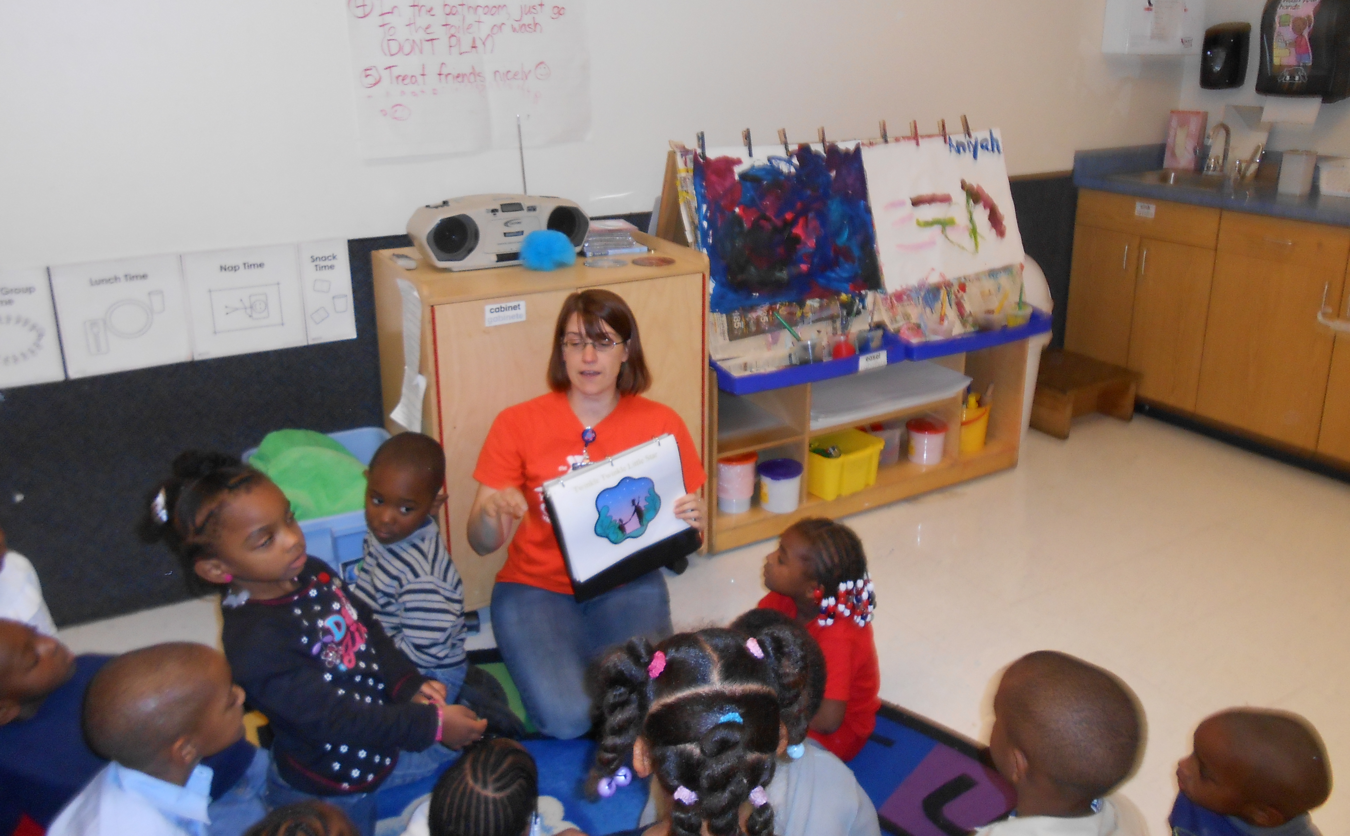

Child’s name: _____________________________________________________

I (parent’s written name) _____________________________________
- DO give permission to the YMCA to use photographs of my child on the RCSD website. I will not be informed or reimbursed for photographs
- DO NOT give permission for my child’s photos

Parent’s Signature:___________________________________________________
Date:________________________________________________________

Return to envelope in the classroom. Thank you!

